Beschreibung: nova_Institut_fOuI_4c_en**Press release**

*nova-Institut GmbH (*[*www.nova-institute.eu*](http://www.nova-institute.eu/)*)*

Hürth, 1 October 2019

# Reducing the use of plastics without changing production technology?

## 130,000 t of biocomposite granulates are available for greening in Europe. World's largest biocomposites conference in November in Cologne (Germany).

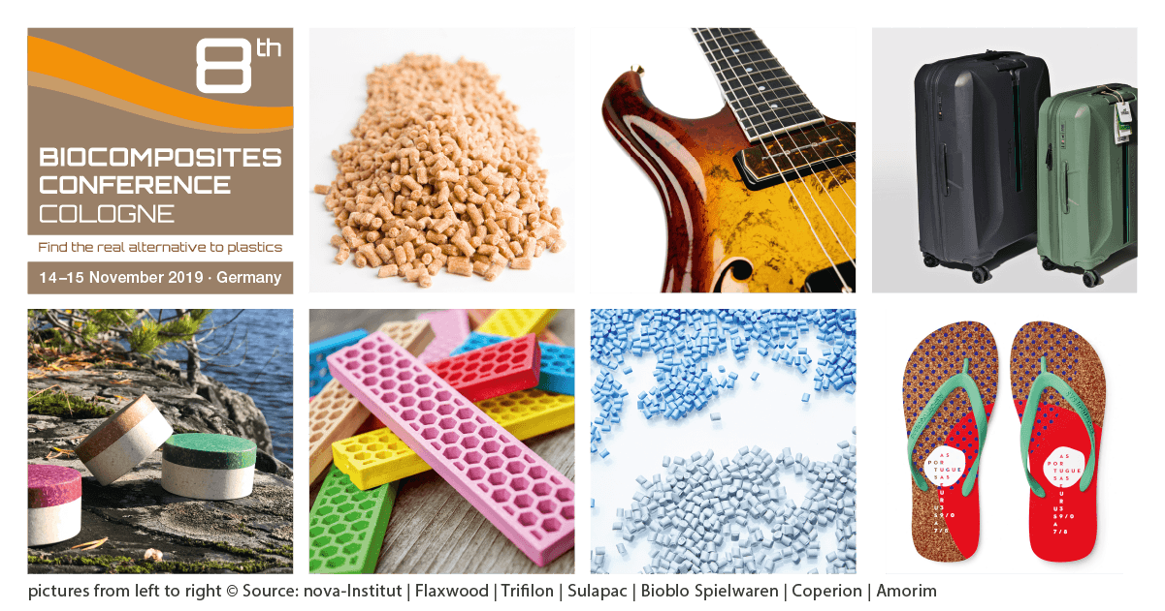

Today’s customers expect companies to reduce plastics in their products. But this is difficult without compromising performance and processability. Biocomposites can be the solution: 30 to 80 % of plastics are replaced by biogenic fillers such as wood flour or cork, or by natural fibres for reinforcement. The advantage is that these granulates can be processed on your existing machines without major modifications, whether by injection moulding, extrusion or additive production (3D printing). At the same time, the products differ from normal plastic products in their very pleasant feel and unusual appearance. Also, mechanical properties change, the products become stiffer and more tensile and bend-resistant due to the natural fibres.

nova-Institute has now published a list of all European producers and suppliers of biocomposite granulates. The list includes 30 producers from nine different countries. The amount of granulates produced and sold in 2018 was almost 130,000 t. This is a considerable increase compared to previous years and double-digit growth is expected in the next few years.

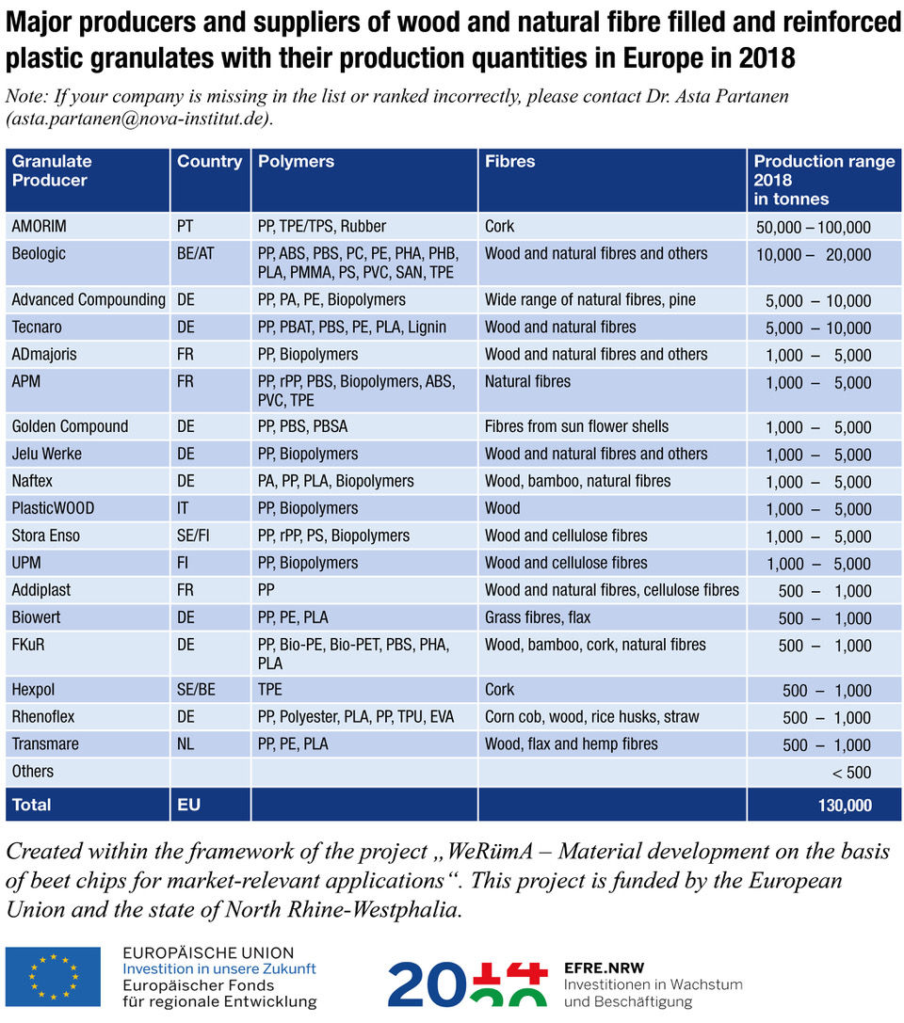

### What are the reasons for this success?

For one thing, there has never been a greater demand for alternatives to classic plastic products. For another thing, larger quantities of high quality granulates are available on the market for the first time. The manufacturers – often active for more than 10 years already – have used the time to further optimize their granulates. The larger volumes in turn allow for lower prices. Never before has it been so inexpensive to make your production greener without compromising on performance and processability.

Today, there are biocomposites for virtually every application: consumer goods, toys, handles and shoes, façade and terrace elements, floors, automotive interiors, and even space applications.

The Portuguese cork manufacturer AMORIM is the largest producer of such granulates with over 50,000 tons per year. Almost everyone owns or knows products such as shoes, handles for sports equipment or bathroom floors, which are made from those cork materials. Next comes Biologic from Belgium (>10,000 t/year) and Advanced Compounding and Tecnaro from Germany with over 5,000 t/year each. These three companies offer a wide range of polymers as well as a wide variety of wood and natural fibres as fillers and reinforcers. Even recycled blue jeans fibres or wine residues can now be processed into plastics. In the meantime, UPM (Finland), Sappi (South Africa) and Stora Enso (Sweden/Finland), large companies from the wood-based products and pulp sectors, have also entered into the production of biocomposites. The two tables above and below give a comprehensive overview of the 30 biocomposite granulate manufacturers in Europe.

Among the biocomposite granulates, cork granulates account for the largest share with approx. 60%. Wood and cellulose fibre granulates account for slightly more than 25% and natural fibre granulates for 15%.

The use of biogenic fillers and reinforcing materials greatly reduces the proportion of fossil carbon in the granulate and increases the proportion of renewable carbon accordingly. This makes it possible to leave more fossil resources in the ground and consequently to protect the climate. If one wants to have even more renewable resources in the product, bio-based and/or recycled plastics can be used. This makes it possible to produce materials that completely dispense with fossil carbon and are based purely on renewable carbon. Most biocomposite granulate producers therefore also offer different bio-based plastics as well as PP and PE as recyclates.

In November this year, the world’s largest conference on biocomposites will take place in Cologne. In addition to biocomposite granulates, which will be presented comprehensively in numerous applications, high-performance materials will also be on the agenda. The Innovation Award “Biocomposite of the Year 2019” will also be elected by participants.

8th Biocomposites Conference Cologne, 14–15 November 2019, Germany

[www.biocompositescc.com](http://www.biocompositescc.com)

**Find all nova press releases, visuals and more free for press purposes at** [**www.nova-institute.eu/press**](http://www.nova-institute.eu/press)

**Responsible for the content under German press law (V.i.S.d.P.):**

Dipl.-Phys. Michael Carus (Managing Director)

nova-Institut GmbH, Chemiepark Knapsack, Industriestraße 300, DE-50354 Hürth (Germany)

Internet: [www.nova-institute.eu](http://www.nova-institute.eu) – all services and studies at [www.bio-based.eu](http://www.bio-based.eu)

Email: [contact@nova-institut.de](mailto:contact@nova-institut.de)

Phone: +49 (0) 22 33-48 14 40

nova-Institute is a private and independent research institute, founded in 1994; nova offers research and consultancy with a focus on bio-based and CO2-based economy in the fields of food and feedstock, technology, economy, markets, sustainability, dissemination, B2B and B2C communication and policy. Every year nova organises several leading conferences on these topics. nova has more than 30 employees and an annual turnover of about 3 million €.

**Get the latest news from nova-Institute, subscribe at** [**www.bio-based.eu/email**](http://www.bio-based.eu/email)

**