PRESS RELEASE
Schwaebisch Hall, August 4, 2020

Further company growth
EMKON becomes part of the OPTIMA Group

The new EMKON automation GmbH has been strengthening the Optima Group from Schwaebisch Hall (Germany) since August 1, 2020 and will focus on the market segment of roll-your-own tobacco. Assets of emkon. Systemtechnik, Projektmanagement GmbH in Kirchlinteln (Verden district, Lower Saxony) will also flow into the new company.
“The technologies and expertise of Emkon make an ideal addition to our product portfolio”, explains Hans Buehler, Managing Director of the Optima Group. Emkon manufactures machine solutions for weighing and packaging fine-cut tobacco (roll-your-own tobacco). Optima has already successfully implemented machine projects for this market segment. Through the integration and associated synergy effects, Optima is strengthening its market position for turnkey solutions. With a new, adapted organizational structure, Emkon will be perfectly equipped for the future.
Young company with innovative machines and a high level of digitalization
Emkon was initially founded in 2000 in Kirchlinteln as a service provider for the packaging industry. Just two years later the company has developed into a packaging machinery manufacturer. Over the past two decades, the technology-driven company has continually developed its portfolio and market presence and realized individual machines as well as turnkey solutions. “Emkon has a similar DNA to Optima. As technology drivers and innovation companies, both companies are ideally equipped for sophisticated, customer-specific projects”, states Joachim Dittrich, Chairman of the Optima Consumer Division confidently. “We are delighted about the company growth and the joint projects”, adds Dittrich.

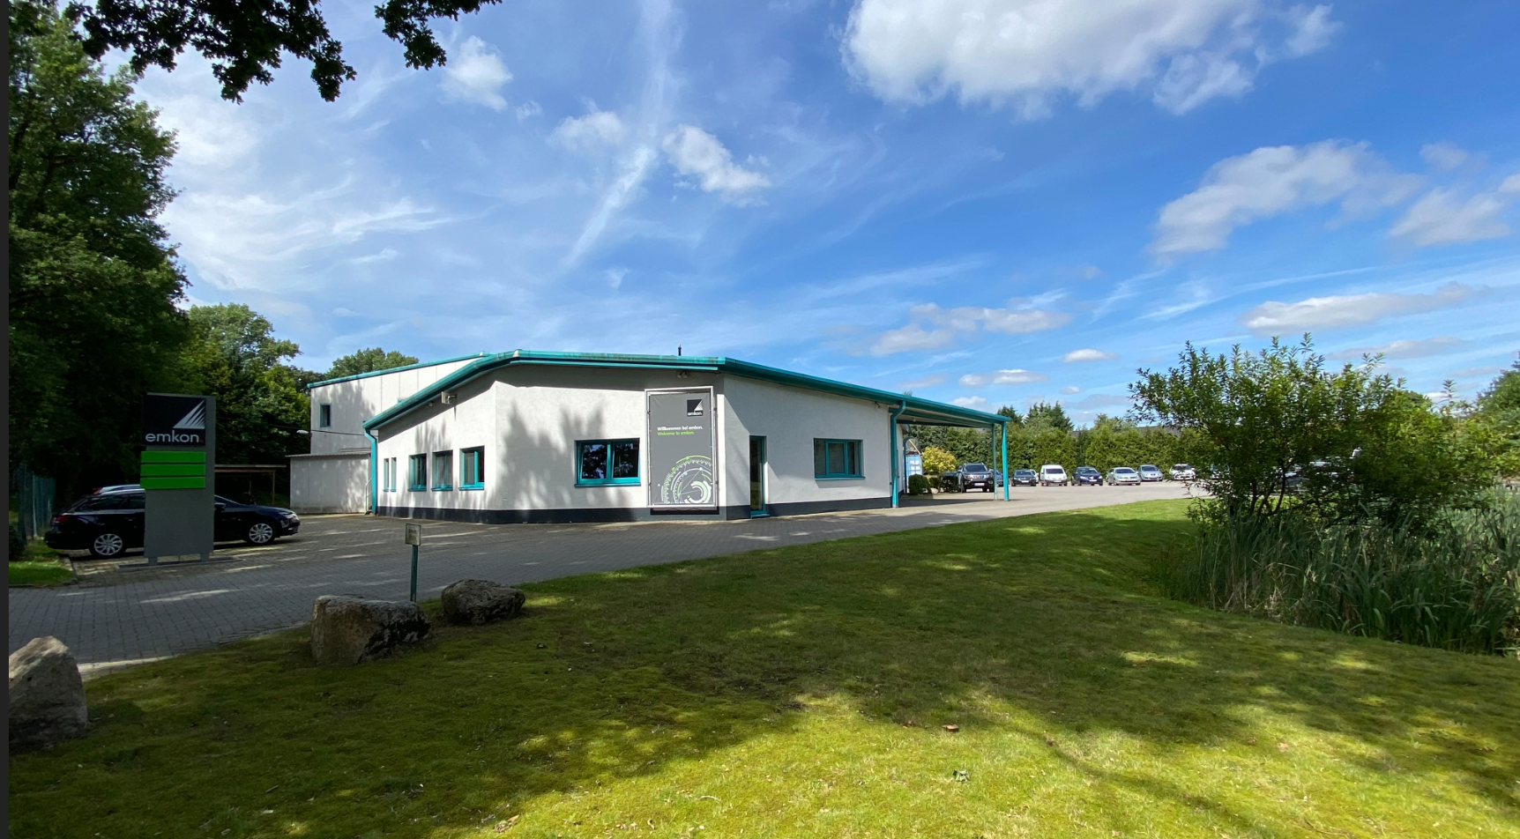
Emkon based in Kirchlinteln (Verden district, Lower Saxony) has been part of the Optima Group since August 1, 2020. (Source: Optima)

Characters (incl. spaces): 1,722

Press contact:
OPTIMA packaging group GmbH
Jan Deininger
Editor
+49 (0)791 / 506-1472
jan.deininger@optima-packaging.com
www.optima-packaging.com

About OPTIMA

Whether for pharmaceuticals, consumer goods, paper hygiene or medical devices: With flexible and customer-specific filling and assembly systems as well as production and packaging machines, Optima supports companies worldwide and accompanies them as a solution and system provider from the product idea to successful production. With the life cycle management program OPTIMA Total Care, Optima is at the customer's side throughout the entire machine life cycle. The family-owned company has been delighting its customers since 1922. 2,450 experts around the globe contribute to Optima's success. 19 locations in Germany and abroad ensure the worldwide availability of services. The company generates more than 85 percent of its sales abroad. Further information: www.optima-packaging.com.

Thank you very much for your publication. We look forward to receiving a specimen copy.

