New Demag radio control system supports tandem control of crane installations

- Intuitive radio control for complex operation
- Simple and ergonomic selection of single and tandem crane control
- Demag SafeControl ensures safety-oriented switch-over between operating modes

Wetter (Ruhr), Germany), 5 Nov 2020. Demag has expanded its range of radio control products. DRC-JT joystick transmitters make it easier to control cranes in complex operating processes and they improve the safety of crane operation thanks to smart interfaces between DRC-JT radio transmitters, the SafeControl system and the crane.
The DRC-JT radio control system is based on the well-known Demag DRC-J. The ‘T’ added to the product designation stands for tandem control. Cranes and hoists can be intuitively controlled by means of two joysticks. They enable the crane operator to control all crane functions without looking away from the crane installation.
The simplicity of the user interface provided by DRC-JT(S) makes it possible for the crane operator to safely switch between single crane operation (crane selector switch: A or B) and tandem crane operation (crane selector switch: A+B) using selector switches. The new, user-friendly and ergonomic feature for the crane operator is located in the centre of the radio control system. The cranes to be controlled can be selected by simply actuating the rotary switch close to the left-hand joystick for the long and cross-travel motions. The selector switch to switch between the three stages for trolley operation (trolley 1 or 1+2 or 2) is located close to the right joystick for lifting and lowering the load.
As soon as the system needs to be switched from single crane control to tandem crane control, one of the two controllers needs to be logged off. With the remaining joystick transmitter, the operator can control both cranes with up to four trolleys. An LCD display enables visual information to be transmitted from the crane to the operator at all times. Several buttons can be used for any special functions. The radio control can be switched on and off via a separate button and the emergency-off switch is arranged in the middle so that it can be quickly reached at all times. Thanks to the combination of functions, operating errors can be reduced and the crane operator can become familiar with the tandem control system more quickly thanks to the intuitive control method.
The Demag SafeControl concept ensures that the switchover between single crane and tandem crane control is performed as a safe process. This process fundamentally includes just two control steps. First, one of the two transmitters is logged off. In the second step, the remaining transmitter takes over the control function of the cranes. This process is interactively controlled by the SafeControl units of both cranes. In this way, a technical fault or a crane operating error can be prevented from causing any unintended change in the operating mode.
The DRC-JTS variant also offers the possibility to incorporate a key-operated safety switch (‘S’) between the two joysticks for switching on and off. In connection with a DRC-DR D3 receiver, the DRC-JT(S) control concept satisfies the requirements of standard EN 13849-1: Cat. 3, PL “d” for safety-related parts of controls. DRC-JT(S) is only available as a D3 variant with a transmission frequency of 2.4 GHz.

Contact for product and trade media:
Christoph Kreutzenbeck
Demag Cranes & Components GmbH
Ruhrstrasse 28
58300 Wetter/Ruhr, Germany
Phone: +49 +2335 92 3907
E-Mail: christoph.kreutzenbeck@demagcranes.com

Images:
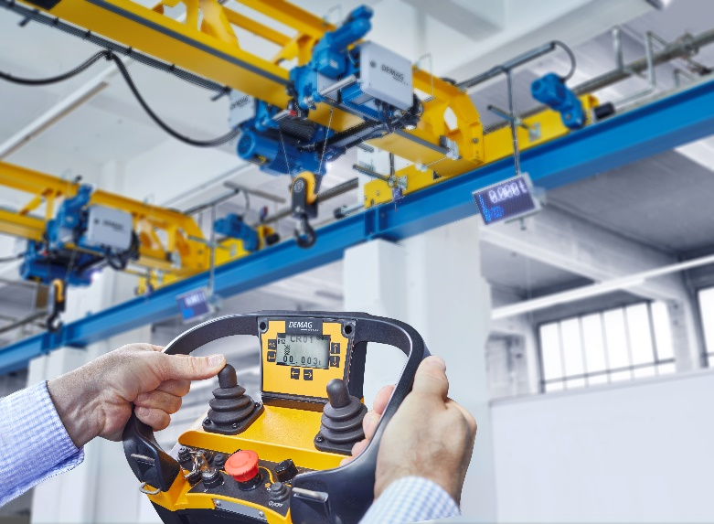
(Photo 42132-4)
Demag DRC-JT and DRC-JT(S) enable the intuitive control of complex crane operating processes.
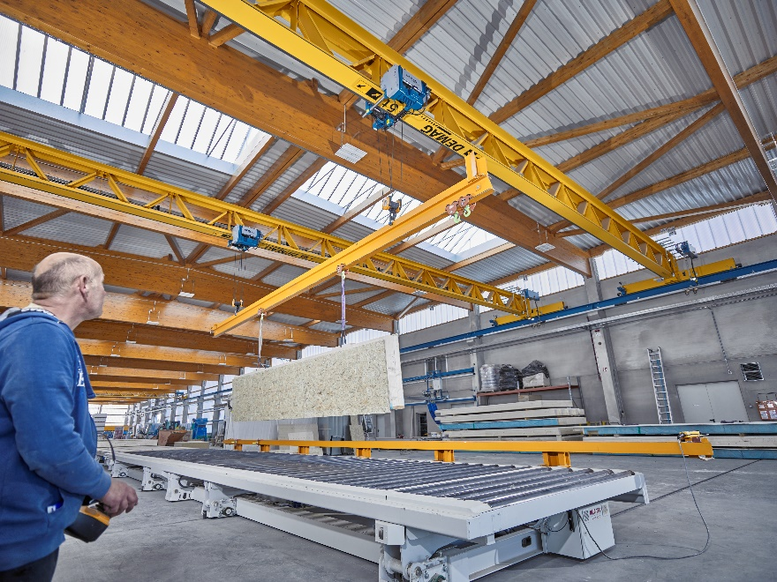
(Photo 41919-10)
Header image: Safe, reliable and intuitive tandem crane operation via radio control.

