PRESS RELEASE
Schwaebisch Hall, October 16, 2019

OPTIMA supports the Digital Hub
New digitalization center for the Heilbronn-Franken region

The “Heilbronn-Franken: Connected (hfcon)” project has commenced operations. The regional network is promoting digitalization in the Heilbronn-Franken region. Optima has invested in the holding company hfcon GmbH & Co. KG. Alongside Optima, the companies ebm-papst, Würth Industrie Service, and Adolf Würth GmbH & Co. KG are also taking part. Through this commitment, Optima wants to promote the digital transfer of knowledge in the region and to push ahead more intensively with digitalization in packaging machine construction.
The state-funded project was launched under the name “Heilbronn-Franken: Connected (hfcon)” to promote digitalization and technology transfer, and is based at the the Reinhold-Würth-Hochschule Künzelsau campus of the Heilbronn University of Applied Sciences. The Baden-Württemberg Ministry of Economic Affairs will provide one million euros for this over the next three years. Alongside Optima, the companies ebm-papst, Würth Industrie Service and Adolf Würth GmbH & Co. KG have invested in the holding company hfcon GmbH & Co. KG. The focus is on a networked economy: “We see huge strengths in the companies themselves. We want to help identify suitable collaboration, benchmark, and network partners to create synergies,” says project manager Thorben Heinrichs about the objectives of the Digital Hub. The work of the hub incorporates both networking and the recognition of potential as well as the consideration of how it can be used to deliver value for all the parties involved.
Digital Hub promotes the sharing of experience and knowledge, and collaboration among companies in the region
The Heilbronn-Franken Digital Hub is one of ten regional digital hubs in Baden-Württemberg. Through the networks, the Ministry of Economic Affairs specifically supports smaller and medium-sized enterprises in digital innovations. As a “regional platform for digitalization” the Heilbronn-Franken Digital Hub intends to bring together all the relevant players to promote collaboration and the sharing of experience and knowledge. Companies can use the Digital Hub to become familiarized with new technologies, gain access to professionals and experts, and be supported throughout the digital innovation process – from the development of new ideas through to their implementation. Measures such as digitalization checks for companies, a set of events with keynote speeches and practical examples, and a series of excursions and workshops are being implemented. Collaboration with the "learning factories for Industry 4.0" is being planned at vocational schools.
OPTIMA successfully helps to shape digitalization in packaging machinery industry
Engagement is part of Optima’s digitalization strategy. Digital services increasingly shape the portfolio of the mechanical engineering company. Digitalization has been an established and constantly changing area for virtually all company divisions for many years now. This is why Optima created a central division called “Industrial IT” to pool expertise in the field of digitalization last year. This will further drive the development of so-called Smart Services. Digital solutions offer great opportunities for the Group’s customers.

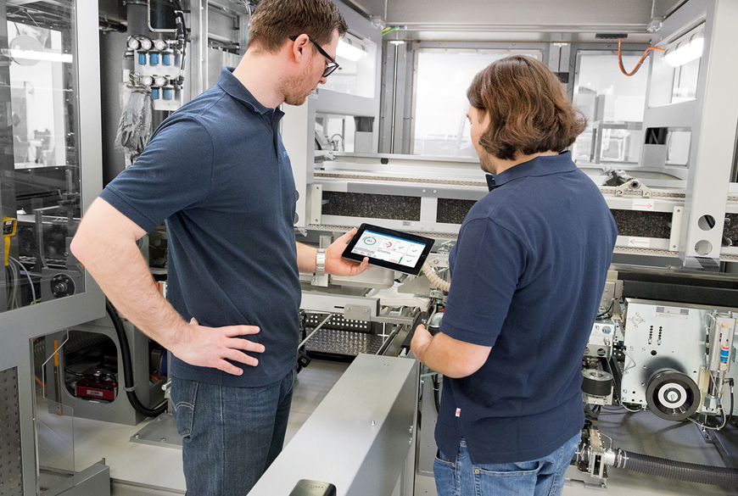
Digital products have become firmly established at Optima and many companies in the Heilbronn-Franken region. The objective of the Digital Hub is to merge these synergies.

Characters (incl. spaces): 3,289

Press contact:
OPTIMA packaging group GmbH
Jan Deininger
Editor
+49 (0)791 / 506-1472
jan.deininger@optima-packaging.com
www.optima-packaging.com
Thank you very much for your publication. We look forward to receiving a specimen copy.

