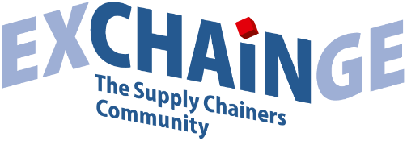

Press Release

Electrolux wins Supply Chain Management Award 2020 –
Schubert earns Smart Solution Award 2020

Frankfurt am Main, November 11, 2020—Home appliance manufacturer Electrolux has won the Supply Chain Management Award 2020. The award was presented for the 15th time by LOGISTIK HEUTE, the industry trade journal of Munich-based publisher HUSS-VERLAG, and by Strategy&, the global strategy consulting team at PwC. The winner of the 3rd annual Smart Solution Award is Schubert Additive Solutions. The awards ceremony took place on November 11, 2020, at EXCHAiNGE. The 8th edition of the Supply Chain Summit (November 10–11, 2020) was entirely remote due to coronavirus restrictions as part of the Hypermotion Digital Experience.

EXCHAiNGE offered its remote participants continuous livestreaming of all sessions, discussions, and interviews—broadcast from the Kap Europa conference center in Frankfurt. The audience had the opportunity to participate through live chats and was encouraged above all to vote on the presentations of the eight finalists for the Supply Chain Awards. As in years past, the audience’s input was considered by the jury in its decision. The jury (supply chain practitioners, prominent academics, consultants, industry journalists) chose the winners from among the previously selected finalists: Bayer Pharmaceuticals, BSH Hausgeräte, Electrolux Hausgeräte, and Takeda Pharmaceuticals International for the Supply Chain Management Award; and Heureka Business Solutions, robominds in collaboration with Daimler Trucks, Schubert Additive Solutions, and WAKU Robotics for the Smart Solution Award.

Supply Chain Management Award 2020
Winner: ELECTROLUX
Concept: Electrolux’s solution targets the transformation of the supply chain toward greater customer-centricity. This includes optimizations in seven areas to achieve better service, more flexibility, and transparency along the entire supply chain while monitoring inventories. The solutions range from establishing an agile supply chain organization (including a control tower) and intensifying the partnership with R&D to using digital tools in production and stepping up the integration of suppliers into the production process. Other key success factors of the new customer-centric supply chain include excellence in new product launches, inventory management, and strategic approaches customized to each sales channel. Electrolux is one of the leading appliance manufacturers worldwide (core brands: AEG, Electrolux, Zanussi) and operates 15 production facilities and 41 warehouses with 12,000 employees in production and supply chain operations throughout Europe.
“We are very pleased to be recognized with this special distinction. The transformation of our supply chain was an important step in our quest to become more customer-centric,” says Dr. Gregor Dudek (Vice President of Supply Chain Management, Electrolux Europe). “It was important for us to look beyond automation and integration to also consider the human side of this transformation. We opened up silos and now work collaboratively in agile, project-specific squads.”

“Predictive planning in the supply chain is essential despite the many uncertainties—even more so amid the ongoing coronavirus pandemic,” adds Nicolas Lefftz (Logistics Director, Electrolux Europe). “Establishing the control tower gives us the transparency we need. The Supply Chain Management Award is wonderful feedback on a job well done, but it also inspires our resolve to continue working on a customer-centric supply chain at Electrolux.”
Voices from the jury
Presenter Jan Axt (Vice President of Automotive SCM Strategy & Innovation, Continental): “This year’s Supply Chain Management Award honors a structured, end-to-end supply chain transformation. Transforming from a traditional supply chain based on production excellence with a push principle toward a customer- and service-driven supply chain model is not easy for any company. Electrolux seems to be on the best path toward mastering this challenge with distinction. At the heart of it all is their focus on organization, employees, agile squads, and other key themes. The successes they’ve scored up to now are already impressive.”

Juror Harald Geimer (Partner at PwC Management Consulting): “The Electrolux concept is a tremendous example of what a well-structured, comprehensive supply chain transformation can look like. The company was very sensible about defining extremely challenging areas to target in their efforts. Electrolux also chose to put the human factor front and center with its concept of agile squads. The aim, after all, is to establish the necessary capacities. In transformations of this nature, the greatest challenge is often the deployment of modern supply chain technology. The overall consistency of the transformation strategy convinced us to honor Electrolux with the Supply Chain Management Award 2020.”

Juror Dr. Petra Seebauer (Managing Director of EUROEXPO Messe- und Kongress-GmbH, Co-Publisher of the trade journal LOGISTIK HEUTE): “We were impressed by the depth and scope of the transformation project at Electrolux. Agile teams, supply chain control tower, direct sales, sustainable logistics: These are precisely the issues that resonate today. Even though the transformation is still underway, Electrolux can already see that the initiatives are bearing fruit and that the supply chain performance has improved considerably.”

About the award
The Supply Chain Management Award is presented by Strategy&, the global strategy consulting team at PwC, and by the industry trade journal LOGISTIK HEUTE, a publication of HUSS-VERLAG in Munich. The honorary sponsor is Steffen Bilger, Member of the German Bundestag and Parliamentary State Secretary at the Federal Ministry of Transport and Digital Infrastructure. Each year since 2006, the award has honored outstanding solutions in industrial value chains and the companies that exhibit perseverance or creativity in optimizing their supply chain. The award recognizes powerful end-to-end supply chain solutions and outstanding implementations within individual links in the value chain. Previous winners include Continental (2019), CEMEX Deutschland (2018), Gries Deco (2017), PERI (2016), and Nokia Networks (2015).

Smart Solution Award 2020
Winner: SCHUBERT ADDITIVE SOLUTIONS
Concept: 3D printing has established itself as a recognized manufacturing technology. Now, the ground-breaking technology faces its next hurdle: 3D parts on demand, as Schubert Additive Solutions (SAS) offers through its part-streaming platform Partbox, will revolutionize not only parts manufacturing but supply chains and storage as well. Electronic design data can be retrieved from a digital warehouse and produced anywhere in the world within seconds. The young company, a spin-off of Gerhard Schubert GmbH Verpackungsmaschinen (Crailsheim, Germany), enables such access to vetted, manufacturer-certified printing data. Anyone, anywhere can now independently produce formatting parts, replacement parts, and wear-and-tear parts in batches of any size through a genuine “click & print” model. All you need is a commercial filament 3D printer and Partbox, which offers direct and secure LTE access to the digital warehouse. SAS provides further support with a portfolio of consulting services covering all aspects of additive manufacturing, with an in-house library of over 120,000 3D-printed parts.

“We are very proud that the experts at EXCHAiNGE have honored Partbox as a smart solution. This proves that the next generation of logistics is about more than just digitizing material flows and automating systems and processes,” explains Marcus Schindler (Managing Director, Schubert Additive Solutions GmbH). “The key is the smart integration of different areas—in our case, manufacturing and logistics. 3D printing not only streamlines and improves parts manufacturing, it also opens up new perspectives with tangible benefits for on-demand logistics. We are convinced that it will someday be normal to send data to customers instead of manufactured parts. We are putting all our efforts behind this vision of decentralized production. This award is a validation that we’re on the right path.”
Voices from the jury
Presenter and previous year’s winner Tobias Buxhoidt (Founder & CEO, parcelLab): “Schubert offers an on-demand, click & print solution for replacement and wear-and-tear parts using a conventional 3D printer. Their vision is that it will someday be normal to send data to customers instead of manufactured parts.”
Juror Harald Geimer (Partner at PwC Management Consulting): “The solution from Schubert shows tremendous potential to revolutionize supply chain and storage models for replacement parts. At the same time, the company attaches great importance to the protection of intellectual property in the use of its part-streaming platform Partbox. This can be a viable solution for the future, especially if a growing demand for customer-specific products leads to a broader diversity of manufacturing variants. The innovative power and potential convinced the jury to honor Schubert with the Smart Solution Award 2020.”
Juror Dr. Petra Seebauer (Managing Director of EUROEXPO Messe- und Kongress-GmbH, Co-Publisher of the trade journal LOGISTIK HEUTE): “Schubert’s industrial 3D print platform offers customers a faster and often more affordable option for procuring replacement and wear-and-tear parts. It also cuts down on transport miles, which helps the environment and improves sustainability.”

About the award
The Smart Solution Award is presented for the third year, honoring particularly innovative concepts that are still in an early stage of implementation. The prize highlights solutions with the potential to fundamentally transform traditional value chains. The previous winners were parcelLab (2019) and InstaFreight (2018).

About EXCHAiNGE
EXCHAiNGE—the Supply Chainers Community is an annual international supply chain conference that brings together decision makers and thought leaders from the worlds of SCM, finance, logistics, and purchasing. The event attracts a diverse business community ranging from innovation officers to business developers to supply chain operations managers at companies of all sizes. The discussions focus on the strategic management issues of tomorrow: new mindsets, modern business models, digital integration, and much more.
EXCHAiNGE provides a roadmap for navigating such key issues of digital transformation as sustainability, culture and mindsets, innovation, collaboration, mobility, 5G, business technologies, and artificial intelligence. Finalists competing for the Supply Chain Awards offer profound insights into pre-eminent examples of best practice.
The international Supply Chain Summit is organized by EUROEXPO Messe- und Kongress-GmbH in Munich—2020 for the first time in a digital format due to coronavirus restrictions.

About EUROEXPO Messe- und Kongress-GmbH
EUROEXPO Messe- und Kongress-GmbH, founded in 1996 and headquartered in Munich, organizes LogiMAT, the annual International Trade Show for Intralogistics Solutions and Process Management in Stuttgart, Germany. EUROEXPO has also partnered with Landesmesse Stuttgart since 2014 to present the annual LogiMAT China in Shanghai in parallel with transport logistic China. LogiMAT | Intelligent Warehouse debuts in Bangkok in 2021, focusing on the Southeast Asian market.
EUROEXPO also organizes “EXCHAiNGE—the Supply Chainers Community.” The international business conference, which convenes for the eighth time in 2020, targets leaders from the areas of SCM, finance, logistics, and purchasing at companies ranging in size from startups to global enterprises. EUROEXPO is also a service provider offering B2C and B2B event management services, such as the organization and implementation of the LOGISTIK HEUTE series.
For more information, please visit www.euroexpo.de.

More images can be found here.

For more information, please contact:

Hendrikje Rother
Marketing/Press
EUROEXPO Messe- und Kongress-GmbH
Phone: +49 89 323 91 240
hendrikje.rother@euroexpo.de
www.exchainge.de/en

(Characters with spaces: 11,936)

EUROEXPO press releases may be reprinted free of charge. Texts and images can be found at the EXCHAiNGE press page under www.exchainge.de.
Please send a copy of any republication by email to hendrikje.rother@euroexpo.de or by postal mail to EUROEXPO Messe- und Kongress-GmbH | Presse- und Öffentlichkeitsarbeit | Joseph-Dollinger-Bogen 7 | 80807 München.

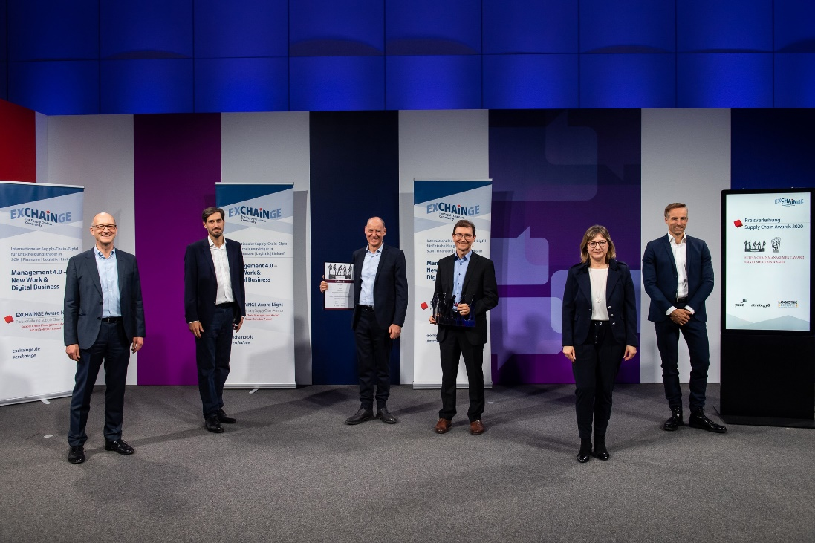
Supply Chain Awards 2020

Happy winners: Dr. Gregor Dudek (VP Supply Chain Management Europe; 3rd from right) and Nicolas Lefftz (Logistics Director Business Area Europe; 3rd from left) from Electrolux, are delighted to receive the Supply Chain Management Award 2020. Jury Member Dr. Petra Seebauer (Managing Director EUROEXPO Messe- und Kongress-GmbH and Co-Publisher LOGISTIK HEUTE; 2nd from right), Jury Member Harald Geimer (Partner at PwC Management Consulting; left), Laudator Jan Axt (Vice President Automotive SCM Strategy & Innovation, Continental AG, Supply Chain Management Award Winner 2019; 2nd from left) and Jury Member Dr. Patric Spethmann (Keynote Speaker und COO/Executive Board for IT & Logistics, Marc O’Polo AG; right) congratulate on behalf of all jury members.
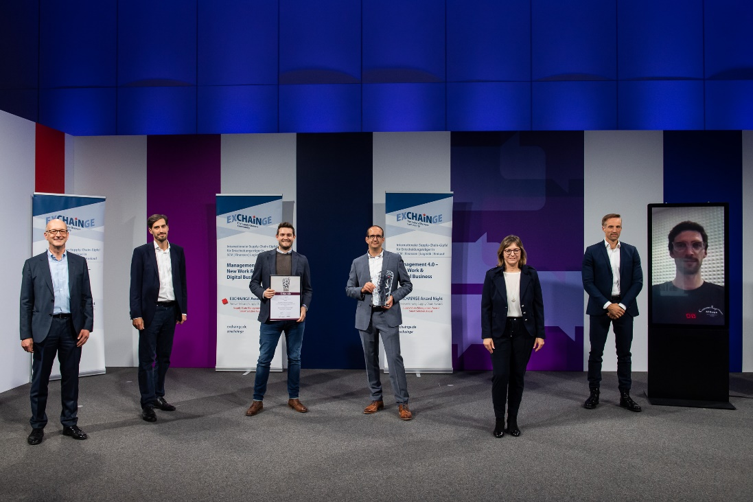

You can see the joy in them: Schubert Additive Solutions wins the Smart Solution Award 2020 and is received by Marcus Schindler (3rd from left) and Jörg Brenner (4th from left) (both CEO, Schubert Additive Solutions GmbH). Jury Member Dr. Petra Seebauer (Managing Director EUROEXPO Messe- und Kongress-GmbH and Co-Publisher LOGISTIK HEUTE; 3rd from right), Jury Member Harald Geimer (Partner at PwC Management Consultants; left), Jury Member Dr. Patric Spethmann, (Keynote Speaker and COO/Executive Board for IT & Logistics, Marc O’Polo AG; 2nd from right), Laudator Jan Axt (Vice President Automotive SCM Strategy & Innovation, Continental AG, Supply Chain Management Award Winner 2019; 2nd from left) und Laudator Tobias Buxhoidt (Founder & CEO, parcelLab GmbH, Smart Solution Award Winner 2019; right)
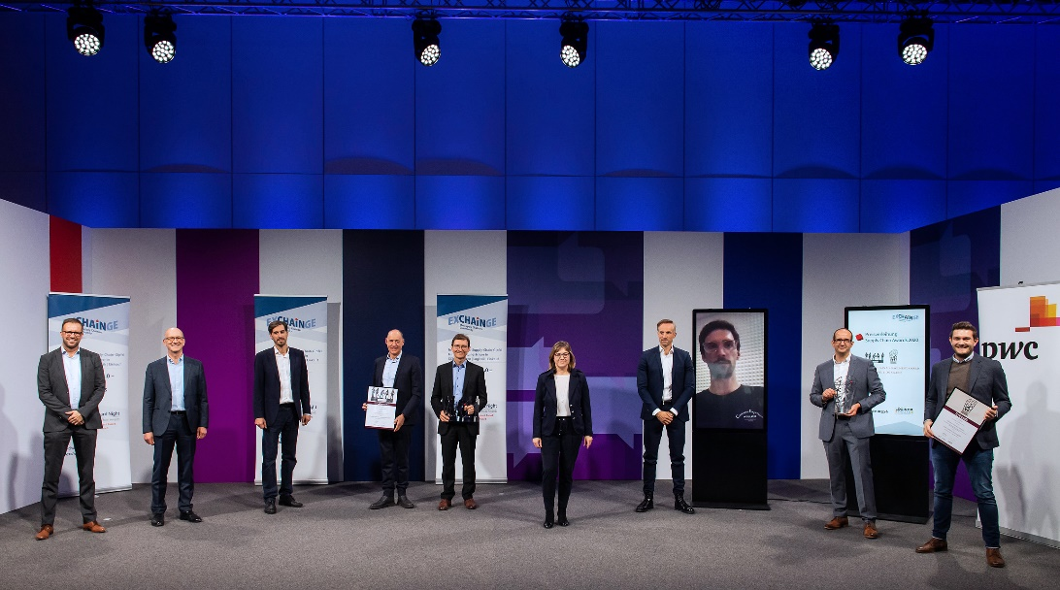

Congratulations to the Supply Chain Award winners 2020: Electrolux and Schubert Additive Solutions

