LAUDA Honors Birgit Littmann-Breuer for 40 Years of Service

A Reliable Pillar of the Purchasing Department

Lauda-Königshofen, May 11, 2026 – LAUDA DR. R. WOBSER GMBH & CO. KG honored Birgit Littmann-Breuer’s 40th work anniversary in a ceremony. In the presence of the management team and the executive board, the long-serving Purchasing employee was recognized for her loyalty, diligence, and reliability toward the family-owned company.

Birgit Littmann-Breuer joined LAUDA on April 7, 1986. Since then, she has worked continuously in Purchasing. Over four decades, she has not only witnessed all the company’s transformations but has actively helped shape them: from manually recording orders on a typewriter to building modern IT systems and on to group-wide intercompany processing and the organization of sea freight shipments from China. Her core responsibilities include processing purchase requisitions, posting invoices, managing supplier declarations, and handling Corporate Fashion – a range of duties that demands accuracy, reliability, and broad process expertise.

Dr. Gunther Wobser, President & CEO, paid tribute to the honoree with personal words in his laudatory speech: “Birgit Littmann-Breuer is a constant at LAUDA. What originally began as a six-month sick leave replacement turned into 40 years of loyalty, diligence, and precision. She has not only experienced systems, processes, and structures, but has actively shaped them – and has always remained true to herself: reliable, precise, and committed. She is the quiet star of the Purchasing department.” In recognition of her achievements, he presented her with the LAUDA certificate of honor and, on behalf of the IHK Heilbronn-Franken (Chamber of Industry and Commerce), its certificate of honor.

As Deputy Mayor of the City of Lauda-Königshofen, Hubert Segeritz conveyed the city’s congratulations and presented the certificate from the Minister-President of the State of Baden-Württemberg. He emphasized that LAUDA is deeply rooted in the city and stands by its workforce, especially in challenging times. Loyal employees like Birgit Littmann-Breuer are an expression of this corporate culture and strengthen Lauda-Königshofen as a business location for the long term.

Chris Moschüring, Purchasing Manager and Birgit Littmann-Breuer’s direct supervisor, emphasized that 40 years of service is outstanding. She has not only embraced changes in IT systems and work processes but has actively shaped them. He particularly values her reliability and openness, which enrich the entire team.

On behalf of her colleagues, Uwe Stastny – for the first time in his role as Chairman of the Works Council – extended his warmest congratulations to the honoree and praised her dependability and team spirit. Littmann-Breuer has mastered the entire breadth of Purchasing, from purchase requisitions to invoicing and reminders – always with exemplary willingness to learn. He also highlighted her long-standing membership in the IG Metall trade union.

Birgit Littmann-Breuer’s anniversary is emblematic of the corporate culture at LAUDA: reliability, continuity, and mutual appreciation as the foundation of a successful family-owned company. With her experience and process expertise, she remains a key pillar of the Purchasing department – and a testament to what strong cooperation can achieve over decades.
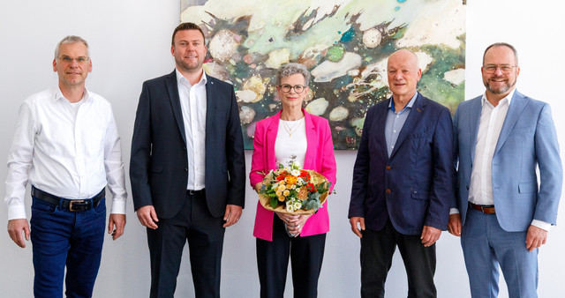

Picture (from right to left): Dr. Gunther Wobser (President & CEO of LAUDA), Hubert Segeritz (Deputy Mayor of the City of Lauda-Königshofen), Birgit Littmann-Breuer, Chris Moschüring (Purchasing Manager), and Uwe Stastny (Chairman of the Works Council) recognized Birgit Littmann-Breuer in their speeches marking her 40th work anniversary. © LAUDA

We are LAUDA – the world leader in precise temperature control. Our constant temperature equipment and systems are at the heart of important applications, contributing to a better future. As a complete one-stop supplier, we guarantee the optimum temperature in research, production and quality control. We are the reliable partner for Aerospace, Electromobility, Hydrogen, Chemistry, Pharmaceuticals/Biotech, Semiconductors and Medtech. We have been inspiring our customers for over 70 years with our expert mentoring and innovative solutions – every day anew and all over the world.

In our company, we always go one step further. We support our employees’ development and are constantly developing ourselves: to create a better future together.

Press contact
We are more than happy to make prepared information about our company, the LAUDA Factory Gallery and our projects in the area of innovation promotion, digitalization and idea management available to the press. We look forward to hearing from you – just give us a call!

CHRISTOPH MUHR
Director Corporate Communications
T + 49 (0) 9343 503-349
christoph.muhr@lauda.de

LAUDA DR. R. WOBSER GMBH & CO. KG, Laudaplatz 1, 97922 Lauda-Königshofen, Deutschland/Germany. Limited partnership: Headquarters Lauda-Königshofen, Registration court Mannheim HRA 560069. General partner: LAUDA DR. R. WOBSER Verwaltungs-GmbH, Headquarters Lauda-Königshofen, Registration court Mannheim HRB 560226. Managing Directors: Dr. Gunther Wobser (President & CEO), Dr. Mario Englert (CFO), Dr. Marc Stricker (COO)

