PRESS RELEASE
Schwaebisch Hall, July 13, 2020

GreenLution: The green alternative
Working together with its business partners, OPTIMA has developed a sustainable capsule system

Working together with the companies Wipf and säntis packaging, Optima has developed a completely recyclable capsule system. It features a single-material capsule with recyclable lid film and a compatible packaging system. This development means that the partner companies are promoting a sustainable recycling economy from production and use, through to recycling of the packaging.
Plastic is a valuable material that whenever possible should be re-integrated into its own production cycle. This was the main aim of the collaboration between Optima, Wipf and säntis packaging, to develop a fully-recyclable coffee capsule. The result is the integrated “GreenLution” project, which encompasses far more than recyclable coffee capsules. “The concept ranges from the RECY⁺Cap from säntis featuring a polypropylene-based single material capsule, to the fully recyclable WICOGREENLINE top film from Wipf with excellent barrier properties, to being filled on a sustainably designed packaging system by Optima,” explain Ulrich Burkart and Dominik Broellochs from Optima. The packaging system is based on the OPTIMA CFL capsule filling machine and has been perfectly adapted to suit the new capsules. The capsule system has been certified as recyclable by the cyclos-HTP institute and the environmental service provider Interseroh, and it is manufactured from polypropylene derived from biological waste.

Eco-friendly dosing and packaging

OPTIMA CFL combines high filling accuracy for a variety of types of coffee with the most minimal space requirements, optimized film utilization, lower energy and gas consumption with maximum efficiency, and a minimum production reject rate of below 0.05 percent. “This also means that filling can be made as sustainable as possible,” adds Burkart. Even existing plants can be retrofitted at any time and optimized in terms of their productivity, material utilization and energy consumption. What this development shows is that greater sustainability can only be achieved by working together in partnership with companies along the entire value chain.

More information on this subject:
https://www.saentis-ips.com/en/newsroom.html
www.wipf.ch

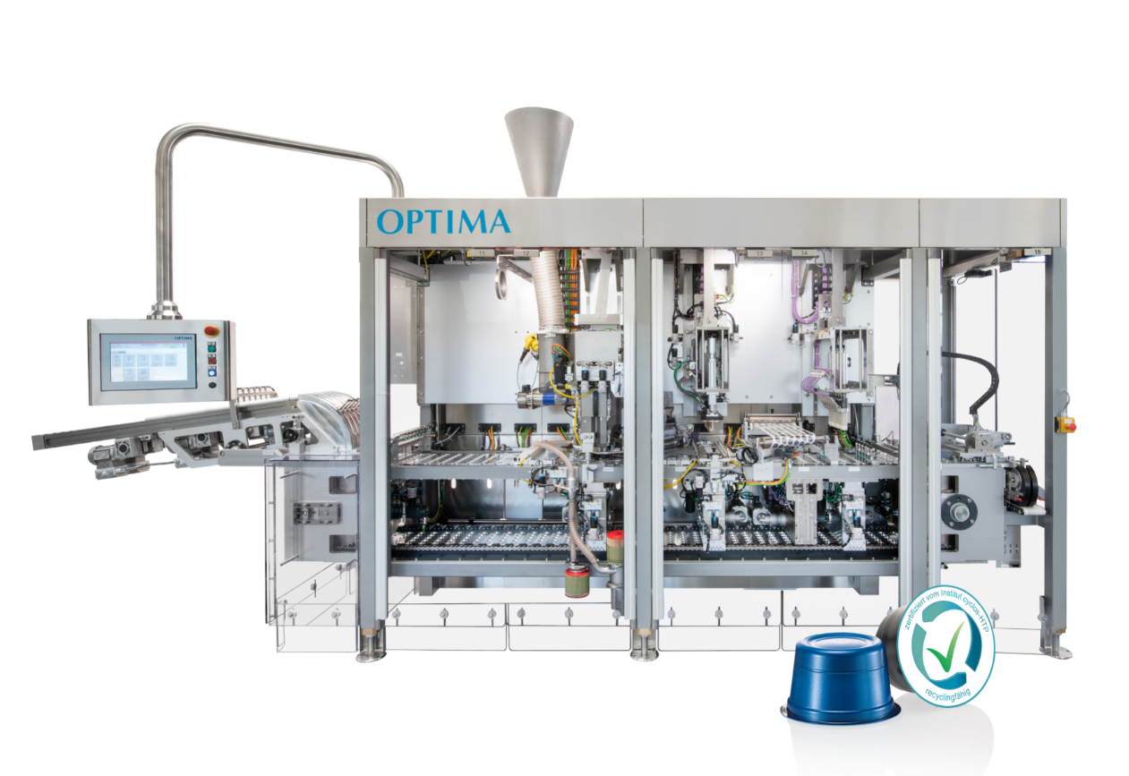
Greater sustainability can only be achieved by working together. This is why Optima, Wipf and säntis packaging have joined forces and developed the environmentally friendly “GreenLution” capsule system. (Source: Optima)

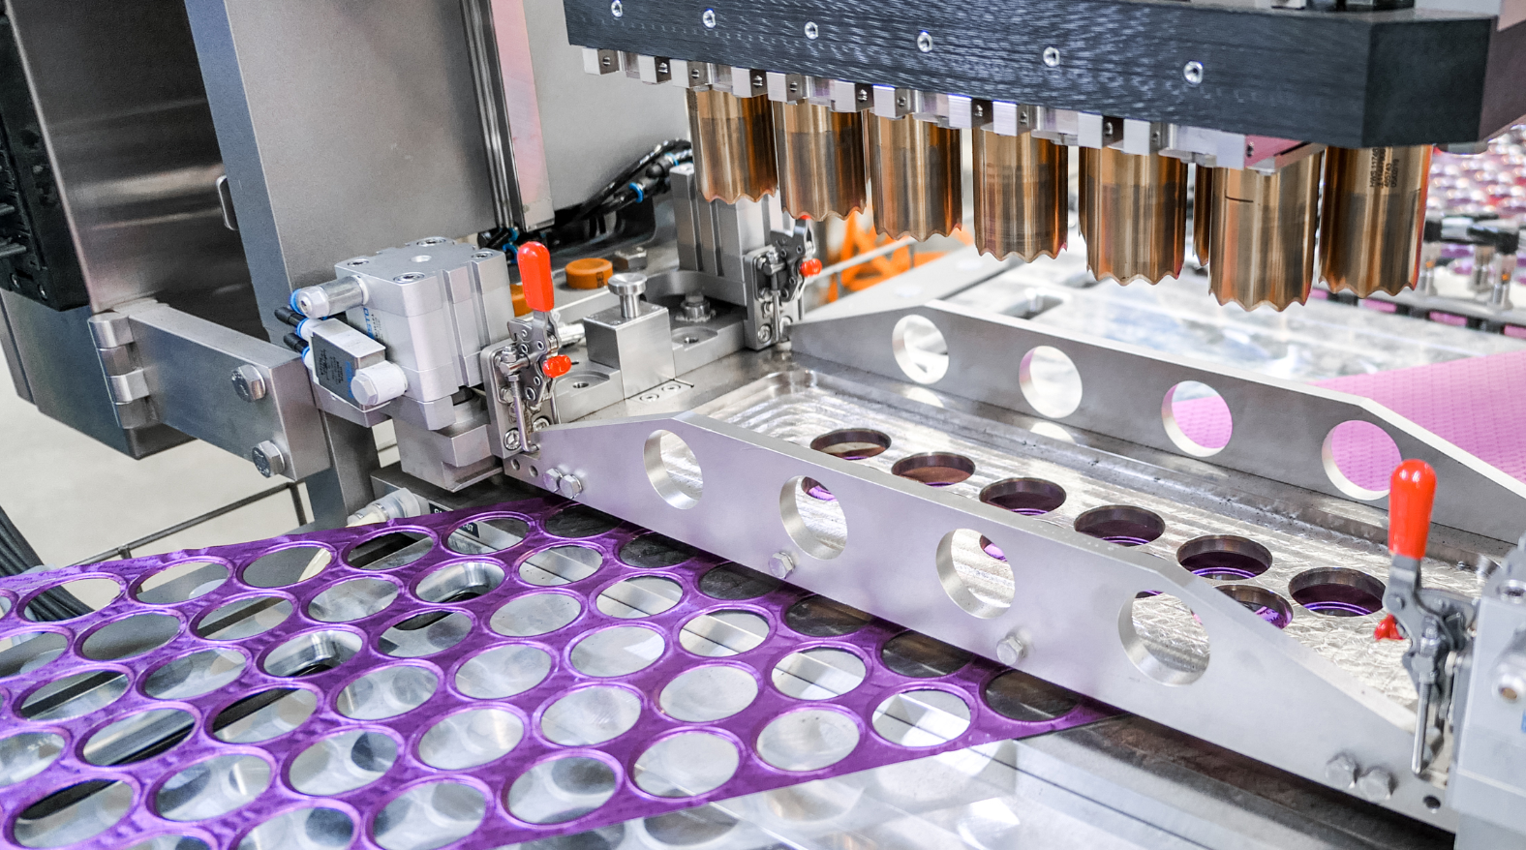
Since the film for sealing the capsules is fed at an angle and punched with offset, optimum material utilization is ensured. (Source: Optima)

Characters (incl. spaces): 2,208

Press contact:
OPTIMA packaging group GmbH
Jan Deininger
Editor
+49 (0)791 / 506-1472
jan.deininger@optima-packaging.com
www.optima-packaging.com
Thank you very much for your publication. We look forward to receiving a specimen copy.

