PRESS RELEASE
Schwaebisch Hall, June 10, 2021

Automation is key to saving lives
The Robert-Bosch-Krankenhaus in Stuttgart, the Universitätsklinikum Heidelberg and OPTIMA pharma are developing an automated production unit for CAR-T cell therapeutics

In late 2020, the Robert-Bosch-Krankenhaus in Stuttgart, the Universitätsklinikum Heidelberg and the Pharma Division of the Schwaebisch Hall-based special machine manufacturer Optima launched an innovative project called "ProCell for Patient". The strategic partnership aims to develop a production system for CAR-T cell therapies. This should deliver benefits in terms of quality, cost and time. The project is funded by the Ministry of Economic Affairs, Labour and Housing Baden-Württemberg as part of the "Forum Health Region Baden-Württemberg" initiative.
Every year, over 430,000 people worldwide are diagnosed with leukemia. A further 500,000 patients suffer from non-Hodgkin's lymphoma worldwide. These include forms of the disease where chemotherapy and donated stem cells are unsuccessful. "Around a quarter of those patients who have already undergone treatment can benefit from treatment with CAR-T cells," says Prof. Dr. med. Michael Schmitt, who is regarded as a luminary in cellular immunotherapy. He heads up the GMP Core Facility at the Universitätsklinikum Heidelberg (UKHD). T-cells are genetically modified there. "We modify the cells so that they can subsequently attack cancer cells in the form of what are called killer cells," explains Prof. Schmitt.
Possibility of decentralized production in hospitals and industry

Since 2017, five CAR-T cell products have been approved worldwide: Kymriah (Novartis), Yescarta and Tecartus (both from Kite/Gilead) and most recently Breyanzi (BMS) and Abecma (bluebird bio & BMS). There are around 1,200 further cell and gene therapies in the clinical pipeline. Several thousand patients could benefit from this treatment every year. Meanwhile, there are many university hospitals that already have the expertise to manufacture CAR-T cell therapies, but their manufacturing processes originate in research, and they are therefore very manual and individualized. The logistics involved and production in class A/B clean rooms generate high costs and take time. Standardized and automated manufacturing at these clinics would lead to significant improvements in patient care.

Quality, cost and time benefits in production

Therefore, under the "ProCell for Patient" project, the UKHD and the Robert-Bosch-Krankenhaus in Stuttgart (RBK) are collaborating with Optima Pharma to develop a unit for decentralized, automated production in treatment centers, which will be used at the RBK. "The automation of CAR-T cell therapy production is long overdue. Not just for reasons of cost and quality. In the future, it will facilitate the innovation process", says Prof. Dr. Walter E. Aulitzky, Chief Physician of the Department of Oncology, Hematology and Palliative Medicine at the RBK.

The amount of work is cut in half

"With the help of the ProCell for Patient system, it will probably be possible to reduce the amount of work, i.e. the number of hours that qualified staff today are spending on producing CAR-T cells by at least 50 percent," summarizes Dr. Andrea Traube, who heads the project at Optima Pharma. She is responsible for the Market Development area, focusing on system solutions for cell and gene therapy. The ProCell for Patient system prototype is scheduled to be installed at the RBK in the summer of 2022. As part of a forerunner project with Charité Hospital in Berlin, Optima Pharma had already taken the first steps towards developing a suitable production unit. Roll-out to additional treatment centers and pharmaceutical contract developers and manufacturers (CDMOs/CMOs) is planned once testing and clinical trials have been completed. Clinics that are involved in decentralized manufacturing can also contribute in the future to optimizing and developing new cell therapies.

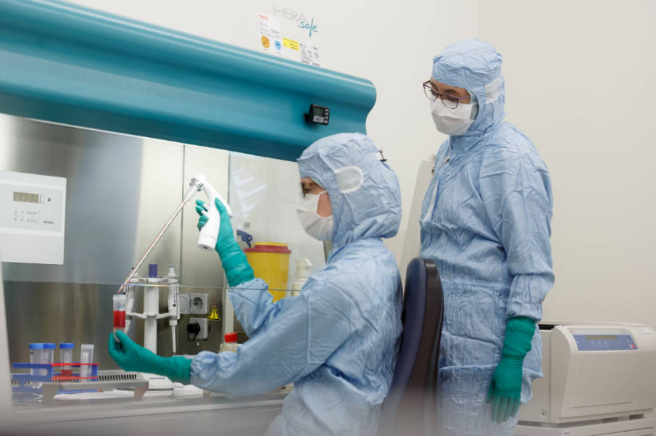
CAR-T cell therapies are currently produced manually in the GMP laboratory at Heidelberg University. This is extremely labor-intensive and also has to be done in the highest Class A or B clean room environments. (Source: Universitätsklinikum Heidelberg)

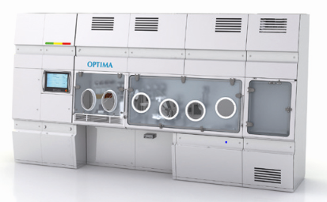
The production unit will be based on isolator technology and will significantly increase process reliability and consequently the therapies' quality. (Source: Optima)

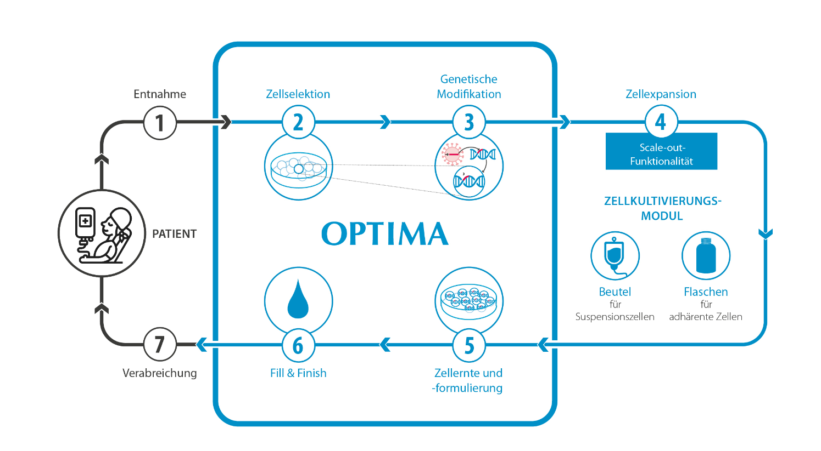
In the Stuttgart/Heidelberg ProCell for Patient model, essential steps in the production of cell therapies are carried out in an isolator in a fully automated process. The prototype will be installed at the Robert-Bosch-Krankenhaus in Stuttgart. (Source: Optima)

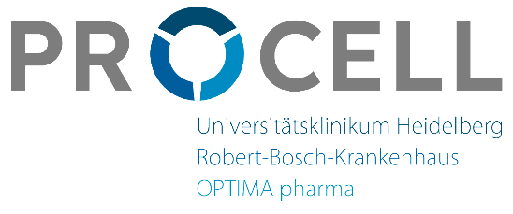

Characters (incl. spaces): 3,947

Press contact:
OPTIMA packaging group GmbH
Jan Deininger
Group Communications Manager
+49 (0)791 / 506-1472
jan.deininger@optima-packaging.com
www.optima-packaging.com

About OPTIMA
Optima supports companies worldwide with flexible and customer-specific filling and packaging machines for pharmaceuticals, consumer goods, paper hygiene and medical devices markets. As a provider of solutions and systems, Optima accompanies these companies from the product idea through to successful production and throughout the entire machine life cycle. Over 2,650 experts around the globe contribute to Optima's success. 19 locations in Germany and abroad ensure the worldwide availability of services.

Thank you very much for your publication. We look forward to receiving a specimen copy.

