Antonio Manconi Ten Years With LAUDA Italia

Managing Director of the Italian sales company expands business further

Lauda-Königshofen, December 18, 2024 – On the occasion of Antonio Manconi's tenth anniversary at LAUDA, the world market leader for precise temperature control honored the Managing Director of LAUDA Italia S.r.l. for his outstanding achievements. Under his leadership, the Italian subsidiary has developed into an important pillar of the family business and achieved a record turnover of around 4 million euros in 2023.

Dr. Gunther Wobser, President & CEO of LAUDA DR. R. WOBSER GMBH & CO. KG, praised Manconi's achievements: “Antonio has made a significant contribution to the growth of LAUDA Italia with his extensive experience and deep understanding of the pharmaceutical and biotech industry. His consistent customer focus and marketing expertise have established the company as the market leader in Italy.”

Manconi can look back on an impressive career that led him to LAUDA via various positions in the chemical and pharmaceutical industries. His professional career began with his studies in industrial chemistry at the Chemical College in Milan. Before joining LAUDA, he gained valuable experience in management positions at well-known companies such as VWR International, including as Managing Director of the Italian subsidiary.

“The past ten years at LAUDA have been an extraordinary journey,” summarizes Antonio Manconi. “I am proud to be part of a company that focuses on innovation and quality. LAUDA Italia's success is the result of hard work and the commitment of our entire team.”

The award was presented during a visit by Dr. Gunther Wobser to LAUDA Italia on November 28. At a festive dinner, he presented a certificate and a gift as a sign of recognition for outstanding achievements.

Dr. Wobser emphasized the importance of Antonio Manconi's expertise for the international orientation of the company: “Antonio is an extremely valuable member of our international management team with his level-headed manner and his experience. His ability to meet local market needs while thinking through global strategies is invaluable to LAUDA.”
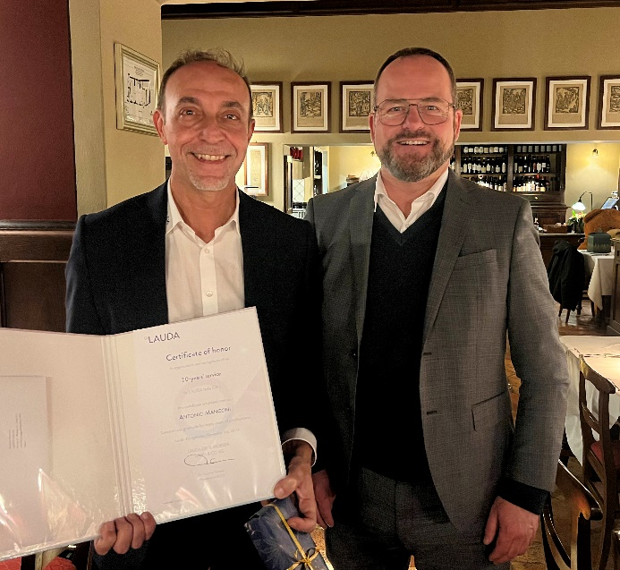

Fig.: Milestone at LAUDA Italia: Antonio Manconi (left), who has successfully managed the company for ten years, accepts the congratulations and certificate of honour from Dr. Gunther Wobser, President & CEO of LAUDA. © LAUDA

We are LAUDA – the world leader in precise temperature control. Our constant temperature equipment and systems are at the heart of important applications, contributing to a better future. As a complete one-stop supplier, we guarantee the optimum temperature in research, production and quality control. We are the reliable partner for electromobility, hydrogen, chemicals, pharmaceuticals/biotech, semiconductors and medical technology. We have been inspiring our customers for almost 70 years with our expert mentoring and innovative solutions – every day anew and all over the world.

In our company, we always go one step further. We support our employees’ development and are constantly developing ourselves: to create a better future together.

Press contact
We are more than happy to make prepared information about our company, the LAUDA Factory Gallery and our projects in the area of innovation promotion, digitalization and idea management available to the press. We look forward to hearing from you – just give us a call!

CHRISTOPH MUHR
Director Corporate Communications
T + 49 (0) 9343 503-349
christoph.muhr@lauda.de

LAUDA DR. R. WOBSER GMBH & CO. KG, Laudaplatz 1, 97922 Lauda-Königshofen, Deutschland/Germany. Limited partnership: Headquarters Lauda-Königshofen, Registration court Mannheim HRA 560069. General partner: LAUDA DR. R. WOBSER Verwaltungs-GmbH, Headquarters Lauda-Königshofen, Registration court Mannheim HRB 560226. Managing Directors: Dr. Gunther Wobser (President & CEO), Dr. Mario Englert (CFO), Dr. Marc Stricker (COO)

