PRESS RELEASE
Schwaebisch Hall, January 15, 2020

A leader in turnkey solutions and offers great service
A look back: OPTIMA at P-MEC India 2019

At the P-MEC India, Optima Pharma impressed visitors with its portfolio for aseptic processing of pharmaceutical drugs. Highly flexible machines for filling and sealing liquids, through to turnkey solutions including isolator technology and pharmaceutical freeze drying, were particularly in demand. Moreover, machines that automate auto-injector assembly were presented for the first time in India. P-MEC India took place in November in Delhi.
The pharmaceutical industry in India is on an upswing. The large number of FDA-certified companies drives high demand for proven, technically and qualitatively leading packaging technology, as presented by Optima at P-MEC. Visitors were particularly interested in the turnkey approach which Optima illustrated with several customer projects using 360° presentations. The highly flexible OPTIMA MultiUse Filler in particular was a very popular "eye-catcher". The MultiUse systems have already been designed for the use of isolators and for connecting freeze drying systems.
Systems that can be flexibly extended were also very popular. These include, for example, the OPTIMA SV125 for entry-level aseptic processing and systems for automatically assembling auto-injectors, such as the OPTIMA AIM. This system was presented for the first time in India and has already proven itself in many different applications worldwide.
Optima sees the demand for services as another significant trend. Any visitors with questions about plant technology were also interested in life-cycle based services, which can include training, maintenance and inspection, or even retrofitting SCADA systems. In this segment, too, numerous potential projects were discussed.
The overall number of visitors was high, and the quality of the contacts made at P-MEC was also encouraging. These were expressed in concrete enquiries about upcoming projects. Furthermore, according to the Optima trade fair managers, a high proportion of the visits came from new, previously unknown companies. The vast majority of visitors to the Optima stand at P-MEC were from India.

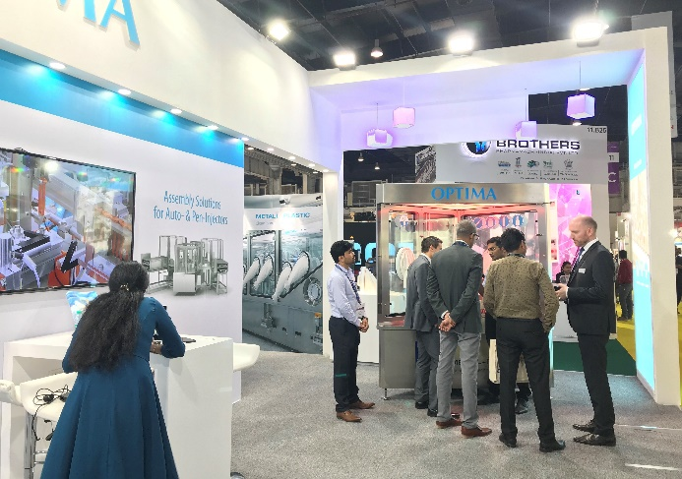
With many specific enquiries, new contacts and great interest in services too, P-MEC India at the end of November was a successful trade fair for Optima in the emerging Indian market.

Characters (incl. spaces): 2,172

Press contact:
OPTIMA packaging group GmbH
Jan Deininger
Editor
+49 (0)791 / 506-1472
jan.deininger@optima-packaging.com
www.optima-packaging.com
Thank you very much for your publication. We look forward to receiving a specimen copy.

