Change of management in the Development, Innovation & Technology division

Niklas Braun becomes Technical Director of the LAMILUX Heinrich Strunz Group

The LAMILUX Heinrich Strunz Group has a new Technical Director in Niklas Braun and a new member of the extended management team. Braun takes over from Joachim Hessemer as head of the general development department within the Skylights division. Since June 2021 in his role as Technical Director, Braun has been responsible for around 400 employees who work in the key areas of development, application technology, pre-project planning, production, assembly, knowledge management as well as quality and process optimisation.

Niklas Braun succeeds Joachim Hessemer, who retired after 27 years with LAMILUX, one of Europe's leading manufacturers of skylights, glass roof constructions, smoke and heat exhaust ventilation systems (SHEVS), and complex building control systems. It all started in 2002 when the civil engineering graduate came to Upper Franconia, where he spent 12 years working for the Rehau Group. There he held various management positions within the production, research, development and technology and innovation management divisions.

With his wealth of international experience and knowledge gained from years as Group Managing Director of the Rehau Group, Executive Vice-President of the automotive supplier faurecia and member of the Executive Management of Bolta Werke GmbH, among others, he will in future be the head of the technology division for skylights and complement the extended management team of the internationally active family-run company based in Rehau, which currently employs a workforce of around 1200 people.

“For me, the focus is always on dealing with people, be it colleagues or customers. Success only comes when you have a connection to people and understand what their needs and concerns are,” explains Niklas Braun. In his new position as Technical Director of Skylights, he is also looking forward to working with his team to develop and offer our customers products, innovations and world premières that inspire people, and to build on existing successes in the field of skylight technology.

…

www.lamilux.com

About the LAMILUX Heinrich Strunz Group
The LAMILUX Heinrich Strunz Group is one of the world's largest producers of high-tech composites made of carbon fibre and glass fibre-reinforced composites and, in Germany and Europe, the Group is one of the leading manufacturers of skylights, glass roof constructions, smoke and heat exhaust ventilation systems (SHEVS) and complex building control systems. In addition to the skylight specialist LAMILUX Heinrich Strunz and the plastics expert LAMILUX Composites, both based in Rehau, other companies are part of the Group: The steel and glass expert MIROTEC from Wettringen and the SHEV and ventilation system specialists roda/E.M.B. from Langenau, Isernhagen and Emmerich. The internationally active family-run company based in Rehau currently employs a workforce of around 1200 people and achieved a turnover of roughly 293 million euros in 2020.

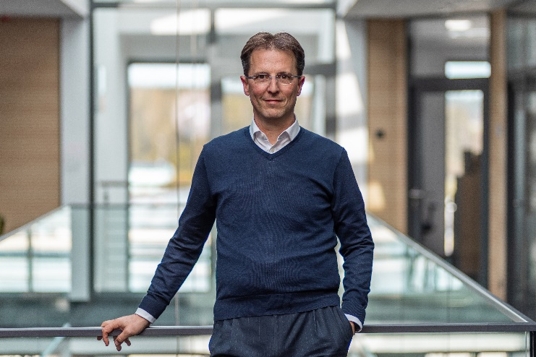
Caption:

Since June 2021, Niklas Braun has been the Technical Director of the Skylight Systems division of LAMILUX and a member of the extended management team of the Rehau-based family-run company.

