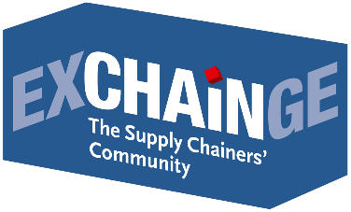
Press Release

“When it comes to the digital revolution,
we rely now more than ever on the private sector”
Interview with Dr. Patric Spethmann, Managing Director and COO, Gries Deco Company GmbH / DEPOT,
at the EXCHAiNGE supply chain summit

Dr. Spethmann, your company was honored with the Supply Chain Management Award 2017 for the digital supply chain of your DEPOT brand. What is your view on the general debate around the digital revolution?
Dr. Patric Spethmann: To me, the digital revolution encompasses such themes as the internet of things, big data, artificial intelligence, and so on. I have mixed sentiments about it nowadays. On the one hand, we all acknowledge the importance of digital technology: the future viability of Germany as an economic base, jobs, the outlook for our prosperity, and everything associated with that. But on the other hand, “digital transformation” is degenerating into a buzzword in Germany. We constantly proclaim its importance, but with each passing day, we’re losing more ground to the countries leading the movement.
And yet, Germany does actually have what it takes to be among the best …
Spethmann: Yes! A couple of examples: The first self-driving car was developed in Munich in the early 1980s. It drove unassisted on the autobahn at 180 kilometers an hour – three times as fast as the Google Car today. A full 50 percent of all patents relating to self-driving technology are held in Germany, but we let the United States and China develop them. Six of the ten most valuable companies are tech giants with over 100 billion euros each in market value. In Germany, we have just one in this category! Tech giants account for 38 percent of the top fifty companies in the world, but in Germany they make up a mere 8 percent.
What does it take to implement a digital solution in such a way that it becomes a significant economic factor?
Spethmann: There are three main pillars: talent/ideas, capital, and market conditions. In 2017, Germany invested some three billion euros of venture capital in ideas. That’s about one-eighth the amount invested in the United States. That means that to keep from falling further behind, Germany would need to invest an additional 20 billion euros annually! From the private sector, but also from the public sector. Which brings us to the market conditions. The government speaks with one voice in praising the digital revolution as the engine of the future, especially artificial intelligence as a key driver in the years ahead. China and the US are investing over 100 billion euros in this sector. Even France is setting aside 1.5 billion euros for AI in 2019. And Germany? Total spending in 2019 is 356.8 billion euros – and only one million euros of that is going to digital transformation. That’s nothing! Germany’s Economic Minister Altmaier just announced that an additional three billion euros will be invested by 2022. Assuming the budget stays the same in the coming years, then that comes to about two-tenths of one percent!
So if you’re still hoping for adequate public funding, you’re wasting your time ...
Spethmann: Precisely! When it comes to the digital revolution, we rely now more than ever on the private sector. We need to experiment, take a chance, and encourage and empower talent. In the realm of talent/ideas, that ties into this year’s Supply Chain Management Award. The success of the winner, CEMEX, stems in part from its investments in systematically training employees at its own academy.

Frankfurt am Main, November 22, 2018 | Interview by Sabine Ursel, Communications | Press | Network, journalist and communications consultant in Wiesbaden (focus: procurement/distribution)

SAVE THE DATE
EXCHAiNGE—the Supply Chainers’ Community 2019 | November 26–27, 2019
Learn more: www.exchainge.de

About EXCHAiNGE
The “Supply Chainers’ Community” brings together movers and shakers from the worlds of SCM, finance, logistics, and purchasing. Representatives from businesses of all sizes – from startups to large enterprises – meet to talk about new business models, disruption, and approaches to successful integration.
EXCHAiNGE provides a roadmap for navigating such key issues of digital transformation as sustainability, culture and mindsets, blockchain, big data, and artificial intelligence. Finalists competing for the Supply Chain Awards offer profound insights into pre-eminent examples of best practice.
Visitors get valuable tips on repositioning their businesses to become drivers of innovation with the goal of generating a critical competitive advantage. EXCHAiNGE stands as an established networking platform that keeps visitors engaged through robust case studies and illuminating roundtables. The event is organized by EUROEXPO Messe- und Kongress-GmbH in Munich.

Learn more about EXCHAiNGE 2018 – for the first time in combination with the Hypermotion trade show – with interviews, photo galleries, and press releases!

About EUROEXPO Messe- und Kongress-GmbH
EUROEXPO Messe- und Kongress-GmbH was founded in 1996. Today, EUROEXPO organizes LogiMAT – the annual international trade show for intralogistics solutions and process management – as well as LogiMAT China and TradeWorld, the professional platform for trade processes.
EUROEXPO also organizes “EXCHAiNGE – the Supply Chainers’ Community.” The international business conference, now in its sixth year, targets leaders from the areas of SCM, finance, logistics, and purchasing at startups, small and medium-sized businesses, and large enterprises. EUROEXPO is also a service provider offering B2C and B2B event management services, such as the organization and implementation of the LOGISTIK HEUTE series.
For more information, please visit: www.euroexpo.de

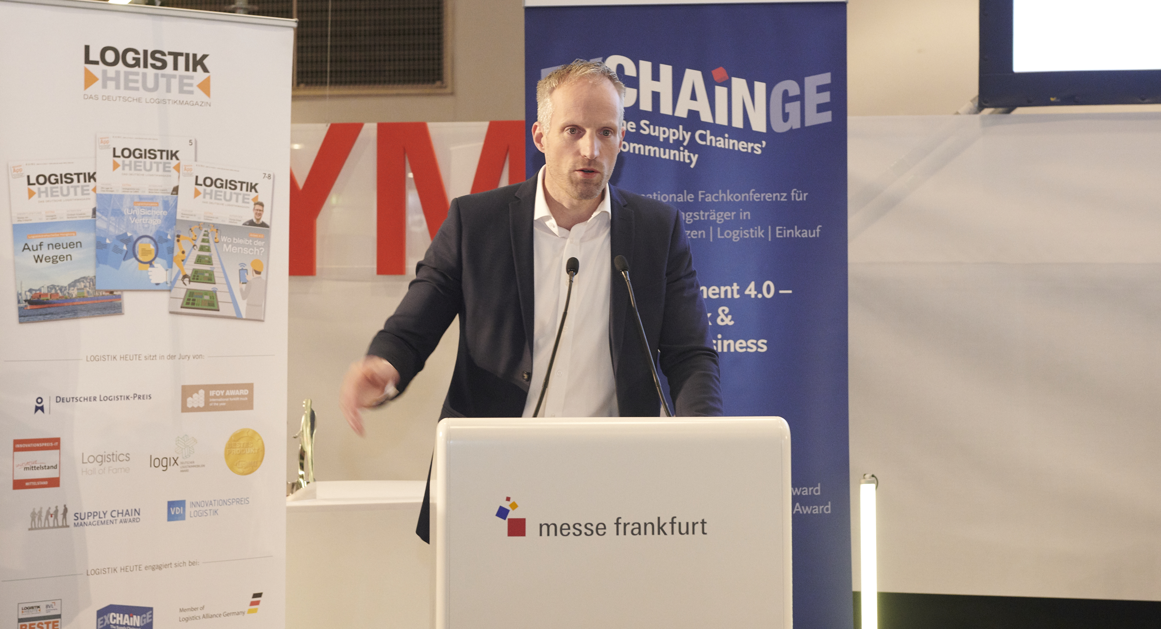
Presenter Dr. Patric Spethmann (Managing Director and COO, Gries Deco Company GmbH/DEPOT) appealed to attendees at the EXCHAiNGE 2018 supply chain summit for Germany to rethink its commitment to the digital revolution.

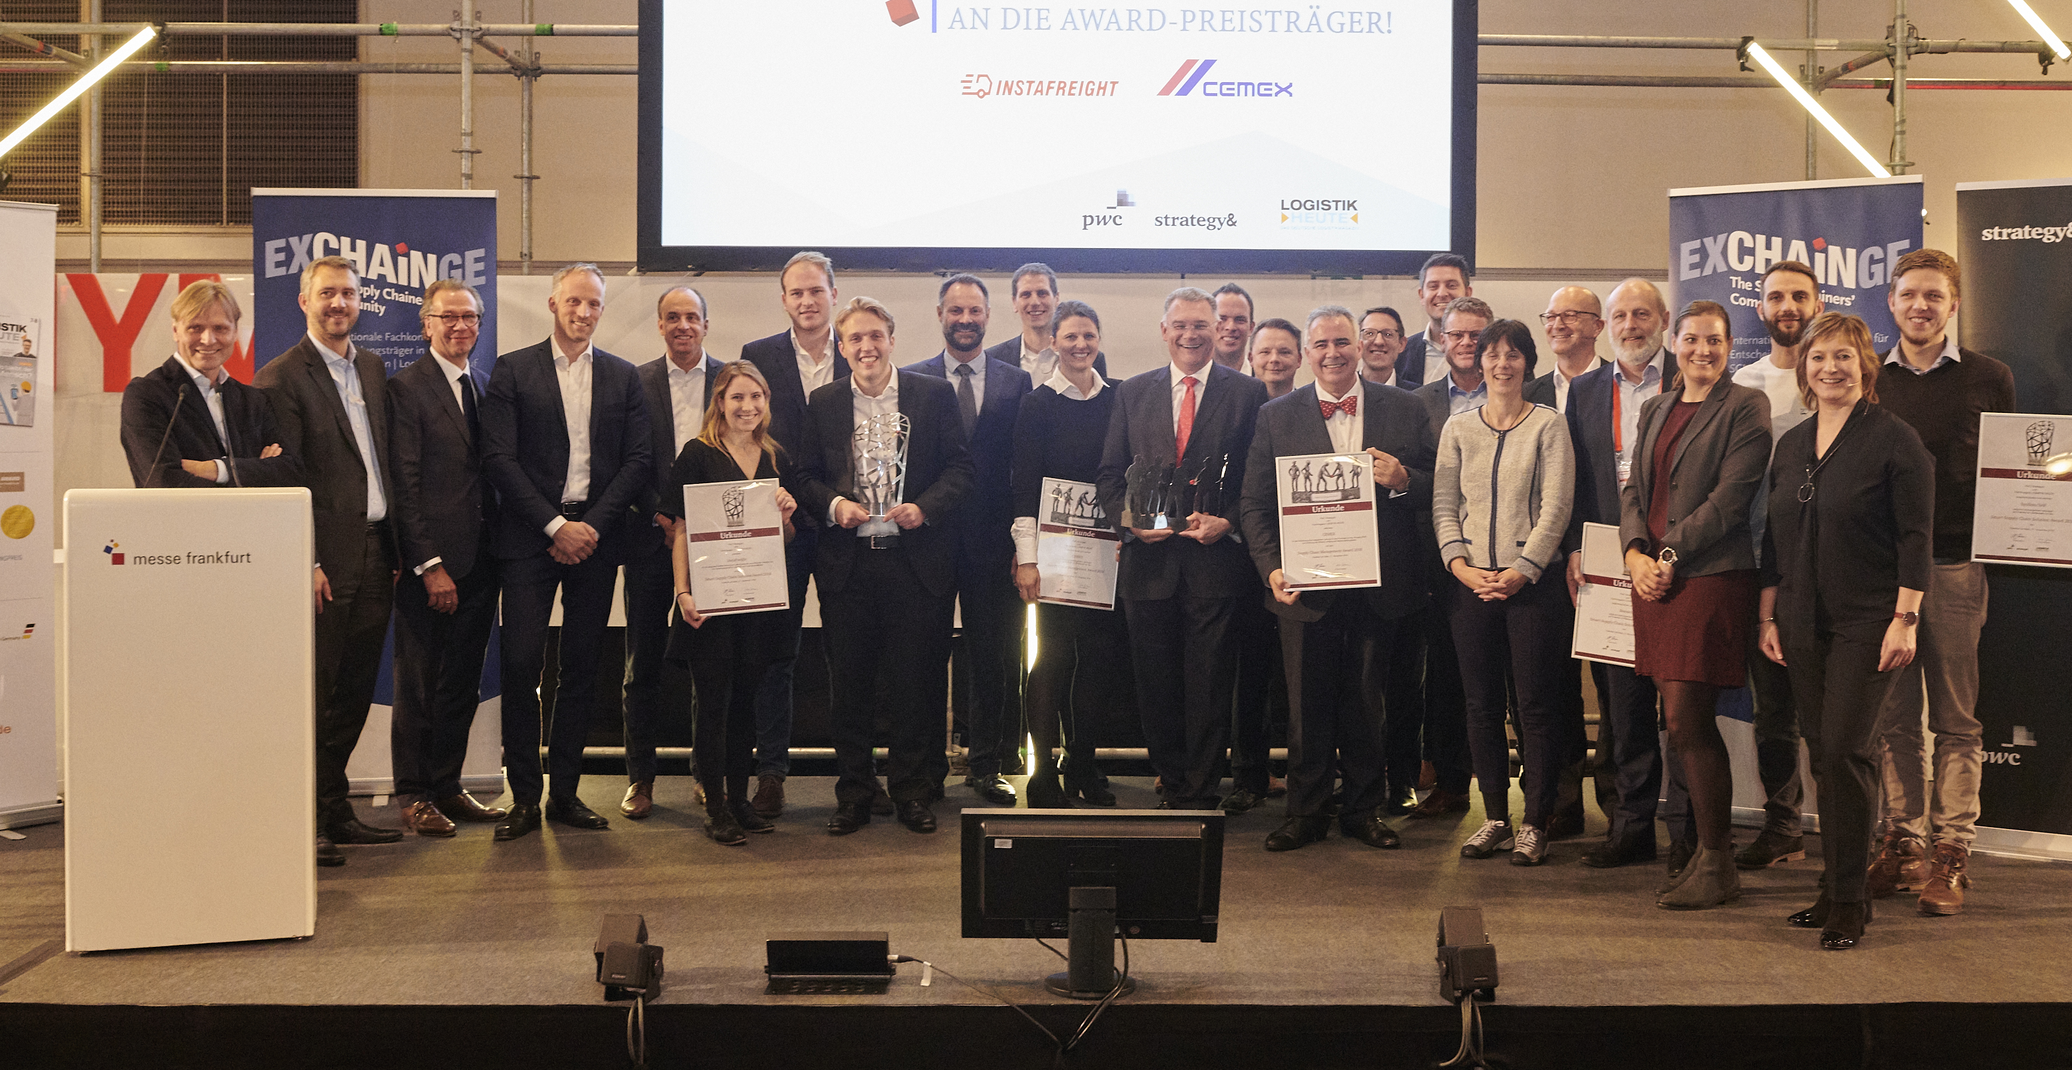
Prize-winning SCM projects: This year’s proud winners CEMEX and InstaFreight are joined by finalists BASF, Bossard, Schaeffler, and Synfioo/SAP and members of the jury at the ceremony to present the Supply Chain Awards at the EXCHAiNGE 2018 supply chain summit.

Images: EUROEXPO Messe- und Kongress-GmbH
More images can be found here.

For more information, please contact:
Hendrikje Rother
Marketing/Press
EUROEXPO Messe- und Kongress-GmbH
Phone: +49 89 323 91 240
hendrikje.rother@euroexpo.de
www.exchainge.de/en

(Characters with spaces: 6,267)

EUROEXPO blog postings may be reprinted free of charge. Texts and images can be found at the EXCHAiNGE blog page under www.exchainge.de.
Please send a copy of any republication by email to hendrikje.rother@euroexpo.de or by postal mail to EUROEXPO Messe- und Kongress-GmbH | Presse- und Öffentlichkeitsarbeit | Joseph-Dollinger-Bogen 7 | 80807 München.

