GEA kytero® 2000 now compatible with Rockwell Automation control systems – Presentation at Automation Fair in Chicago, Illinois

Duesseldorf/Chicago,Illinois (USA), November 14, 2025 – GEA, one of the world's leading providers of process technology, will present the GEA kytero® 2000 Single Use Separator with a control system from Rockwell Automation, the world’s largest company dedicated to industrial automation and digital transformation, at this year's Automation Fair, Rockwell’s annual event in Chicago, Illinois (November 17–20, 2025). GEA is a gold-level OEM in Rockwell’s PartnerNetwork™ ecosystem. The GEA kytero® 2000, which is already established in medium-to-large-scale biopharmaceutical production, is now fully compatible with Rockwell's latest hardware and software solutions, including FactoryTalk Optix, offering customers an integrated, digitized centrifuge solution. FactoryTalk Optix is a cloud-enabled, open, and scalable platform from Rockwell Automation for human-machine interfaces (HMI), connectivity, and data visualization. It enables the creation of industrial applications via a web browser and supports industrial IoT (IIoT) functions and edge computing. The platform enables collaboration between multiple users, easy access from anywhere, and integration of data from various sources, making operations more transparent and efficient.

GEA kytero® 2000 enables yields of over 99 percent

The GEA kytero® 2000 continues to offer proven single-use disc separator technology for production-scale bioprocessing and processes mammalian cell cultures from 150 to 500 liters per hour and E. coli from 30 to 120 liters per hour, achieving yields of over 99 percent when separating mammalian cells. The compact, mobile “plug & produce” design minimizes space requirements and eliminates the need for CIP (clean-in-place) and SIP (sterilize-in-place) since all product-contact parts are single-use items.

Seamless digitalization and modularity

Integration with Rockwell Automation solutions enables seamless operation and data visualization via FactoryTalk Optix. Customers benefit from unified interfaces, cloud connectivity, and advanced analytics, including FactoryTalk® Analytics™ and GuardianAI™, which enables real-time monitoring of drive performance and process optimization. The GEA kytero® 2000 also utilizes the open automation standard MTP (Module Type Package), which enables “plug &produce" integration into existing production environments. Combined with digital twin and augmented reality solutions by EPLAN, customers gain access to real-time design data, simplified commissioning, and enhanced maintenance operations.

Strong collaboration between GEA and Rockwell Automation

“The compatibility of the GEA kytero® 2000 with Rockwell Automation solutions enables our customers to operate GEA separators with maximum efficiency, scalability, and digital connectivity,” says Dieter Hille, Senior Director Product Management Automation & Digital Product.

Technology on display at Automation Fair 2025 in the “Industry Pavilion, OEM – Machine Builders”

Visitors to Automation Fair 2025 can see the GEA kytero® 2000 with Rockwell controls in the Life Science section of the Industry Pavilion for OEM – Machine Builders and experience the advantages of a fully integrated single-use centrifuge for medium to large-scale biopharmaceutical production.

Background information: Facts and figures about the GEA kytero® 2000

- Ideal for bioreactors up to 2,000 liters
- Fed-batch harvesting and highly productive perfusion operation
- Compact dimensions: 1,220 × 960 × 1,810 mm (Inches: 48‘ × 37,8‘ × 71,2‘)
- Biocontainment-safe, contactless breezeDrive® system
- No supply lines required except standard power and compressed air

Photo:

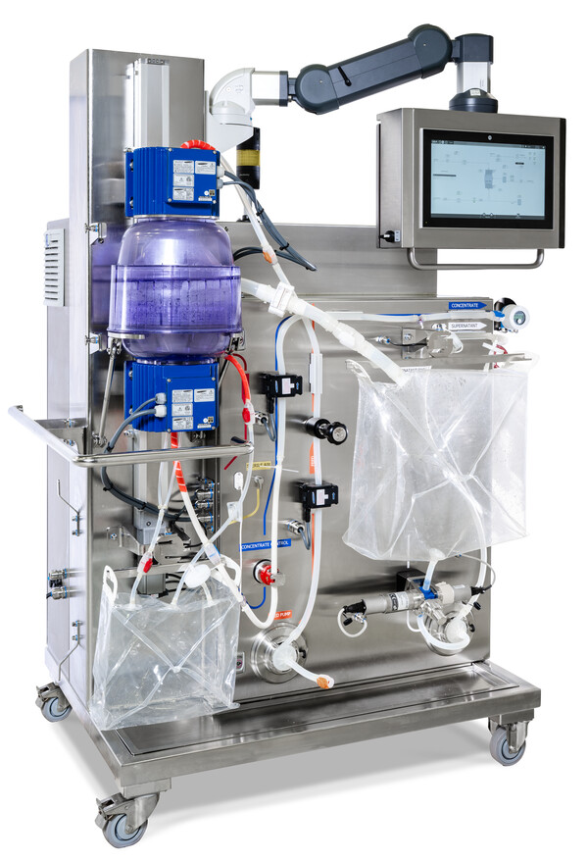

Photo, caption: The GEA kytero® 2000, which has already established itself in medium to large-scale biopharmaceutical production, is now fully compatible with the latest hardware and software solutions from Rockwell. (Photo: GEA)

About GEA
GEA is one of the world’s largest suppliers of systems and components to the food, beverage and pharmaceutical industries. The international technology group, founded in 1881, focuses on machinery and plants, as well as advanced process technology, components and comprehensive services. For instance, every second pharma separator for essential healthcare products such as vaccines or novel biopharmaceuticals is produced by GEA. In food, every fourth package of pasta or every third chicken nugget are processed with GEA technology. With more than 18,000 employees, the group generated revenues of about EUR 5.5 billion in more than 150 countries in the 2024 fiscal year. GEA plants, processes, components and services enhance the efficiency and sustainability of customers’ production. They contribute significantly to the reduction of CO2 emissions, plastic usage and food waste. In doing so, GEA makes a key contribution toward a sustainable future, in line with the company’s purpose: ”Engineering for a better world.”

GEA is listed on the DAX, the STOXX® Europe 600 Index and is also a constituent of the leading sustainability indices DAX 50 ESG, MSCI Global Sustainability and Dow Jones Best-in-Class World.

More information can be found online at gea.com.
If you do not want to receive any further information from GEA, please send an e-mail to pr@gea.com.

About Rockwell Automation

Rockwell Automation, Inc. (NYSE: ROK), is a global leader in industrial automation and digital transformation. We connect the imaginations of people with the potential of technology to expand what is humanly possible, making the world more productive and more sustainable. Headquartered in Milwaukee, Wisconsin, Rockwell Automation employs approximately 26,000 problem solvers dedicated to our customers in more than 100 countries as of fiscal year end 2025. To learn more about how we are bringing Connected Enterprise to life across industrial enterprises, visit www.rockwellautomation.com

NOTE TO EDITORS

- Further information about GEA
- To the GEA Press page
- To the GEA Media Center
- Background information on current topics can be found at Features
- Follow GEA on  

GEA
Media Relations GEA
Dr. Michael Golek
Ulmenstraße 99, 40478 Düsseldorf
Phone +49 211 91361505
Tel. +491736205746
michael.golek@gea.com

