GEA presented L XHP high-pressure screw compressor at HeatExpo in Dortmund

Duesseldorf (Germany), December 9, 2025 – GEA presented the GEA Grasso L XHP screw compressor at HeatExpo in Dortmund (November 25 to 27). The L XHP is ideal for ammonia heat pumps and high-pressure applications. Based on proven GEA Grasso screw compressor technology, which has been continuously developed and improved over the last 50 years, the L XHP with its optimized design is suitable for a wide range of applications. The compressor series comprises three sizes with a swept volume of 1,990 to 2,748 m³/h at 2,940 rpm. The machines can be operated at up to 3,600 rpm. This results in a heating capacity range of 2 to 11 MW per compressor.

Background information

Highlights & technical features

- New design, optimized for NH₃ heat pumps and high-pressure gas applications
- Long service life, high reliability, and easy maintenance
- Wide range of applications
- Variable Vi (internal volume ratio)
- Maximum condensation temperature: 95 °C
- Design pressure: 70 bar (g)
- Maximum final compression temperature of 140 °C
- Available in three sizes: 1,990 m³/h to 2,748 m³/h at 2,940 rpm.
- Maximum speed: 3,600 rpm.

About GEA
GEA is one of the world’s largest suppliers of systems and components to the food, beverage and pharmaceutical industries. The international technology group, founded in 1881, focuses on machinery and plants, as well as advanced process technology, components and comprehensive services. For instance, every second pharma separator for essential healthcare products such as vaccines or novel biopharmaceuticals is produced by GEA. In food, every fourth package of pasta or every third chicken nugget are processed with GEA technology. With more than 18,000 employees, the group generated revenues of about EUR 5.5 billion in more than 150 countries in the 2024 fiscal year. GEA plants, processes, components and services enhance the efficiency and sustainability of customers’ production. They contribute significantly to the reduction of CO2 emissions, plastic usage and food waste. In doing so, GEA makes a key contribution toward a sustainable future, in line with the company’s purpose: ”Engineering for a better world.”

GEA is listed on the DAX, the STOXX® Europe 600 Index and is also a constituent of the leading sustainability indices DAX 50 ESG, MSCI Global Sustainability and Dow Jones Best-in-Class World.

More information can be found online at gea.com.
If you do not want to receive any further information from GEA, please send an e-mail to pr@gea.com.

Photo:

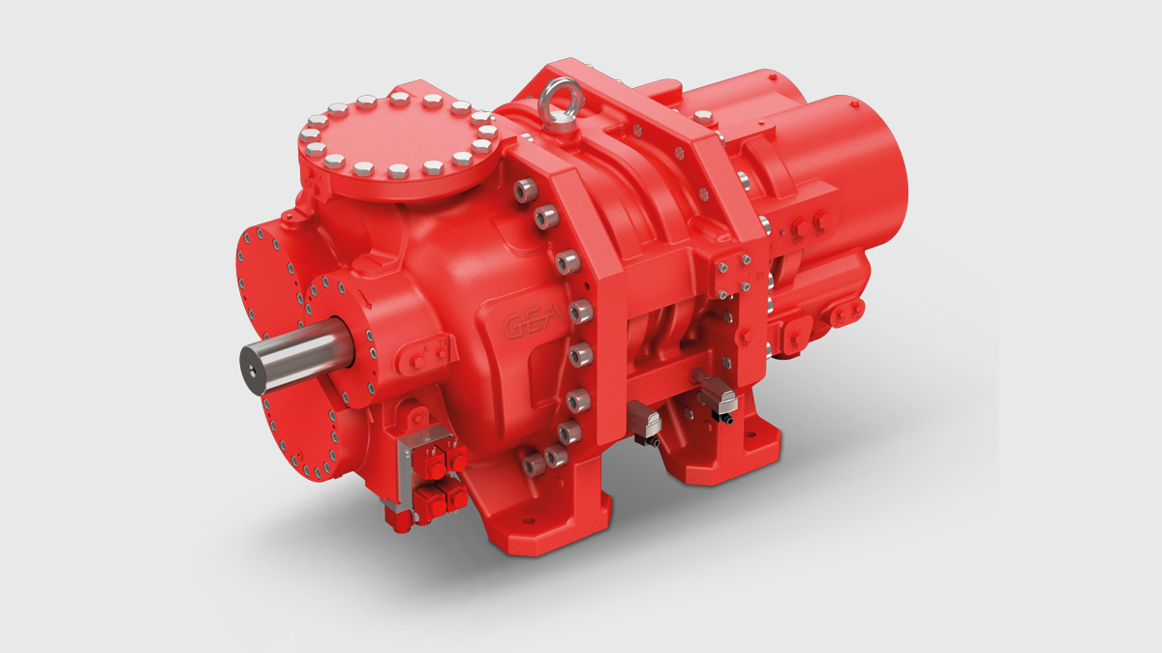

Photo, caption: The L XHP is ideal for ammonia heat pumps and high-pressure applications. (Photo: GEA)

NOTE TO EDITORS

- Further information about GEA
- To the GEA Press page
- To the GEA Media Center
- Background information on current topics can be found at Features
- Follow GEA on  

GEA
Media Relations GEA
Dr. Michael Golek
Ulmenstraße 99, 40478 Düsseldorf
Phone +49 211 91361505
Tel. +491736205746
michael.golek@gea.com

