Decarbonization of the thermal process industry with GEA meVap®
Duesseldorf (Gerrmany), May 5, 2026 – With meVap®, the machinery and plant manufacturer and solutions provider GEA is introducing a new product family to the market for the decarbonization of thermal process industries. Based on Mechanical Vapor Recompression (MVR) technology, the GEA meVap® portfolio offers highly efficient solutions for evaporation, distillation, crystallization, and industrial steam generation. The meVap® concept replaces fossil-fuel-fired steam with electrically driven steam compression, enabling significant CO₂ reductions, lower operating costs, and long-term resilience for energy-intensive industries such as chemicals, food, beverages, pharmaceuticals, and environmental technology. With this new product family, GEA is strengthening its position as a global pioneer in energy-efficient thermal processing, building on decades of experience and hundreds of MVR-heated systems worldwide.

A unified product family with four future-proof products

The meVap® product initiative introduces a harmonized technology platform consisting of four products: In all four product areas, the unifying principle of the meVap® is temperature rise generated by electrically driven mechanical fans, which increases thermal efficiency and reduces dependence on fossil fuels. Mechanical vapor compression is the core technology behind every meVap® system and is increasingly establishing itself as the first choice for evaporation, distillation, and crystallization. In addition, our advanced high-temperature heat pump system converts waste heat into valuable process steam.

The first product from GEA meVap® is meVap® Evaporation. These are electrified evaporation systems based on MVR technology that enable the continuous recycling of process steam, reducing both energy consumption and the carbon footprint.

The second product in the GEA meVap® portfolio is meVap® Distillation. GEA meVap® Distillation consists of MVR-based distillation solutions designed for compression in the primary or secondary circuit to reuse process steam, significantly reducing energy consumption.
The third product in the GEA meVap® product family is meVap® crystallization. These are highly efficient crystallization systems that use recompressed steam as the primary heat source and ensure stable crystal formation, reduced operating costs, and outstanding thermal performance.

Finally, the fourth product is meVap® Compression. This is a next-generation industrial high-temperature heat pump solution that converts low-temperature waste heat into valuable process steam—a key factor for CO₂-neutral industrial operations.

Decarbonization through electrification and smart heat integration

The meVap® portfolio enables customers to:
- reduce energy consumption and improve thermal efficiency through steam reuse
- minimize dependence on fossil fuels through electrified steam generation
- recover and reuse waste heat for internal or external steam needs
- Achieve stable, robust plant operation with high availability and proven technical expertise
GEA emphasizes a holistic approach that combines process technology, simple operation, user-friendliness, and digital support tools , thereby ensuring consistent plant performance throughout the entire lifecycle.

Photos/Grafic:

Photo 1:

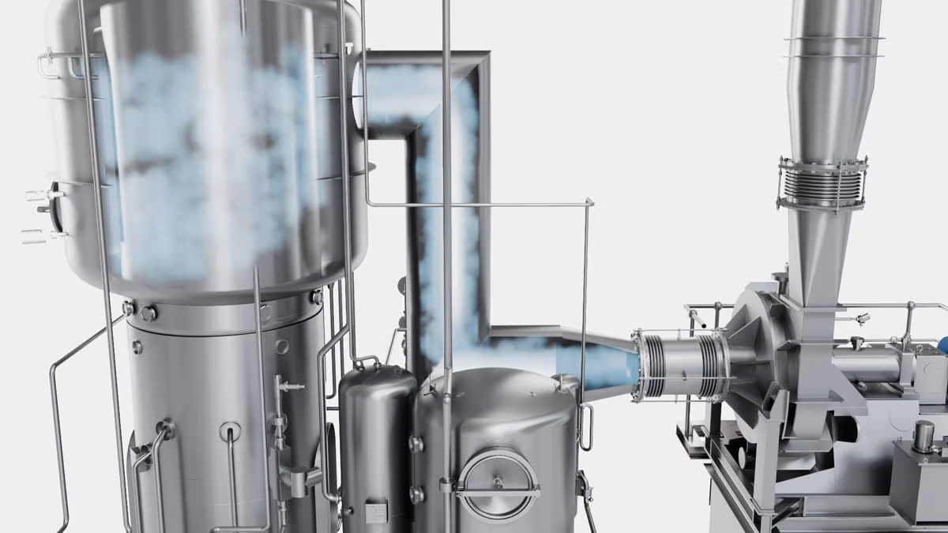

Photo 1, caption: meVap® Evaporation by GEA. (Photo: GEA)

Photo 2/Grafic:

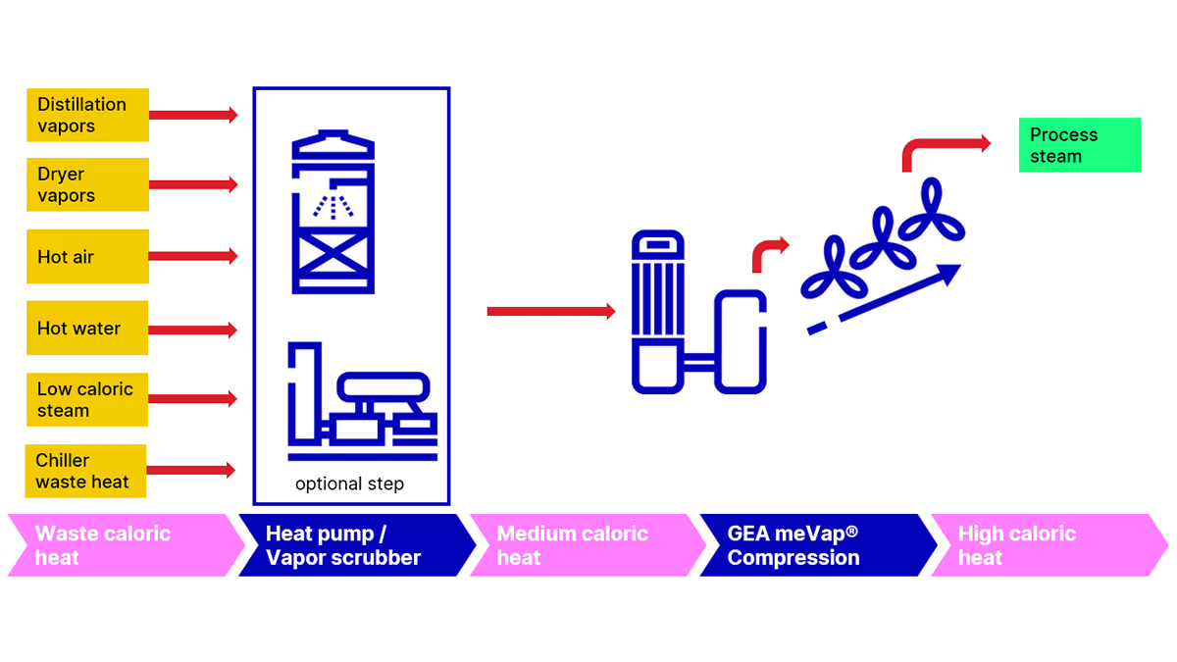
Photo 2/Grafic, caption: meVap® Compression by GEA. (Photo/Grafic: GEA)

About GEA

GEA is one of the world’s largest suppliers of systems and components to the food, beverage and pharmaceutical industries. The international technology group, founded in 1881, focuses on machinery and plants, as well as advanced process technology, components and comprehensive services. For instance, every second pharma separator for essential healthcare products such as vaccines or novel biopharmaceuticals is produced by GEA. In food, every fourth package of pasta or every third chicken nugget are processed with GEA technology.

With more than 18,000 employees, the group generated revenues of about EUR 5.5 billion in more than 150 countries in fiscal year 2025. GEA plants, processes, components and services enhance the efficiency and sustainability of customers’ production. They contribute significantly to the reduction of CO2 emissions, plastic usage and food waste. In doing so, GEA makes a key contribution toward a sustainable future, in line with the company’s purpose: ”Engineering for a better world.”

GEA is listed on the DAX, the STOXX® Europe 600 Index and is also a constituent of the leading sustainability indices DAX 50 ESG, MSCI Global Sustainability and Dow Jones Best-in-Class World.

More information can be found online at gea.com.

NOTE TO EDITORS

- Further information about GEA
- To the GEA Press page
- To the GEA Media Center
- Background information on current topics can be found at Features
- Follow GEA on  

GEA
Media Relations GEA
Dr. Michael Golek
Ulmenstraße 99, 40478 Düsseldorf
Phone +49 211 91361505
Tel. +491736205746
michael.golek@gea.com

