PRESS RELEASE
Schwaebisch Hall, April 22, 2020

Working through the crisis in a spirit of partnership
OPTIMA carries out a highly complex virtual machine acceptance

Optima is currently carrying out the most complex virtual machine acceptance in the company's entire history. Eleven cameras track the acceptance of a highly complex high-performance filling system for cosmetics. The client – a multinational US corporation – is there live. Every day, over 30 members of the customer's staff follow every step of the virtual factory acceptance test.
The coronavirus crisis and the travel restrictions associated with it mean that established digital technologies are now becoming even more appealing. The same is true at Optima. Right now, the customers of the special machine manufacturer are not permitted to travel to view the factory acceptance tests for their new systems in person, so Optima is live-streaming the factory acceptance tests (FATs) by video instead. For Optima, the process is not a new one, but the most comprehensive and complex virtual FAT the company has ever performed is taking place at the moment.
Over 30 members of the customer's staff are following the acceptance.
For a US-based global player, Optima has realized an extremely flexible, highly automated high-performance filling line which fills liquid cosmetics in 30 different variants in over 30 different containers. A ten-strong team, eleven high-tech cameras, state-of-the-art media technology and more than 30 observers per day – these are the key figures for virtual factory acceptance testing. Apart from the customer not being physically present, nothing else has changed with the execution of the virtual FAT. All production and safety related tests were carried out on the machine according to the FAT protocol, and were streamed live. Communication with the customer is facilitated by chat functions and audio transmission.
Using streaming technology delivers additional benefits
This variant has additional advantages, besides prompt delivery. “This means that additional customer experts who are not part of the acceptance team can be called in for certain areas,” explains Heiko Kühne, Vice President Cosmetics & Chemicals at Optima Consumer. Key suppliers are also contacted by Optima to answer customer questions. This generates an exchange of ideas across disciplines and has strengthened the sense of partnership. Even operating staff who do not normally get to travel to the acceptance test are also able to gain in-depth insight. This means short commissioning times and a rapid start to production. The wide range of formats and the multiple steps in the process make the acceptance process particularly challenging. The team needs a little over a week to check all the functions and formats. According to Kühne, “complex acceptances like these require maximum trust”. Now the close partnership that Optima maintains with its customers is paying dividends. The customer is impressed with the virtual FAT: “We have already asked other suppliers whether they could envisage a virtual acceptance of this kind,” the technical project manager states.
Moving forward
“This is the confirmation that we made the right decision some time ago when we added virtual FATs to the portfolio of our life cycle management program, OPTIMA Total Care,” says Kühne. Customers can choose the extent to which the acceptance process is accompanied virtually – either as a complement or in full. At Optima Consumer, there are already two more virtual acceptances in the pipeline.
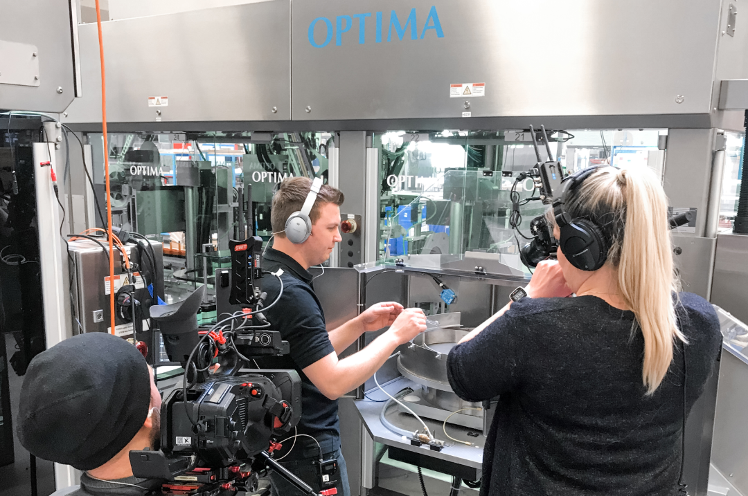
Eleven high-tech cameras relay live images to the customer in the USA. (Source: Optima)

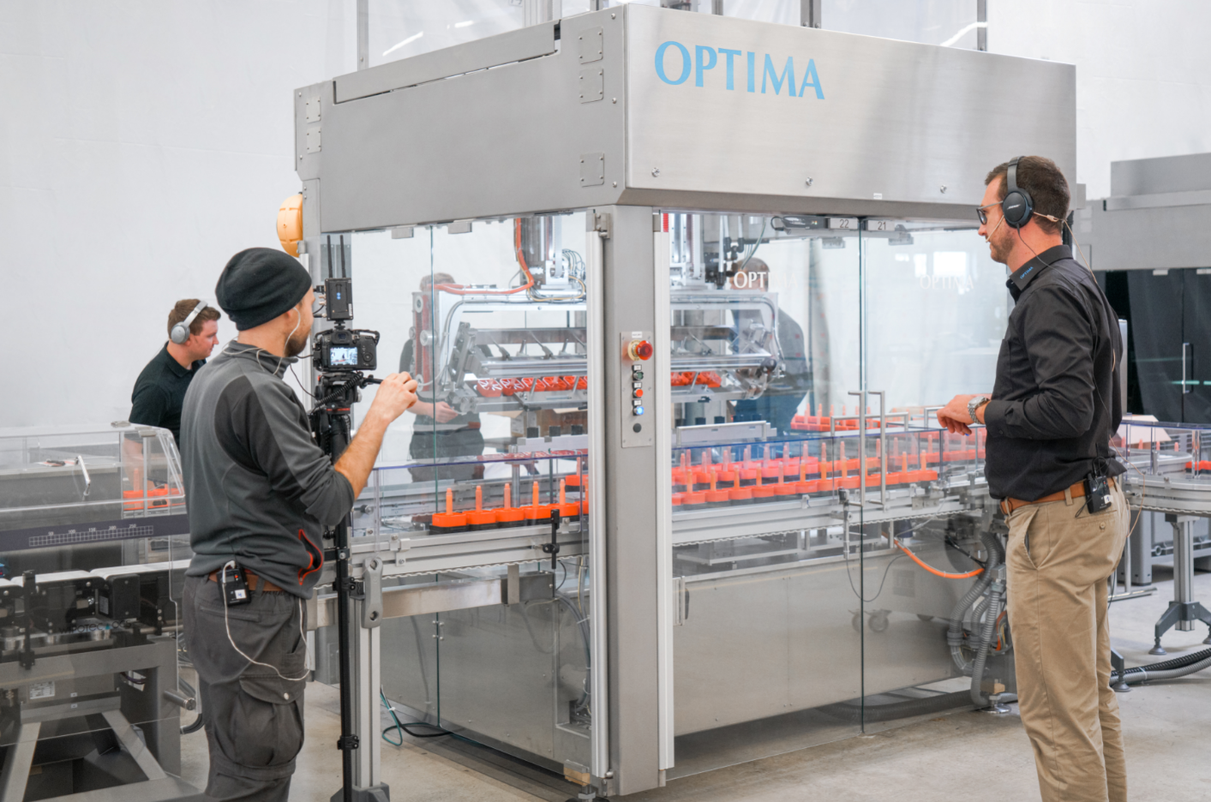
Optima Consumer project manager Jochen Weller (to the right of the picture) communicates with the customer and explains the processes going on inside the machine. (Source: Optima)
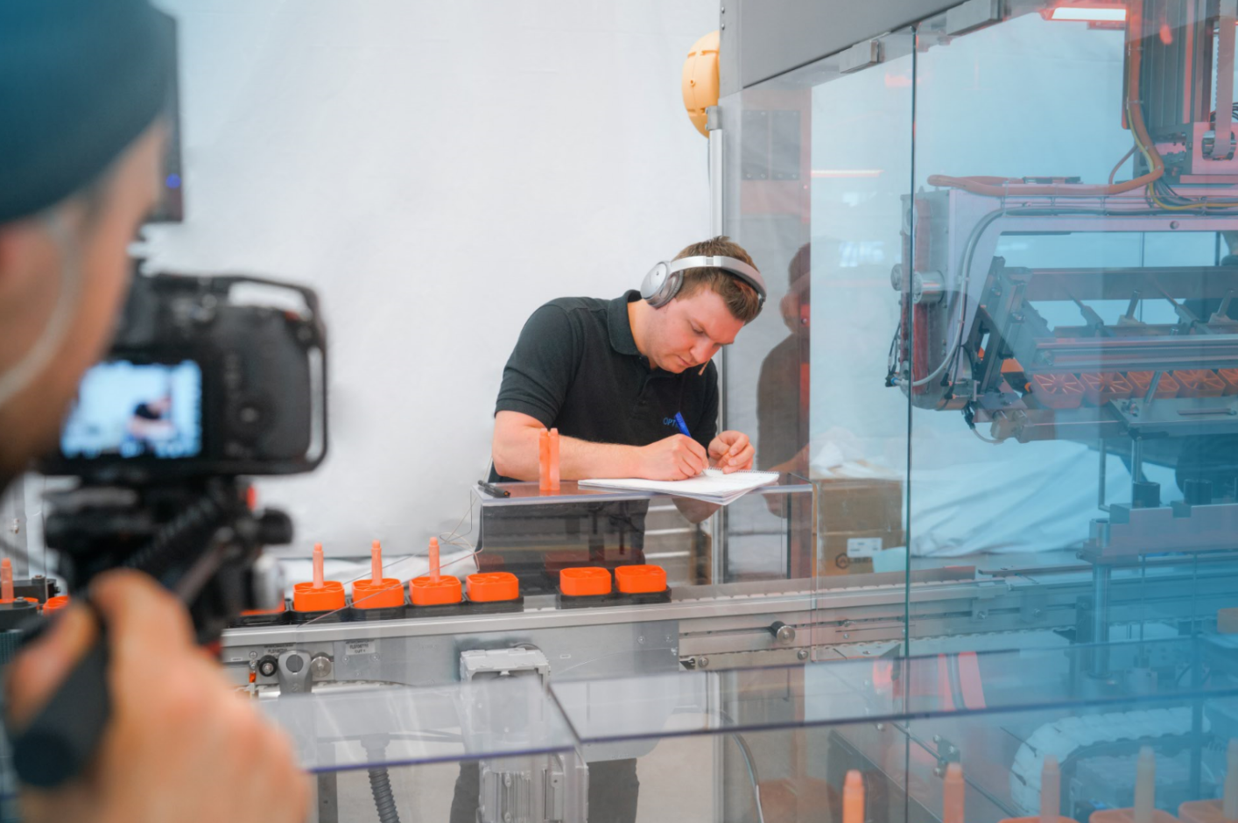
Optima staff document all the functional tests in detail. (Source: Optima)

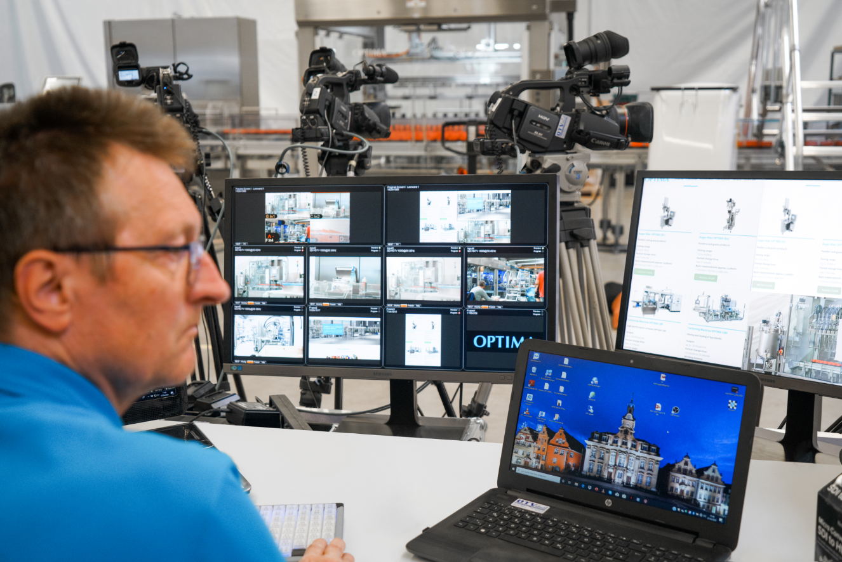
A video technician monitors the live streaming. (Source: Optima)

Characters (incl. spaces): 3,504

Press contact:
OPTIMA packaging group GmbH
Jan Deininger
Editor
+49 (0)791 / 506-1472
jan.deininger@optima-packaging.com
www.optima-packaging.com
Thank you very much for your publication. We look forward to receiving a specimen copy.

