First product chambers in the “Factory of the Future” of GEA in Elsdorf – growing demand for freeze-drying systems

Duesseldorf (Germany), July 24, 2025 – GEA is investing EUR 80 million in the construction of a pharmaceutical technology center for freeze-drying systems in Elsdorf (North Rhine-Westphalia). Partial approval was granted by the authorities in July 2025. With the new location, GEA is responding to the growing global demand for freeze-drying systems while creating capacity for further growth and technological innovation. The relocation of the previous operations in Hürth to Elsdorf has now begun. Shortly after the partial handover, the first product chambers, central components for the production of freeze dryers in which the actual drying process takes place, were delivered. The installation of the first freeze dryers at the new location represents an important milestone in the construction of GEA's new pharmaceutical technology center.

Covering an area of more than 40,000 square meters, the new competence and production center will primarily be used for the construction of freeze drying systems, which are used worldwide for the manufacture of injectable drugs such as vaccines. The complete relocation of the production, storage, and laboratory areas as well as the administrative functions will take place in the fourth quarter of 2025.

Strategic investment in innovation and sustainability

The “Factory of the Future” in Elsdorf stands for future-proof production processes, consistent digitalization, and sustainable construction: The photovoltaic system supplies environmentally friendly electricity, waste heat is recycled, and green roof areas promote a pleasant working environment and a focus on biodiversity. An intelligent warehouse management system and digital workflows ensure increased efficiency and transparency in operations.

Further assembly in “early access” mode

The partial approval gives the GEA team access to the first assembly areas while construction work continues elsewhere. This means that the assembly of complex systems can begin at an early stage, avoiding time-consuming relocation of these large components at a later date. The gradual commissioning process guarantees that the project will be completed on time and within budget.

Background information: Facts about the new pharmaceutical technology center

– New building enables growth and innovation in the strategically important pharmaceutical sector
– GEA's second factory of the future is being built in Elsdorf on a site covering more than 40,000 m²
– The construction of the new site in Elsdorf complies with the highest sustainability standards (e.g., own energy generation, CO₂ neutrality) and includes new, innovative digital solutions for the entire value chain.
– All 250 permanent employees will move to the new location

Photos:

Photo 1::

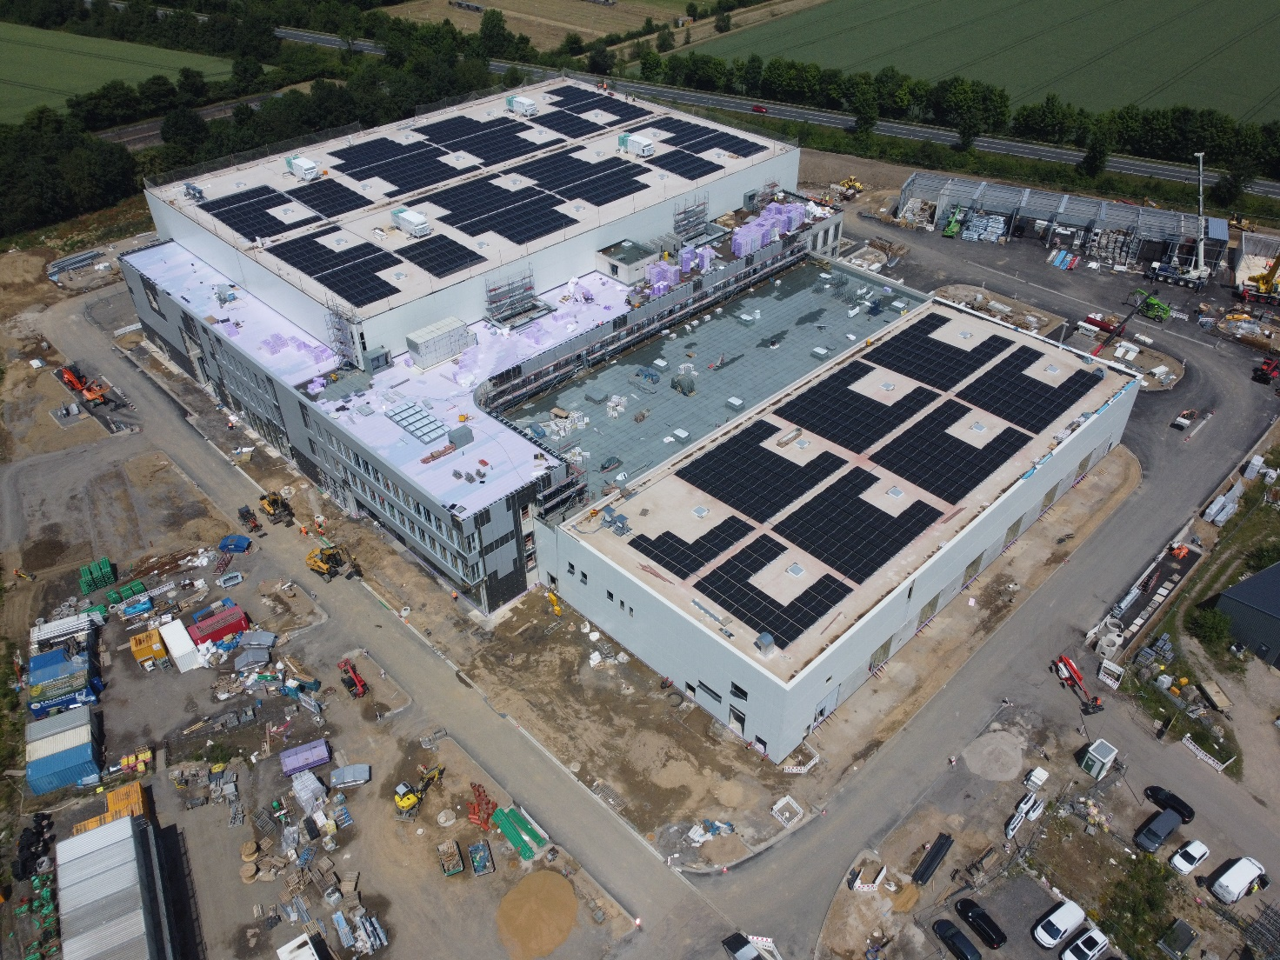

Photo 1, caption: Construction of GEA's new pharmaceutical technology center in Elsdorf (North Rhine-Westphalia) is on schedule. The relocation of the previous operations in Hürth to Elsdorf has now begun. (Photo: GEA)

Photo 2:

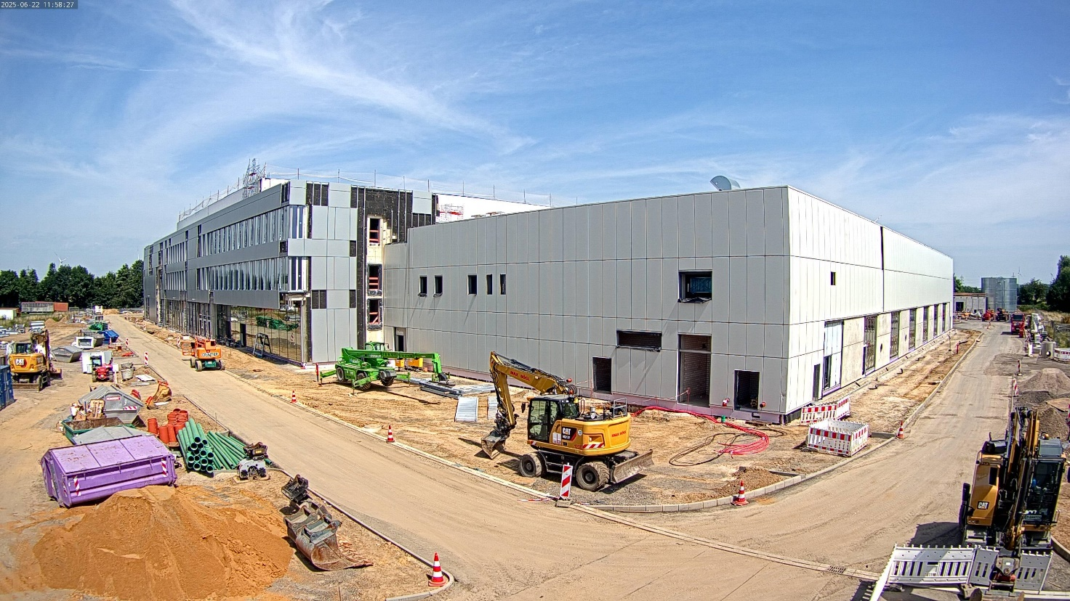

Photo 2, caption: Covering an area of more than 40,000 square meters, the new competence and production center will primarily be used for the construction of freeze-drying systems. (Photo: GEA)

About GEA
GEA is one of the world’s largest suppliers of systems and components to the food, beverage and pharmaceutical industries. The international technology group, founded in 1881, focuses on machinery and plants, as well as advanced process technology, components and comprehensive services. For instance, every second pharma separator for essential healthcare products such as vaccines or novel biopharmaceuticals is produced by GEA. In food, every fourth package of pasta or every third chicken nugget are processed with GEA technology. With more than 18,000 employees, the Group generated revenues of about EUR 5.4 billion in more than 150 countries in the 2024 fiscal year. GEA plants, processes, components and services enhance the efficiency and sustainability of customers’ production. They contribute significantly to the reduction of CO2 emissions, plastic usage and food waste. In doing so, GEA makes a key contribution toward a sustainable future, in line with the company’s purpose: ”Engineering for a better world.”

GEA is listed on the German MDAX, the European STOXX® Europe 600 Index and is also a constituent of the leading sustainability indices DAX 50 ESG, MSCI Global Sustainability and Dow Jones Best-in-Class World.

More information can be found online at gea.com.
If you do not wish to receive any further information from GEA, please send an e-mail to pr@gea.com.

NOTE TO EDITORS

- Further information about GEA
- To the GEA Press page
- To the GEA Media Center
- Background information on current topics can be found at Features
- Follow GEA on  

GEA
Media Relations GEA
Dr. Michael Golek
Peter-Müller-Str. 12, 40468 Düsseldorf
Phone +49 211 91361505
Tel. +491736205746
michael.golek@gea.com

