LAMILUX receives European Classification for Fire-Resistant Glass Roofs

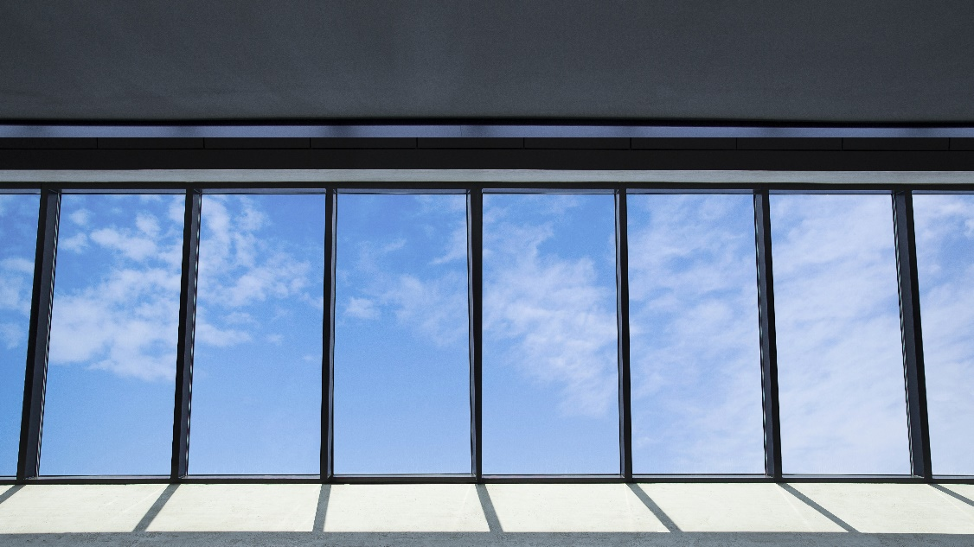
Glass roof prevents fire spreading

In busy buildings, people and property need to be protected, especially in the event of fire. LAMILUX has now also received the REI30 European fire resistance classification for its in-house developed glass roof design. The LAMILUX Glass Roof Fire Resistance F30/REI30 design, prevents fire and smoke from spreading to other building complexes for more than 30 minutes.

F30 (German standard DIN 4102-2/ DIN 4102-13) and REI30 (European standard DIN EN 13501-2) certified fire resistance guarantees that fire and smoke will not escape from the element for at least 30 minutes. At around 1000 degrees Celsius on the fire side, the average heat build-up on the outer side remains under 140 Kelvin, even after a half-hour of fire – while the element remains fully functional. The effect is similar to that of a fire protection door: if a fire breaks out in one building section, the daylight element will prevent the fire from spreading further.

During the tests for European fire resistance class REI30, real conditions including extreme weather events with corresponding loads were simulated. The glass roof design passed this test as a self-supporting construction, without the need for a special support element.

Fire protection and daylighting
The LAMILUX F30/REI30 Fire Resistance Glass Roof combines the tried and tested features of the LAMILUX PR60 system with outstanding fire protection characteristics – without optical drawbacks. The construction piece can be installed as a rigid element between zero and 80 degrees. It also possesses the classic advantages of the LAMILUX PR60 Glass Roof: enhanced insulation properties ensure an extremely airtight building envelope. In addition, the narrow profile lines deliver great potential for savings due to the generous daylight intake. So, there are significant savings to be made on expensive artificial light.

...
www.lamilux.com

About LAMILUX Heinrich Strunz GmbH

LAMILUX has been manufacturing high-quality daylight systems made from plastic, glass and aluminium for more than 60 years. Architects, construction engineers, planners and roofers use LAMILUX CI Systems when building industrial facilities, commercial buildings and industrial shed complexes as well as private residences. The purpose of these structures primarily consists in optimising the use of natural light and guiding it into building interiors. Fitted with controllable flap systems, they also serve as smoke and heat exhaust ventilation systems (SHEV) and energy-efficient building systems providing natural ventilation. The unique LAMILUX CI Systems range includes a wide variety of different structures – from rooflight domes and continuous rooflights through to glass roof constructions in aesthetically pleasing shapes. The company also offers considerable expertise in developing and manufacturing building control systems for activating and automating both smoke and heat exhaust systems as well as ventilation and solar protection installations. In 2017, LAMILUX, with its 950 employees, achieved a turnover of 263 million euros in its two corporate divisions, LAMILUX Daylight Systems and LAMILUX Composites.

www.lamilux.com

