PRESS RELEASE
Schwaebisch Hall, July 31, 2018

P-MEC 2018
OPTIMA pharma and OPTIMA life science combine their expertise in Madrid

Visitors to the exhibition stand of Optima Pharma and Optima Life Science at P-MEC will have the opportunity to find out how the time between an order being placed and production starting can be kept to a minimum. The MultiUse concept, which consists of highly flexible, fully automated filling machines that can process different types of containers, will also be taking center stage. Another key feature of the companies' exhibition presence will be the modern engineering technologies that enable Optima Pharma to complete complex turnkey projects on budget and on schedule.
A shorter time to production with CSPE
One area of emphasis at the exhibition will be Comprehensive Scientific Process Engineering (CSPE), which has revolutionized the planning and implementation of pharmaceutical filling machines. A combination of scientific methods and technological processes ensures that the time from the order being placed to the start of production is as short as possible.
Filling vials, pre-filled syringes, and cartridges in one machine
The MultiUse concept developed by Optima Pharma is the ideal solution for small batch sizes and different container types in the pharmaceutical industry. This type of machine can be used for production on a laboratory scale up to medium-sized batches and for the first time is fully automated and also highly flexible. The MultiUse Filler can quickly be adjusted to different format sizes and types of containers, including vials, pre-filled syringes, and cartridges.
The latest engineering technologies guarantee a fast start to production
The turnkey experts will inform visitors to the exhibition about complex projects involving filling and sealing, isolator technology, and freeze-drying. Optima Pharma takes overall responsibility for developing and implementing projects of this kind, from online planning and design through to integrated factory acceptance tests (FATs), building site management, site acceptance tests (SATs), and a comprehensive range of services, using the latest engineering technologies such as flow visualizations.
DECOpulse technology halves decontamination times
The experts from Optima Pharma in Mornshausen and Metall+Plastic in Radolfzell add the finishing touches to the portfolio of products and services on show at P-MEC. Metall+Plastic is a world leader in the design, production, installation, qualification, and validation of customized isolators. The company attracted attention at ACHEMA 2018 with its exciting new technologies, including DECOpulse, a new contamination system, and the user friendly, modular STISO sterility test isolator.
Cost-effective freeze-drying in a small space
Optima Pharma in Mornshausen develops state-of-the-art freeze-drying machines. The company's most recent innovation is the CS freeze-dryer. It is designed for products that are new on the market and are initially being produced in small and medium-sized batches. The CS freeze-dryer is ideal for installation in existing buildings and can easily be configured to ensure an efficient overall layout for the production system. Its space-saving design also makes it highly cost-effective.
New alliance simplifies the small-scale manufacturing and packaging of transdermal patches and oral film strips
Optima Life Science has a strong reputation as a converting specialist across a number of industries. As well as combined manufacturing and packaging machines for wound dressings, transdermal patches, and oral film strips, the company makes systems that automatically coat microtiter plates for use in ELISA test kits. At ACHEMA 2018 the company announced a new alliance with Coatema Machinery GmbH. The alliance, which is known as Comedco, will make it easier for pharmaceutical companies to move into manufacturing and packaging transdermal patches and oral dispersable films with pharmaceutical active ingredients.
Optima Pharma and Optima Life Science are part of the Optima packaging group GmbH, which has its headquarters in Schwäbisch Hall in southern Germany. Optima has 2250 employees and 14 sites worldwide.
Optima Pharma and Optima Life Science at P-MEC 2018 in Madrid, October 9 to 11, 2018: Hall H4, Stand 4F61

About Optima Pharma
For uncompromising pharmaceutical applications: Optima Pharma develops and manufactures filling, sealing and process technology for pharmaceuticals. Highly sophisticated, fully automated systems from Optima Pharma are used to process blood plasma products, vaccines, oncology and biotech products in prefilled syringes, vials, bottles and cartridges. Non-sterile pharmaceuticals and diagnostics are further applications. The company’s extensive technology portfolio includes washing machines, sterilization tunnels, filling and sealing, robotic product handling and other functions. Freeze drying systems and isolator technology are part of turnkey systems by Optima Pharma. The product range comprises machinery for laboratory filling up to high-speed systems. The division guarantees quick, professional service with 14 international locations. Optima Pharma is a member of the OPTIMA packaging group GmbH (Schwaebisch Hall), which employs a workforce of 2,250 around the globe.

About Optima Life Science
Unsurpassed flexibility for medical and pharmaceutical products: Optima Life Science offers flexible manufacturing and packaging processes, for fields as diverse as wound dressings, oral film strips (ODF) transdermal and electrode patches, and immunoassays (ELISA test kits). The division’s core expertise lies web-processing technologies as well as liquid handling processes. The company develops complete automated lines with integrated packaging functions. Modular machine systems from Optima Life Science offer customers unique “plug & play” flexibility. The division guarantees quick, professional service with 14 international locations. OPTIMA Life Science is a member of the OPTIMA packaging group GmbH (Schwaebisch Hall), which employs a workforce of 2,250 around the globe.

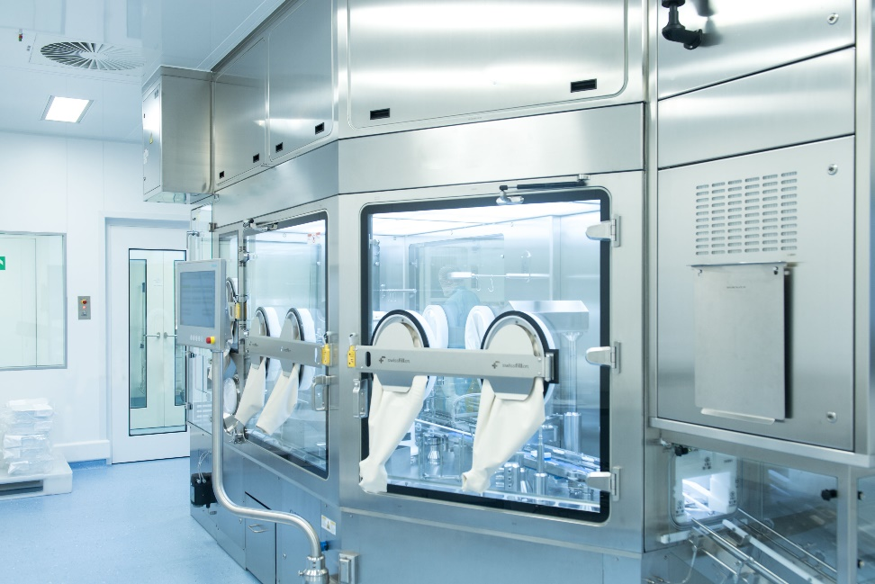 The MultiUse filler is one of Optima Pharma's most recent developments.

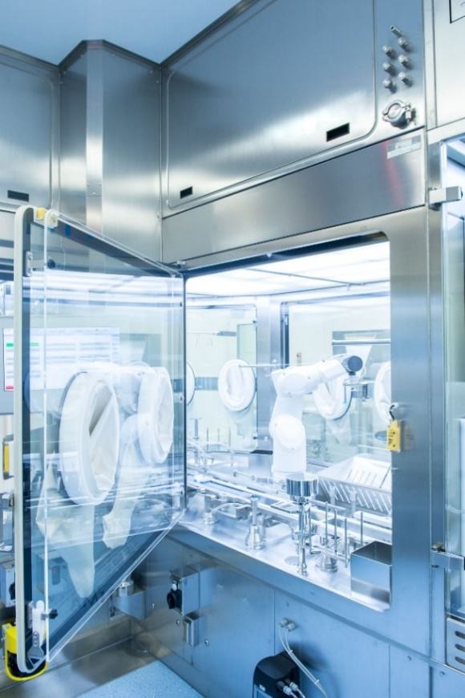
The MultiUse concept allows for the flexible production of small batches in a wide range of different format sizes and container types.

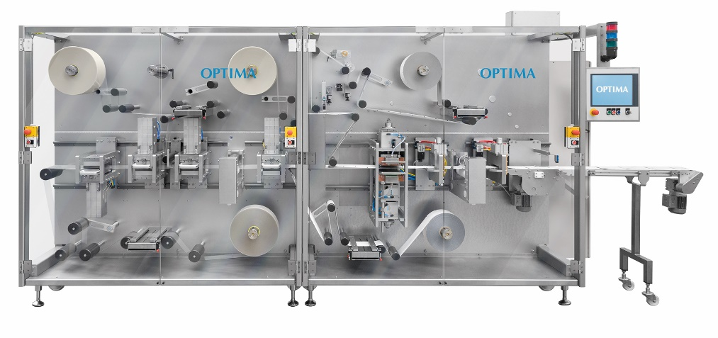
The OPTIMA TDC 125 from Optima Life Science allows oral film strips and transdermal patches to be produced in small and medium-sized batches.

Characters (incl. spaces): 4,166

Contact:
OPTIMA packaging group GmbH
Sabine Gauger
Marketing Director
sabine.gauger@optima-packaging.com
www.optima-packaging.com
Thank you very much for your publication. We look forward to receiving a specimen copy.

