PRESS RELEASE
Schwaebisch Hall, December 4, 2019

OPTIMA honored with an award in the regional competition "familyNET 4.0"
The Ministry of Economic Affairs and the Bildungswerk training institute honor approaches to digitization in human resources work

OPTIMA packaging group GmbH received a special award in the regional competition "familyNET 4.0". With this award, the Ministry of Economic Affairs of Baden-Wuerttemberg and other cooperative partners honored companies that develop and implement offerings and measures which help reconcile work and family life in the digital workplace. The award ceremony was held on December 2 in Stuttgart.
"We are thrilled to have received this award and regard it as an incentive to continue being open to new approaches to digitization," said Sebastian Henke, Director Human Resources at OPTIMA packaging group GmbH. Katrin Schuetz, state secretary at the Ministry of Economic Affairs, and Stefan Kuepper, Managing Director of the training institute Bildungswerk der Baden-Wuerttembergischen Wirtschaft e.V [Educational Institute of the Economy of Baden-Wuerttemberg, registered association] and the employers of Baden-Wuerttemberg, presented the awards to the winners in Stuttgart. "Digital transformation is an important topic for the future. Companies that are well-positioned in terms of their corporate culture and digital, family- and life-phase-oriented offerings are more attractive in the competition for specialists," Kuepper emphasized during the award ceremony.
Optima received a special award in the field of "Staff and organizational development". "Optima supports the principle of learning organizations and is open for new approaches in digitization," was the justification for the award. The company proactively addresses new topics and faces challenges. Specifically, the jury mentioned the diverse initiatives in staff development: cross-qualification for specialists, the new training and study concept, and adoption of new continuing education offers for the digitized workplace in its exceptional staff development program. The performance review forms were redesigned and contain ideas for discussions concerning Work 4.0 for employees and managers.
As part of a business association, Optima participates in operating a virtual reality center which enthralls customers, trainees, students at Baden-Wuerttemberg Cooperative State University, and external student visitor groups. The training center teaches about robot technology with its own robot. In addition, the diverse offerings revolving around work-life balance were decisive for the award. Lana Ruder, HR Development Manager at Optima, structured them. The offerings for a good work-life balance include, for instance, child care during school vacations, mobile work, and company health management with a digital focus.
The Ministry of Economic Affairs supported the project, and the Bildungswerk der Baden-Wuerttembergischen Wirtschaft e.V. carried it out. Specific solution approaches for a family-conscious Corporate Culture 4.0 were developed together with approximately 100 people who are responsible for staff in 20 so-called "innovation labs" and workshops. The results led to the new "Digital, family-conscious company" guidelines. These should help companies in Baden-Wuerttemberg meet the challenges in the transformation process regarding compatibility of family and work in the digital workplace, for example, by promoting mobile work and co-working.

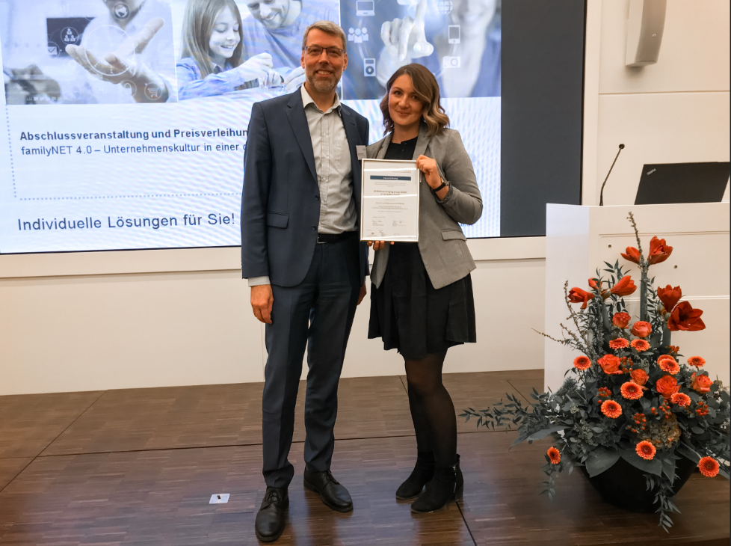
Sebastian Henke (Head of Human Resources at OPTIMA packaging group GmbH) and Lana Ruder (HR Development Manager at OPTIMA packaging group GmbH) accept the special award in the field of activity "Staff and organizational development".

Characters (incl. spaces): 3,434

Press contact:
OPTIMA packaging group GmbH
Jan Deininger
Editor
+49 (0)791 / 506-1472
jan.deininger@optima-packaging.com
www.optima-packaging.com
Thank you very much for your publication. We look forward to receiving a specimen copy.

