**traser H3 watches: the right timepiece for every adventure**

**High time to discover new horizons**

**Break free from the greyness of everyday life and leave it all behind – with temperatures on the rise and the sun shining brightly, there is very little standing between you and the adventure awaiting you beyond the familiar. From endless forest landscapes to the deep blue sea and rugged mountain ranges: with their robust construction, their uncompromising functionality and trigalight self-illuminating technology, explorers can place their trust entirely in timepieces from traser swiss H3 watches – at all times, and in all elements. Completely independent of power outlets and radio masts, all that matters for the wearer and watch is the here and now.**

Higher, deeper, further – leave behind the limits of the known and go and discover new worlds. Driven by an irrepressible sense of freedom, adventurers deliberately venture into unknown territory, always looking for new challenges. What does not change, however, is the need for a reliable companion to take along that will never let you down, come what may. With the P68 Pathfinder GMT, the P67 Diver Automatic and the P69 Black Stealth, the Bernese watch pioneer traser offers the perfect timepiece for the adventurer who is constantly seeking new challenges and strives to overcome the limits of everyday life.

Although the three timepieces are each tailored to their own area of application, they have a lot in common – most notably, the unique self-illuminating technology trigalight. As with all traser watches, hands, dials and bezels are equipped with quality luminous elements, so you can read the time in complete darkness and poor visibility – without an external energy source and with a luminescence that has not changed over the years. In addition, anti-reflective sapphire glass, screw-down crowns and a high degree of water resistance guarantee effective protection of the Swiss movement from physical influences.

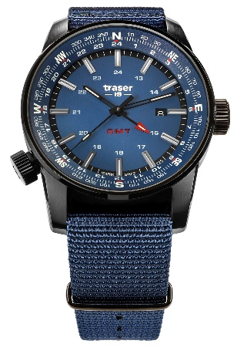**Breaking new ground with the P68 Pathfinder GMT**

Unlimited freedom – that's exactly what the P68 Pathfinder GMT stands for. Equipped with the energy-independent self-powered illumination technology trigalight, an integrated compass ring and the display of a second time zone, the P68 is aimed at people for whom no journey can be too far and no destination too remote. It is a timepiece for pioneers who leave established routes behind and resolutely go their own way. Thanks to the hard-wearing textile strap and water resistance of up to 10 bar, wearer and watch easily overcome natural boundaries such as rushing rivers and deep waters. Uniquely functional and versatile: The P68 Pathfinder GMT is not just a watch. It is an indispensable tool for the explorer who discovers the world on their own terms!

**Deeper than ever with the P67 Diver Automatic**

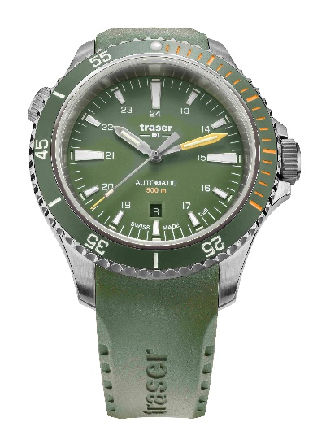Taking the proverbial dive into a world apart from your everyday life – with the right equipment and the necessary expertise, this is entirely possible. However, exploring the underwater world is as challenging as it is fascinating. With limited oxygen reserves, time is a factor that plays a crucial role. When the light and colour intensity diminish as you descend deeper, the trigalight capillaries of the luminous hands and indices of the P67 Diver Automatic enable you to read the time correctly. The unidirectional rotating ceramic bezel, the helium valve and water resistance up to 500 meters as well as the hard-wearing rubber strap provide the P67 Diver Automatic with all the invaluable features for diving enthusiasts.

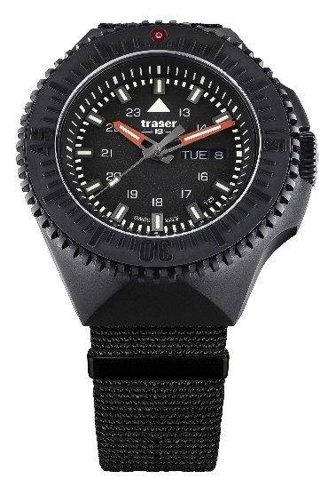**The P69 Black Stealth – a watch for all conditions**

Dark mountain caves, rugged rock formations and rushing torrents: if you want to aim high on your quest of discovery, you have to be prepared for a wide variety of contingencies. Designed to withstand exactly these conditions, the P69 Black Stealth is uncompromisingly at your side with its solid and functional design. The angular, PVD-coated stainless steel case, anti-reflective sapphire crystal and the profiled bezel with ceramic inlay make the P69 extremely robust against everything that the next mountain adventure has in store. With water resistance of up to 20 bar, a robust textile strap and trigalight self-powered illumination technology, this timepiece masters every interaction with the elements – and is the perfect all-rounder at its wearer's side when tackling any challenge.

In search of unbridled freedom, in the deepest waters and on the highest peaks: outdoor enthusiasts, adventurers and explorers will find highly functional and always reliable companions in the timepieces from traser swiss H3 watches. Wherever wearer and watch go on their journey, the goal is always the same: breaking boundaries.

|  |  |  |
| --- | --- | --- |
| **P68 Pathfinder GMT** | Blue with textile strap | 109034 | |
| **Illumination:** | trigalight & Super-LumiNova,  Luminescent glass seal |
| **Movement:** | Swiss Made Quartz GMT |
| **Size:** | Ø 46 mm |
| **Glass:** | Anti-reflective sapphire |
| **Case:** | PVD coated stainless steel |
| **Crown:** | Screw-retained crown |
| **Strap:** | NATO strap |
| **Water resistance:** | 10 atm / 10 bar |
| **Price:** | CHF 495.00 |
|  |  |  |
| **traser P67 Diver Automatic** | Green with rubber strap | 110327 | |
| **Light elements:** | trigalight & Super-LumiNova,  Luminescent glass seal |
| **Movement:** | Swiss Made Automatic |
| **Size:** | Ø 46 mm |
| **Glass:** | Anti-reflective sapphire |
| **Watch case:** | Stainless steel case with unidirectional rotating ceramic bezel |
| **Crown & helium release valve:** | Screw-down crowns at 3 and 10 o'clock |
| **Wristband:** | Rubber strap |
| **Water resistance:** | 50 atm / 50 bar |
| **Price:** | CHF 1.095.00 |
|  |  |  |
| **P69 Black Stealth** | Black with textile strap | 109854 | |
| **Illumination:** | trigalight & Super-LumiNova,  Luminescent glass seal |
| **Movement:** | Swiss Made Quartz |
| **Size:** | Ø 46 mm |
| **Glass:** | Anti-reflective sapphire |
| **Case:** | PVD coated stainless steel, PVD-coated stainless steel bezel with ceramic inlay and trigalight at 12 o'clock, rotatable on both sides |
| **Crown:** | Screw down crown |
| **Strap:** | NATO strap |
| **Water resistance:** | 20 atm / 20 bar |
| **Price:** | CHF 495.00 |

|  |
| --- |
| **About traser swiss H3 watches – #theoriginal #unlimited #illumination**  **traser** swiss H3 watches are developed and manufactured under the SWISS MADE quality seal in Niederwangen, Bern, in Switzerland. All traser watches boast a unique feature: permanent, non-stop illumination of the time in darkness and poor visibility thanks to traser’s proprietary trigalight self-powered illumination tubes. These trigalights require no external energy or power source and deliver constant luminescence day and night for decades. Customers from all over the world, for whom reliable timekeeping is essential for every environment and occasion (including active individuals, explorers, athletes, nature-lovers, and tactical and special forces professionals), rely on the functional, rugged watches from traser. |

**Press contact:**

|  |  |
| --- | --- |
| Convensis Group  Marc Steinsberger  Valentin King  Friedrichstraße 23b  70174 Stuttgart  Germany  +49 711 36 53 37 78 [PRtraser@convensis.com](mailto:PRtraser@convensis.com) | Ferris Bühler Communications GmbH  Svenja Peters  Stadtturmstrasse 8  5400 Baden  Switzerland  +41 56 544 61 68 [svenja@ferrisbuehler.com](mailto:svenja@ferrisbuehler.com) |