Burning Down the House: Rethinking Family
Kunstmuseum St.Gallen
01.06.−08.09.2024

IMG_01
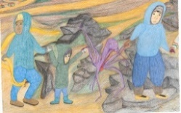
Shuvinai Ashoona, Find Yourself, 2023
colored pencil and ink on paper
83.8 x 127 cm
Servais Family Collection, Brussels
© Shuvinai Ashoona, 2024. Courtesy of the artist and Fort Gansevoort, New York

IMG_02
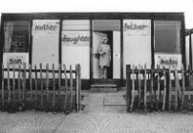
Bobby Baker, An Edible Family in a Mobile Home, the artist at the installation in the prefab Acme house in Conder Street, London, E1, 1976
Photo: Andrew Whittuck

IMG_03
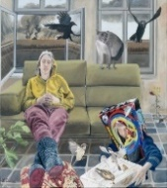
Laurence Durieu, Butterflies and Birds, 2020
Oil on canvas
100 x 100 cm
© Laurence Durieu, 2024

IMG_04
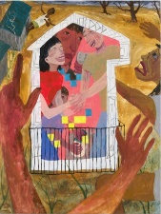
Kyoko Idetsu, Safe House, 2022
Oil on canvas
193.99 × 161.93 cm
Photo: Pierre Le Hors
© Kyoko Idetsu, 2024. Courtesy Bridget Donahue, NYC and Nonaka-Hill, Los Angeles

IMG_05
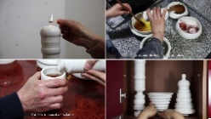
Ju Sekyun, Dinner, 2015
Single-channel video (still)
15'28"
© Ju Sekyun, 2024

IMG_06
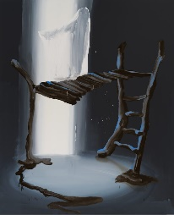
Tala Madani, Shit Mom (Playground), 2024
Oil on linen
248.9 x 203.2 cm
© Tala Madani, 2024. Courtesy the artist and Pilar Corrias, London

IMG_07
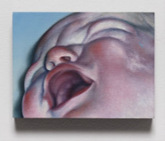
Alexandra Noel, The Color of Fluid III, 2022
Oil and enamel on wood panel
7.6 x 10.2 x 1.9 cm
© Alexandra Noel, 2024. Courtesy of the artist

IMG_08
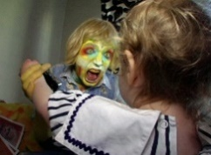
Ryan Trecartin, I-Be Area, 2007
Video, color, with sound, 108' (still)
© Ryan Trecartin, 2024. Courtesy of Sprüth Magers and Morán Morán

IMG_09
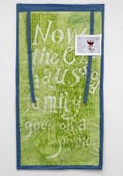
Evelyn Taocheng Wang, Untitled 1, 2019
Paper, watercolor, digital print, cotton
198 x 104 cm
Photo: Gert Jan van Rooii
© Evelyn Taocheng Wang, 2024. Courtesy Antenna Space, Shanghai; Carlos|Ishikawa, London; KayokoYuki, Tokyo; Galerie Fons Welters, Amsterdam

