## 40th work anniversary at the world market leader

### LAUDA honors Gabriele Sack for her many years of commitment

Lauda-Königshofen, November 5, 2024 – At the beginning of October, a special employee award ceremony was held at LAUDA DR. R. WOBSER GMBH & CO. KG. On the occasion of Gabriele Sack's 40th anniversary with the company, the management honored the long-serving employee in the presence of her colleagues for her loyalty to the family-owned company.

Gabriele Sack's career at LAUDA began on September 10, 1984 with an apprenticeship as an industrial clerk. After successfully completing her training, she worked in various departments of the company and established herself as an indispensable expert in order processing, particularly for plant engineering.

Dr. Gunther Wobser, President & CEO of LAUDA, emphasized the special merits of the anniversary in his laudation: “Mrs. Sack is a pillar of our company. With her extensive know-how in order processing for plant engineering and her reliable, conscientious manner, she is an invaluable support for our internal processes and procedures. Her calm nature and her precise, conscientious way of working are of great value to LAUDA.”

In recognition of her many years of service, Gabriele Sack received the LAUDA certificate of honor and a certificate from the state of Baden-Württemberg, signed by Prime Minister Winfried Kretschmann. Hubert Segeritz, representing the mayor of the city of Lauda-Königshofen, emphasized the rarity of a 40-year anniversary and acknowledged the importance of LAUDA as a reliable employer – both for the city and the region.

Sonja Hörner-Dürr (Manager Order Processing) and Gabriele Sack's direct supervisor, highlighted the special qualities of the jubilant: “Gabi is a highly valued employee – both by her colleagues and our customers. Her helpfulness, friendliness and precision make her a valuable member of our team. She is a calming influence in our department and always works for the good of the company.”

Works Council Chairman Elmar Mohr concluded by noting the special nature of the anniversary: “40 years with a company is a remarkable anniversary. Mrs. Sack has been exemplary in balancing her career and family, as well as her volunteer work, including in the local carnival club.”

Gabriele Sack's company anniversary once again underlines the importance of long-standing employees for the success of LAUDA. It shows how valuable experience and loyalty contribute to the long-term growth of a family business. The world leader in precise temperature control underscores its position as an attractive employer and will continue to honor many of its long-standing employees in the future.

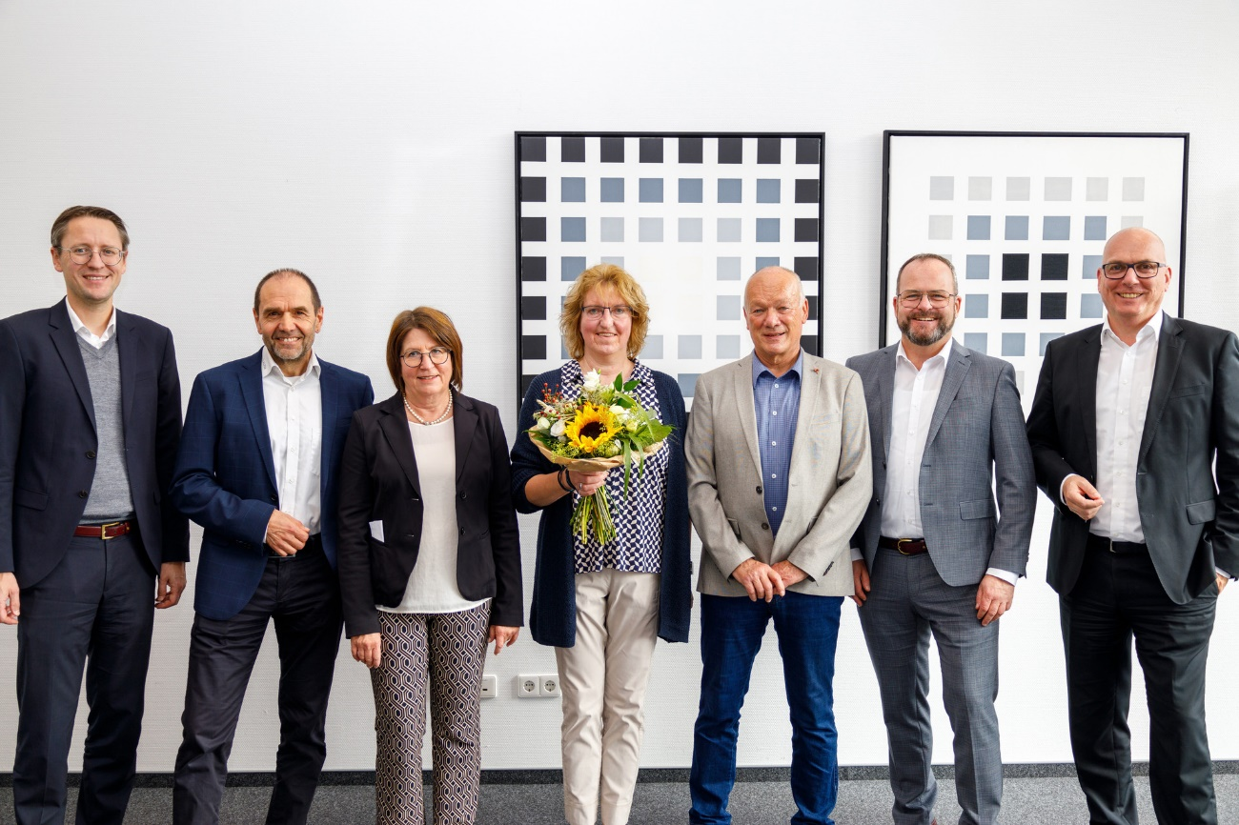

**Fig.:** 40th anniversary of employment at LAUDA: Gabriele Sack (center) was honored for her long-standing loyalty. She was congratulated by (from left to right): Dr. Mario Englert (CFO), Works Council Chairman Elmar Mohr, Sonja Hörner-Dürr (Manager Order Processing), Hubert Segeritz (representative of the city of Lauda-Königshofen), President & CEO Dr. Gunther Wobser and Dr. Marc Stricker (COO). © LAUDA

**We are LAUDA** –the world leader in precise temperature control. Our constant temperature equipment and systems are at the heart of important applications, contributing to a better future. As a complete one-stop supplier, we guarantee the optimum temperature in research, production and quality control. We are the reliable partner for electromobility, hydrogen, chemicals, pharmaceuticals/biotech, semiconductors and medical technology. We have been inspiring our customers for almost 70 years with our expert mentoring and innovative solutions – every day anew and all over the world.

In our company, we always go one step further. We support our employees’ development and are constantly developing ourselves: to create a better future together.

**Press contact**

We are more than happy to make prepared information about our company, the LAUDA Factory Gallery and our projects in the area of innovation promotion, digitalization and idea management available to the press. We look forward to hearing from you – just give us a call!

CHRISTOPH MUHR

Director Corporate Communications

T + 49 (0) 9343 503-349

[christoph.muhr@lauda.de](mailto:christoph.muhr@lauda.de)

LAUDA DR. R. WOBSER GMBH & CO. KG, Laudaplatz 1, 97922 Lauda-Königshofen, Deutschland/Germany. Limited partnership: Headquarters Lauda-Königshofen, Registration court Mannheim HRA 560069. General partner: LAUDA DR. R. WOBSER Verwaltungs-GmbH, Headquarters Lauda-Königshofen, Registration court Mannheim HRB 560226. Managing Directors: Dr. Gunther Wobser (President & CEO), Dr. Mario Englert (CFO), Dr. Marc Stricker (COO)