PRESS RELEASE
Schwaebisch Hall, April 30, 2020

Ensuring the global availability of goods
OPTIMA provides support to companies with machine solutions which are particularly in demand during the crisis

The Corona crisis is leading to strong shifts in demand. The need for specific consumer goods and hygiene products, pharmaceuticals and medical technology has increased exponentially. The broad-based Optima Group was quick to respond to this development, and is supporting customers with special machine solutions which can be flexibly adapted to suit the new market requirements. A new website provides information about the portfolio.
“Developing customer-specific solutions is part of Optima's DNA”, says Hans Buehler, the Managing Director of the Optima Group based in Schwaebisch Hall. This is why the special machine manufacturer is supporting manufacturing companies during this difficult time, specifically with its expertise, highly flexible machine solutions, virtual machine acceptance and digital services. “We are currently handling several machine projects which specifically relate to products for the Corona pandemic”, stresses Buehler. Examples of these include filling systems for diagnostic test kits which are used for the detection of SARS-CoV-2. There is also demand for manufacturing equipment for filters used in ventilators and machines for filling vaccines and therapeutic drugs.

New information page for particularly high demand machines

The company has now grouped together on a special website all the machine solutions, which are particularly in demand at this time. Prospective customers can find information at www.optima-packaging.com/fightcovid19 on the right machines for filling, closing and packaging diagnostic test kits, full face protective masks, disinfectants, filters for ventilators, vaccines and medications, toilet paper, as well as important information on digital services during the crisis and contact options.

Successful use of streaming technology for machine acceptance

Virtual machine acceptance means that Optima can ensure that machines are delivered on time during the crisis. Recently, the most complex virtual machine acceptance in the company’s history was performed. Eleven cameras tracked the acceptance of a highly complex high-performance filling system for cosmetics. Over 30 employees of the customer from the USA followed every step of the virtual factory acceptance test every day. “This means that additional customer experts who are not part of
the acceptance team can be called in for certain areas,” explains
Heiko Kuehne, Vice President Cosmetics & Chemicals at Optima
Consumer. Key suppliers are also contacted by Optima to answer
customer questions. This generates an exchange of ideas across
disciplines and has strengthened the sense of partnership. Even
operating staff who do not normally get to travel to the acceptance
test are also able to gain in-depth insight. This means short
commissioning times and a rapid start to production.

Social responsibility

As its contribution to tackling the crisis, Optima is assisting the company Wrapping Solutions, based in Rosengarten, Schwaebisch Hall, in producing full face protective masks with manual folding devices. Numerous inquiries from all over Germany have been received for this solution in recent weeks. The manufacturing of folding devices will be organized and carried out via the Optima training center.

Further information: www.optima-packaging.com/fightcovid19

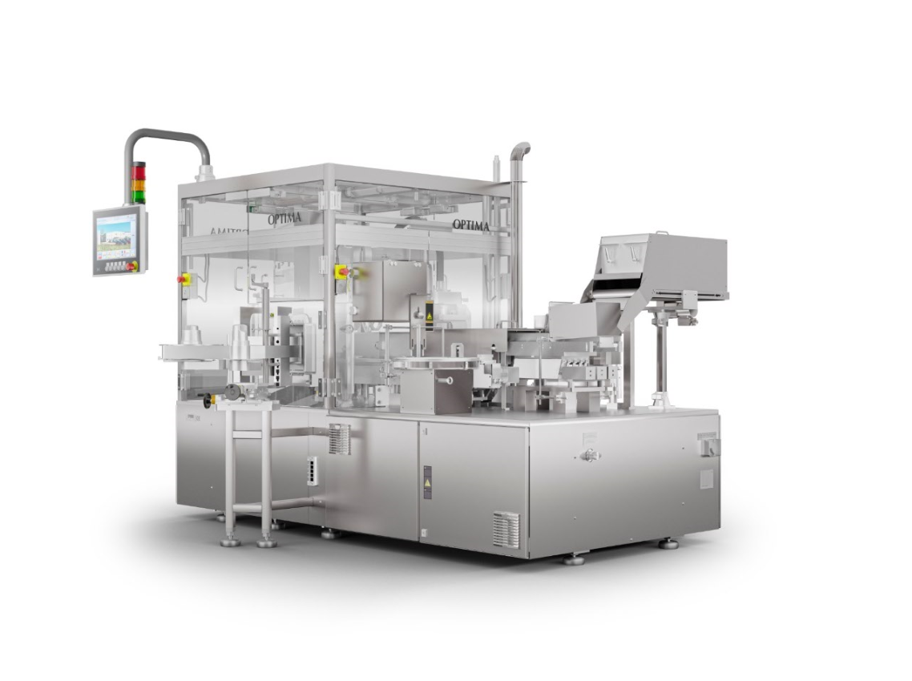
With OPTIMA ImmuFill® reagents for PCR test kits can be filled and closed in vials. (Source: Optima)

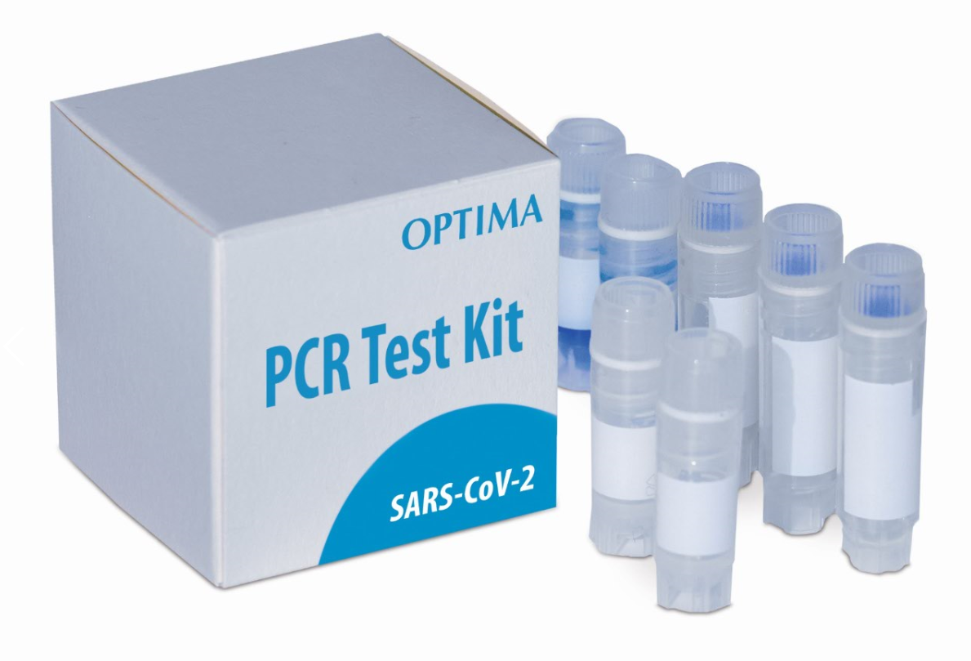
Various diagnostic methods are used to detect coronavirus, including PCR test kits (PCR: polymerase chain reaction). Optima offers suitable filling and closing systems for all diagnostic test kits. (Source: Optima)

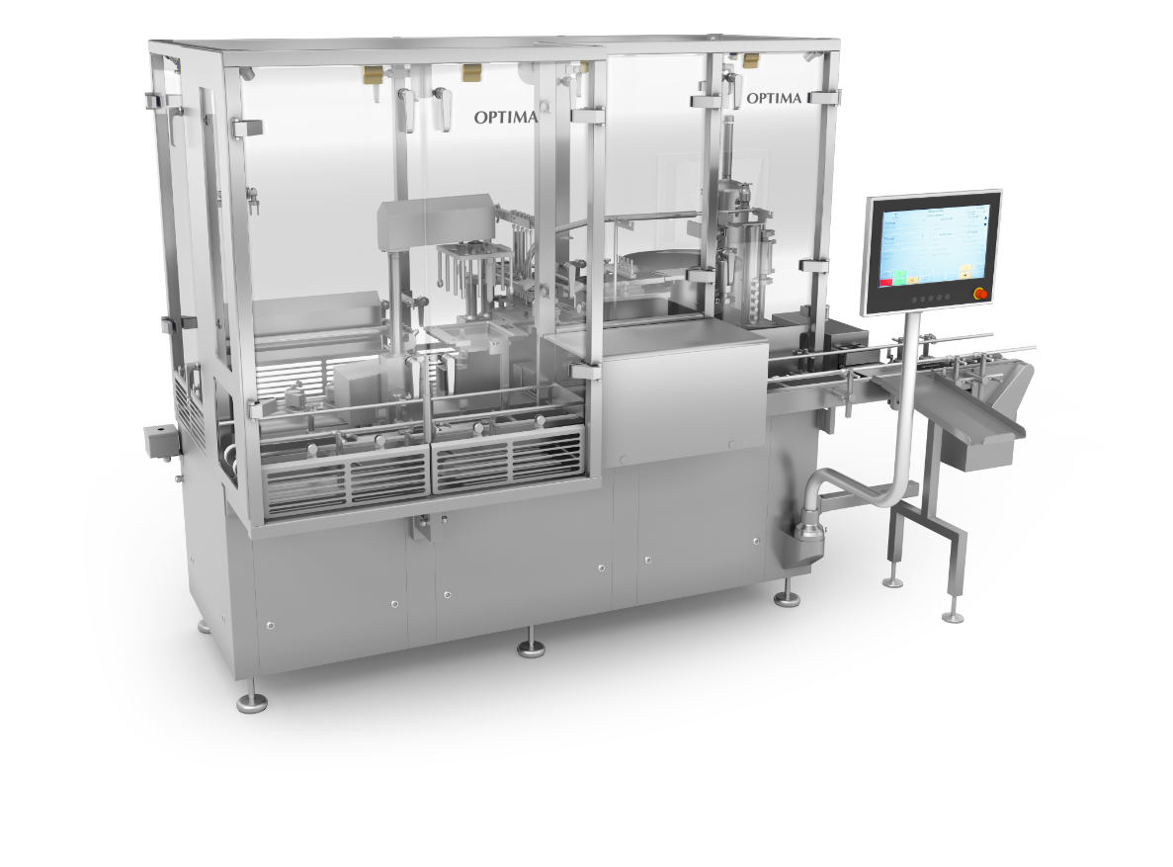
The OPTIMA SV / H filling and closing machine can process three various types of container on one machine. The machine can be used for processing nested pre-filled syringes, vials and cartridges. (Source: Optima)

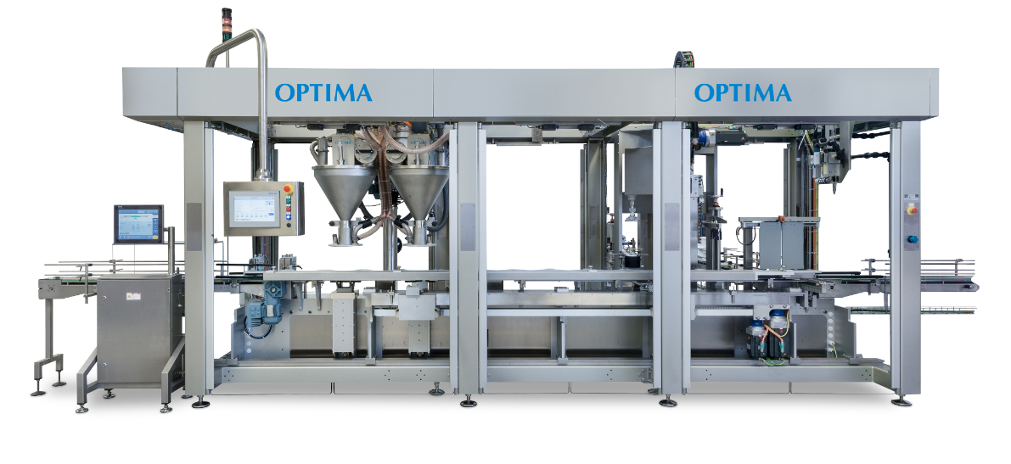
The highly flexible OPTIMA MPS machine solution can help to counteract current shortages and automates the manufacturing of air filters which are used in ventilators. (Source: Optima)

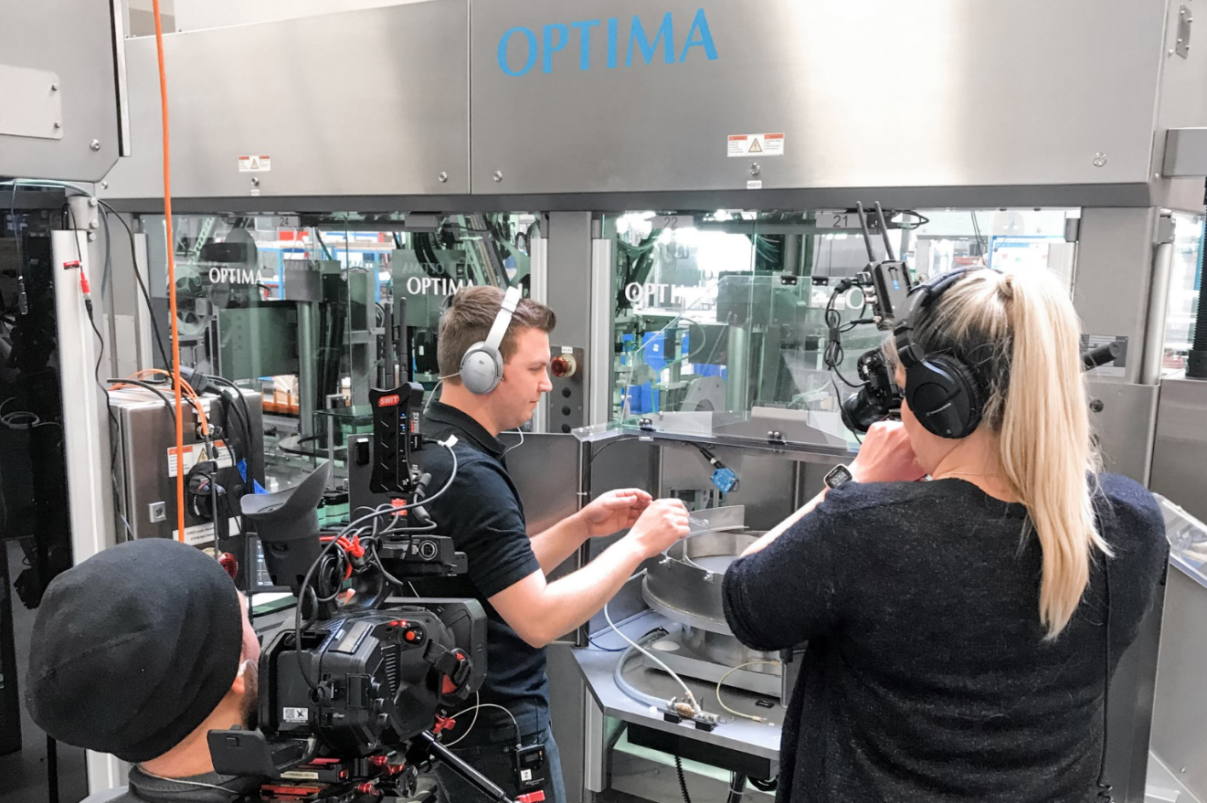
During virtual machine acceptance eleven high tech cameras transmit live images to the customer in the USA. (Source: Optima)

Characters (incl. spaces): 3,435

Press contact:
OPTIMA packaging group GmbH
Jan Deininger
Editor
+49 (0)791 / 506-1472
jan.deininger@optima-packaging.com
www.optima-packaging.com
Thank you very much for your publication. We look forward to receiving a specimen copy.

