PRESS RELEASE
Schwaebisch Hall, November 19, 2019

Coffee capsules, cobots, and factory automation
Looking back – OPTIMA at Host 2019

Optima impressed visitors at Host 2019 with plant automation relating to all aspects of production and packaging of capsule products and with leading capsule filling technologies. For the first time, there was also the opportunity to experience how a cobot inserts capsules in a machine. Compostable materials and aluminum as a capsule material were also topics that were of major interest to the visitors at the trade show booth. Host 2019 took place in Milan in October.
With the OPTIMA CFL1-6, Optima presented the current leading filling technology for coffee powder to visitors live. In conjunction with a universally aroma-optimized treatment of the coffee powder and extremely gentle processing of sensitive aluminum capsules, the result is single-serve packaging of the highest quality. Optima's close collaboration with a network of established capsule and foil manufacturers was also of great interest to visitors.
But the secret star of the trade show was a cobot, which equipped the OPTIMA CFL with capsules. As a suitable addition, Optima presented a line management software, which can expand the evaluation of the process efficiency to entire production lines where necessary. An option for simplified entry into systematized service with adaptable cycles was further presented with a maintenance program also developed by Optima.
The high number of concrete projects discussed during the trade show was also striking. New projects for single-serve packaging were scheduled and existing projects developed further. The open Optima trade show booth concept proved successful once again at Host 2019, inviting visitors to experience the company's high level of coffee expertise.
Visitors at the Optima trade show booth at Host came from all over Europe, in particular Italy, Spain, and Portugal, as well as North and South America, Africa, Asia, and Australia. Due to the positive experience, Optima decided immediately after the trade show that it will be taking part in the next Host too.
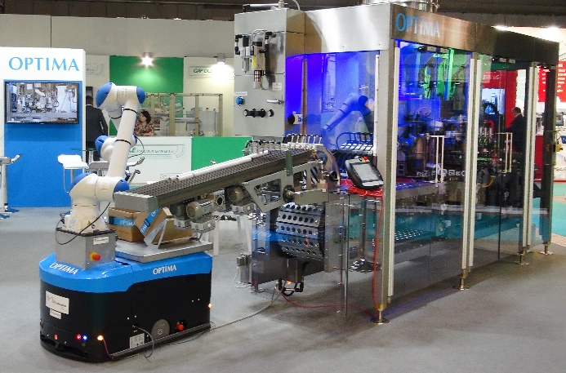
A cobot equipping an OPTIMA CFL1-6 with empty capsules. In combination with its leading dosing and sealing technologies and efficient line management software, entry into the world of comprehensive plant automation runs smoothly.

Characters (incl. spaces): 2,083

Press contact:
OPTIMA packaging group GmbH
Jan Deininger
Editor
+49 (0)791 / 506-1472
jan.deininger@optima-packaging.com
www.optima-packaging.com
Thank you very much for your publication. We look forward to receiving a specimen copy.

