Honey from own bee colonies

LAUDA expands its ecological commitment

Lauda-Königshofen, October 10, 2024 - LAUDA DR. R. WOBSER GMBH & CO. KG established two bee colonies on the company premises last year. The first honey production was completed this summer. During an on-site visit, Dr. Gunther Wobser, President & CEO of the world market leader for precise temperature control, and the company's two hobby beekeepers were impressed by the beehives and the quality and taste of the first honey harvested.

“With the bee colonies, we want to make a contribution to local biodiversity and at the same time raise awareness of the importance of bees,” explains Dr. Wobser of the project. “It is a concrete step in our efforts to assume social responsibility.”

The two bee colonies, tended by LAUDA employees Stephen Bauer and Manuel Faulhaber, produced a total of 20 kilograms of honey in their first season. The mixture of rapeseed and late harvest is offered for sale to the company's employees. The proceeds will be used to cover costs and to purchase another colony in 2025.

Hobby beekeeper Stephen Bauer sees remarkable parallels between temperature regulation in the beehive and LAUDA's core business: “Bees keep the temperature in their hive constant between 34 and 35 degrees Celsius. They achieve this through behaviors such as fanning their wings to cool down or muscle tremors to generate heat. This natural precision is impressive, even if it is fundamentally different from our technical solutions.”

Stephen Bauer gave an overview of the challenges to date. In particular, the phenomenon of premature crystallization of honey in the combs has been a major difficulty in the harvesting process. The natural population dynamics of the bee colonies, especially the process of swarming, was also a new and instructive experience.

LAUDA plans to further expand the bee project in the coming years and establish it as an integral part of the company's commitment to the environment and sustainability. If the harvest is successful, the honey will be used as a delicious gift for LAUDA guests.

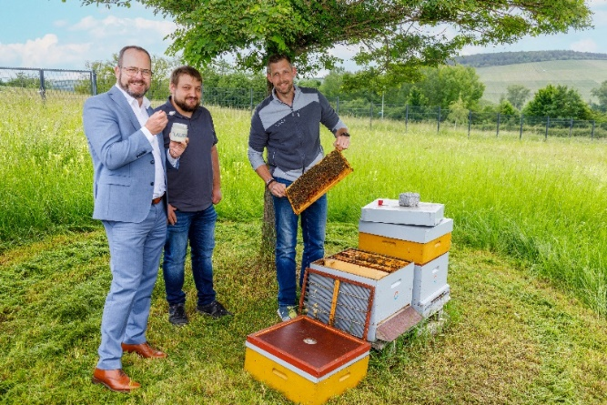  Fig. 1: Dr. Gunther Wobser (left), President & CEO of LAUDA, with hobby beekeepers Manuel Faulhaber (middle) and Stephen Bauer (right) inspecting the beehives. © LAUDA | 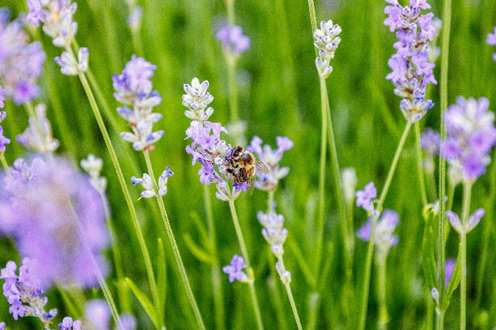  Fig. 2: A busy bee – probably from one of the LAUDA beehives – working on a lavender bush in the entrance area of ​​the company premises. Planting bee-friendly plants supports the ecological commitment of the world market leader. © LAUDA
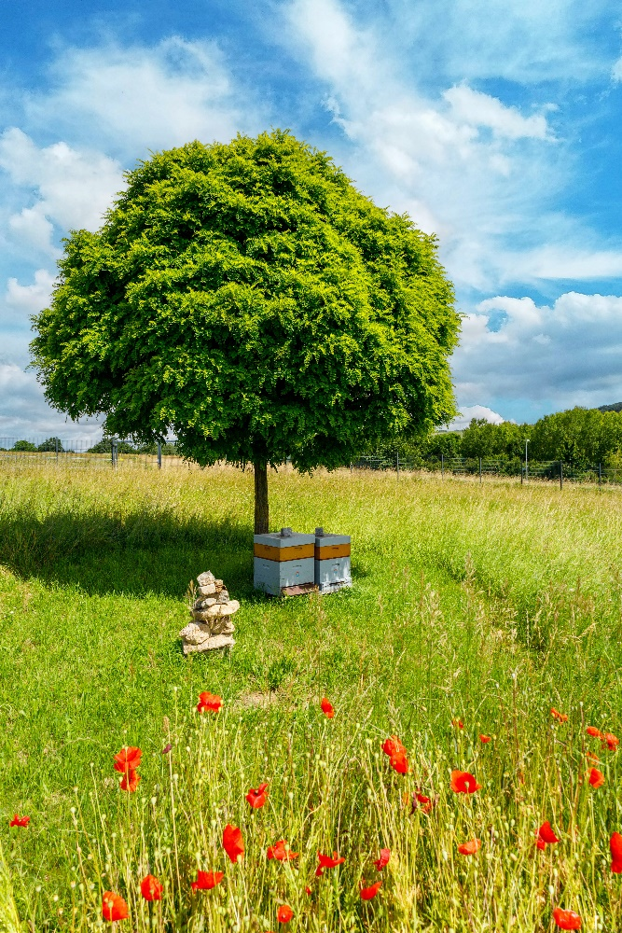
Fig. 3: Natural diversity: The two LAUDA beehives in the shade of a tree, surrounded by a flowering meadow with bright poppies. The bee project promotes biodiversity on the company premises and offers honey bees an ideal environment. © LAUDA

We are LAUDA – the world leader in precise temperature control. Our constant temperature equipment and systems are at the heart of important applications, contributing to a better future. As a complete one-stop supplier, we guarantee the optimum temperature in research, production and quality control. We are the reliable partner for electromobility, hydrogen, chemicals, pharmaceuticals/biotech, semiconductors and medical technology. We have been inspiring our customers for almost 70 years with our expert mentoring and innovative solutions – every day anew and all over the world.

In our company, we always go one step further. We support our employees’ development and are constantly developing ourselves: to create a better future together.

Press contact
We are more than happy to make prepared information about our company, the LAUDA Factory Gallery and our projects in the area of innovation promotion, digitalization and idea management available to the press. We look forward to hearing from you – just give us a call!

CHRISTOPH MUHR
Director Corporate Communications
T + 49 (0) 9343 503-349
christoph.muhr@lauda.de

LAUDA DR. R. WOBSER GMBH & CO. KG, Laudaplatz 1, 97922 Lauda-Königshofen, Deutschland/Germany. Limited partnership: Headquarters Lauda-Königshofen, Registration court Mannheim HRA 560069. General partner: LAUDA DR. R. WOBSER Verwaltungs-GmbH, Headquarters Lauda-Königshofen, Registration court Mannheim HRB 560226. Managing Directors: Dr. Gunther Wobser (President & CEO), Dr. Mario Englert (CFO), Dr. Marc Stricker (COO)

