LAMILUX Composites innovations at transport logistic

Strongest and lightest tank cladding in the world

Numerous specialist companies, including LAMILUX Composites, showcased their services for logistics, transport and freight forwarding at the transport logistic trade fair in Munich between 9 and 12 May. The fibre-reinforced composites manufacturer presented its product innovations that impress in the tank containers segment at its stand in the ITCO Village, alongside numerous leading tank container manufacturers. The lightest and strongest cladding LAMILUX X-treme tank was the undoubted highlight.

LAMILUX Composites exhibited a revolutionary innovation in glass fibre reinforced plastics, its LAMILUX X-treme tank cladding material, at the international trade fair for logistics, mobility, IT and supply chains. Developed and manufactured in Germany, the material is about five times stronger and 30% lighter than other tank cladding materials. LAMILUX X-treme is the gold standard in tank cladding materials. “It's a fibre-reinforced composite with the maximum possible reinforcement fibre content in a highly elastic epoxy resin matrix. Its excellent durability saves operators time and money by reducing container downtimes and maintenance and repair costs,” affirms Product Manager Sascha Oswald.

LAMILUX Composites Sales Manager Oliver Liebsch was also in attendance in Munich: “We truly value personal contact with our customers. Exchanging ideas on an international level about innovations, new fields of application and challenges on the market takes us forward and gives us as a strong partner the opportunity to provide our customers with a comprehensive consultation right from the outset.”

“Some manufacturers, operators and leasing companies already decided to acquire the new LAMILUX X-treme tank cladding during the trade fair and ordered new containers with this tank cladding. The trade fair was a great success for us,” states Oswald, summing up his participation in transport logistic in Munich.

…

www.lamilux.com

About LAMILUX Composites GmbH
LAMILUX Composites GmbH has been producing fibre-reinforced composites for around 70 years. The medium-sized company is a leading European producer thanks to its technologically advanced continuous production process, large manufacturing capacities and wide product range. LAMILUX supplies customers around the globe in a wide range of sectors, such as the building industry, the automotive and recreational vehicle sectors, refrigerated store room and cell construction, and many other industrial sectors. In 2022, LAMILUX and its some 1,300 employees generated a turnover of 392 million euros. The family-managed company is based in Rehau, Bavaria.

Caption
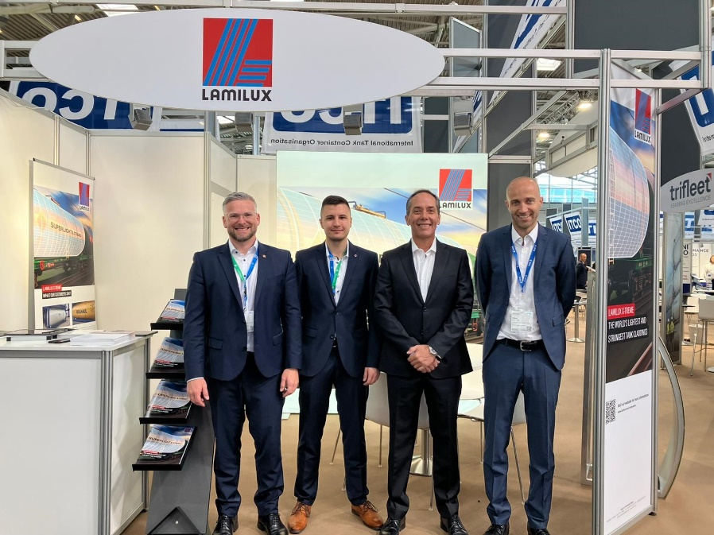
From left to right: Sascha Oswald (Product Manager LAMILUX), Colin Blaschke (New Business Development Sales Force), Jorge Sandoval (Sales Manager Mexico), and Oliver Liebsch (Sales Manager LAMILUX Composites)

