LAMILUX expands its fire-resistant flat roof window to REI 90

LAMILUX Glass Skylight Fire Resistance
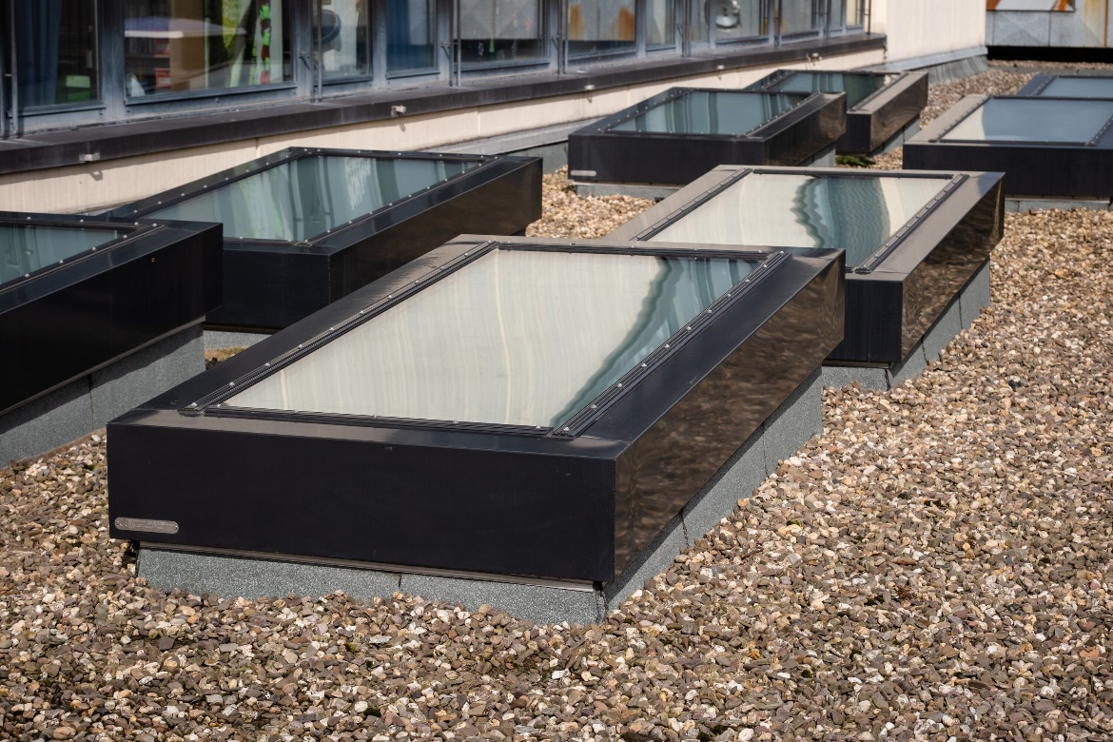
prevents fire spread for 90 minutes

For three years now, LAMILUX has included Skylights from the "Fire Resistance" series in its portfolio, which defy fire and heat for a certain period of time in case of fire and prevent the spread of fire. Now the skylight manufacturer has succeeded in extending this protection even further: The new LAMILUX Glass Skylight Fire Resistance REI 90 provides daylight and prevents flames from spreading to other fire compartments for at least 90 minutes.

Award-winning design of the LAMILUX product innovation
With its reduced design on the inside and filigree cover strips on the outside, the skylight is also visually impressive. The LAMILUX Glass Skylight Fire Resistance REI 90 has already been awarded the "Special Mention" of the German Design Awards in the category "Excellent Product Design - Building and Elements" for the outstanding design 2023.

…

www.lamilux.com

LAMILUX Heinrich Strunz Group, Rehau
Continuous rooflights, glass roofs or rooflights: the LAMILUX Heinrich Strunz Group is one of the leading manufacturers of skylights in Europe. The skylights ensure efficient use of natural daylight in a wide variety of buildings. In addition, special smoke and heat extraction systems provide safety in case of fire and are therefore essential components of fire protection concepts. LAMILUX is also known for its solutions for object smoke extraction. Furthermore, the medium-sized family business founded in 1909 is one of the world's largest producers of carbon and glass fibre reinforced plastics. These composite materials provide stability, lightweight construction and impact resistance for instance in roof, wall and floor linings in commercial vehicles. The company has around 1300 employees at present and has achieved a turnover of around 392 million euros in 2022.

