GEA at SMM 2026: setting a course toward net zero

Düsseldorf (Germany), September 1, 2026 – From September 1 to 4, 2026, Hamburg will once again be a meeting place for the international shipping industry. At SMM 2026, GEA will present solutions for the use of alternative fuels, the treatment of fuel, lubricating oil, and water, as well as digital ship systems in Hall A3, booth 316. One focus will be the new GEA methanol Fuel2Engine system, which was developed in close technical coordination with engine manufacturer Everllence. With this system, GEA will support shipowners and shipyards throughout the integration of the newly developed products into methanol-fueled retrofits and newbuilding projects, ensuring efficient implementation and reliable operation.

Methanol system solution in collaboration with Everllence
The GEA methanol Fuel2Engine System combines the GEA methanol Booster Unit with the GEA methanol Valve Train to form a coordinated system for fuel delivery to methanol-powered ships.
The GEA methanol Booster Unit was developed for use with corresponding methanol engines. In addition, the collaboration with Everllence is an important element of the technical design of the GEA methanol Valve Train, which is based on the official Everllence design package. This approach is intended to maximize safety in product design, reduce interfaces, simplify integration on board with the Everllence engine, and better reflect the requirements of newbuild and retrofit projects.

GEA methanol Booster Unit
The GEA methanol Booster Unit pressurizes methanol to the level required for engine injection and conditions the fuel to the necessary temperature. It is designed for continuous operation under marine conditions and is intended to support a stable fuel supply. The system builds on experience in booster technology and marine fuel handling. Its technical development is aligned with the operating requirements of methanol-powered engines.

GEA methanol Valve Train
The GEA methanol Valve Train serves as the dedicated safety and control interface between the methanol Booster Unit and the engine. It ensures a precise methanol supply tailored to the engine's requirements while meeting high safety standards for maritime applications. The system was developed based on the official Everllence design package, is intended for two-stroke and four-stroke engines and will be DNV-certified. In combination with the GEA methanol Booster Unit, it creates a coordinated fuel supply solution for methanol-powered vessels.

GEA biofuel Separator
In addition to methanol, GEA will present solutions for the use of alternative biofuels. The GEA biofuel Separator is designed for the treatment of different biogenic fuels. The system removes water and solid particles from fuels such as HVO, FAME, SVO, and PPO, helping to ensure more consistent fuel quality. This supports combustion, reduces deposits in the engine, and can have a positive effect on the service life of drive components. The GEA biofuel Separator is equipped with Viton rubber gaskets that can withstand the corrosive and acidic properties of biofuel.. Customized biofuel skid options and biofuel upgrades of existing machines are available on request.

GEA ecomarine Separator
With the ecomarine Separator, GEA offers a compact standard solution for lubricating oil treatment on board. Unlike conventional filtration systems, separator technology reduces the need for replaceable filter elements and therefore lowers purchasing, storage, and disposal costs. At the same time, the continuous and unlimited water removal process helps to keep lubricating oil quality stable for longer, reduce wear, and extend maintenance intervals. Especially for smaller vessels, the separator offers a low-maintenance alternative to conventional filtration and can help reduce total cost of ownership over the life cycle.

GEA bilgEGR Solution
The GEA bilgEGR Solution combines bilge water treatment with the treatment of EGR wash water in a single system. EGR stands for Exhaust Gas Recirculation. In this technology, part of the exhaust gas is recirculated into the engine to lower the combustion temperature and thereby reduce the formation of nitrogen oxides. In marine EGR systems, this process creates contaminated wash water or drain water that must be treated before discharge. The two-in-one approach of the GEA solution can reduce installation effort, space requirements, and equipment costs compared with separate systems.
GEA NOx Separator
The GEA NOx Separator is designed for the treatment of EGR drain water.The system purifies the bleed-off water from the EGR process before discharge into the ocean, removing contaminants generated during exhaust gas recirculation. The GEA NOx Separator supports water treatment in accordance with MEPC.307(73) and, optionally, MEPC.259(68). This enables the use of modern EGR systems for NOx reduction while supporting compliance with applicable maritime environmental regulations.

GEA Grasso compressors
In compression technology, GEA will present Grasso compressors for marine applications. The screw compressors are designed for natural refrigerants and are used, among other applications, in boil-off gas applications, low-pressure systems, and concepts for ammonia and methanol fuels. The systems are also suitable for applications such as onboard carbon capturing. In this way, GEA addresses additional technical building blocks for future vessel concepts.

GEA AWP Components
The portfolio is complemented by GEA AWP Components. These include valves, control components, oil management systems, and fuel supply systems for marine applications. The components support the use of alternative fuels such as methanol and ammonia and can be adapted to different system concepts. Certifications and project-specific engineering are intended to support safe operation in conventional and future marine fuel systems.

GEA marine X Control
GEA marine X Control is the new-generation HMI (Human Machine Interface) platform by GEA for marine systems, combining advanced connectivity, cloud-enabled services, and cyber-secure operation. Built for seamless integration into vessel automation systems and prepared for future AI capabilities, it enables more efficient operation, remote diagnostics, and continuous performance optimization.
Highlights
- AI-ready control architecture
- Cloud connectivity and remote support
- Easy integration into ship automation systems
- IEC 62443-4-1 cybersecurity compliant
- Standardized GEA Codex® operator interface
- OPC-UA MTP ready

Digitalization as an additional focus
In addition to hardware solutions, GEA focuses on the digital integration of its systems into modern ship management and automation environments. OPC stands for Open Platform Communications and refers to a standardized communication approach for data exchange between machines, sensors, controllers, and higher-level IT or ship management systems. OPC-based data communication can provide process data such as temperatures, pressures, flow rates, operating states, and alarm messages in real time. This creates a basis for process monitoring, predictive maintenance, and more efficient onboard operations.

SMM 2026
- Date: September 1–4, 2026
- Location: Hamburg, Germany
- GEA booth: Hall A3, booth 316

Photo:

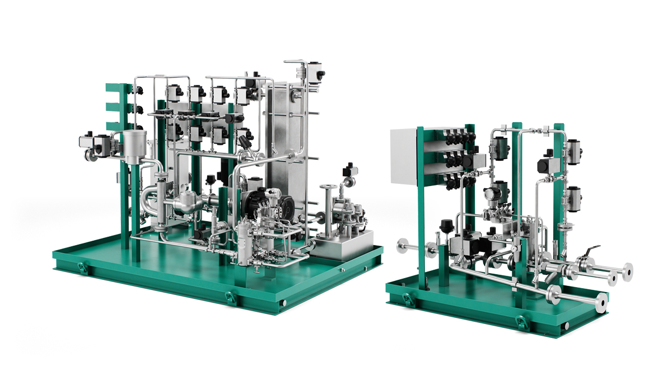
Photo 1, caption: GEA methanol Fuel2Engine System: Integrated solution combining the Booster Unit and Valve Train for safe and reliable methanol fuel supply – from fuel conditioning to engine injection. (Photo: GEA)

NOTES TO EDITORS
- Further information about GEA
- To the GEA Media Library
- Features on current topics
- Overview press events
- Follow GEA on

About GEA
GEA is one of the world’s largest suppliers of systems and components to the food, beverage and pharmaceutical industries. The international technology group, founded in 1881, focuses on machinery and plants, as well as advanced process technology, components and comprehensive services. For instance, every second pharma separator for essential healthcare products such as vaccines or novel biopharmaceuticals is produced by GEA. In food, every fourth package of pasta or every third chicken nugget are processed with GEA technology.

With more than 18,000 employees, the group generated revenues of about EUR 5.5 billion in more than 150 countries in fiscal year 2025. GEA plants, processes, components and services enhance the efficiency and sustainability of customers’ production. They contribute significantly to the reduction of CO2 emissions, plastic usage and food waste. In doing so, GEA makes a key contribution toward a sustainable future, in line with the company’s purpose: “Engineering for a better world.”

GEA is listed on the DAX, the STOXX® Europe 600 Index and is also a constituent of the leading sustainability indices DAX 50 ESG, MSCI Global Sustainability and Dow Jones Best-in-Class World.

More information can be found online at gea.com.
If you do not want to receive any further information from GEA, please send an e-mail to pr@gea.com.

Media Relations
GEA Group Aktiengesellschaft
Dr. Michael Golek
Ulmenstraße 99, 40476 Düsseldorf, Germany
Phone +49 211 9136-1505
michael.golek@gea.com

