GEA supplies key components for water treatment solution at Lignatherm wood fiber insulation plant

Duesseldorf (Germany), May 26, 2025 – GEA, a leading global provider of process technology and sustainable industrial solutions, is supporting Lignatherm AG in Küssnacht, Switzerland, with the supply of key components for a customized, three-stage water treatment solution at its new wood fiber insulation board factory in Küssnacht. Lignatherm's goal is to produce wood fiber insulation boards with the lowest possible environmental impact. The new plant is scheduled for completion in fall 2025 and will process around 50,000 tons of wood chips per year into high-performance, resource-saving insulation boards.

A breakthrough in water-saving production – a three-stage process

At the heart of the plant is GEA's customized water treatment process, which is applied at three different critical points in the production process to ensure that more than 95 percent of the wastewater can be reused as steam – which also reduces the demand for fresh water by over 95 percent. The three-stage process is as follows. The first stage involves mechanical separation using GEA decanter centrifuges. Here, suspended solids are effectively removed from the wastewater stream. The second stage is thermal separation using a falling film evaporator. Here, the dissolved solids are concentrated for later disposal, while clear condensate is produced for feeding into the third stage. This stage is particularly resource-efficient thanks to the mechanical vapor compression (MVR) system, which operates the evaporator without fossil fuels at maximum energy efficiency. This system achieves a coefficient of performance (COP) of more than 25. This is at least five times higher than other heating options such as heat pumps or gas boilers. The third stage consists of a GEA steam reformer. This stage ensures complete recirculation of the water recycling system by collecting the wastewater in a loop where it is converted into process steam, so that no steam needs to be generated otherwise.

By drastically reducing fresh water consumption and minimizing wastewater discharge, the solution sets a new benchmark for sustainability in the wood processing industry. "Our innovative three-stage process not only meets Lignatherm's ambitious environmental goals, it exceeds them. It shows what is possible when technology and sustainability go hand in hand," said Roland Moser, Evaporation Sales & Process Manager at GEA.

A model for collaboration with industry

The success of this project is the result of a close partnership between GEA and Lignatherm, underpinned by open communication and shared values. “From day one, GEA's expert advice and cooperative approach helped us develop a solution tailored to our demanding standards,” said Tobias Osterwalder, Head of Processing and Managing Director at Lignatherm. “Together, we are proving that sustainable production and responsible environmental management can drive industrial innovation.”

Setting new standards for water protection

GEA's three-stage water treatment system benefits from the company's centuries of experience in thermal separation and chemical processing. The solution is specifically tailored to the unique challenges of wood fiber production and ensures maximum water savings and energy efficiency – even with seasonal fluctuations in raw material properties.
“Thanks to the synergy between our technologies and Lignatherm's commitment to sustainability, this project not only achieves its goals but also raises the bar for water protection and resource efficiency in the industry,” said Rafael Piña, Project Manager Evaporation at GEA.

Photos:

Photo 1:

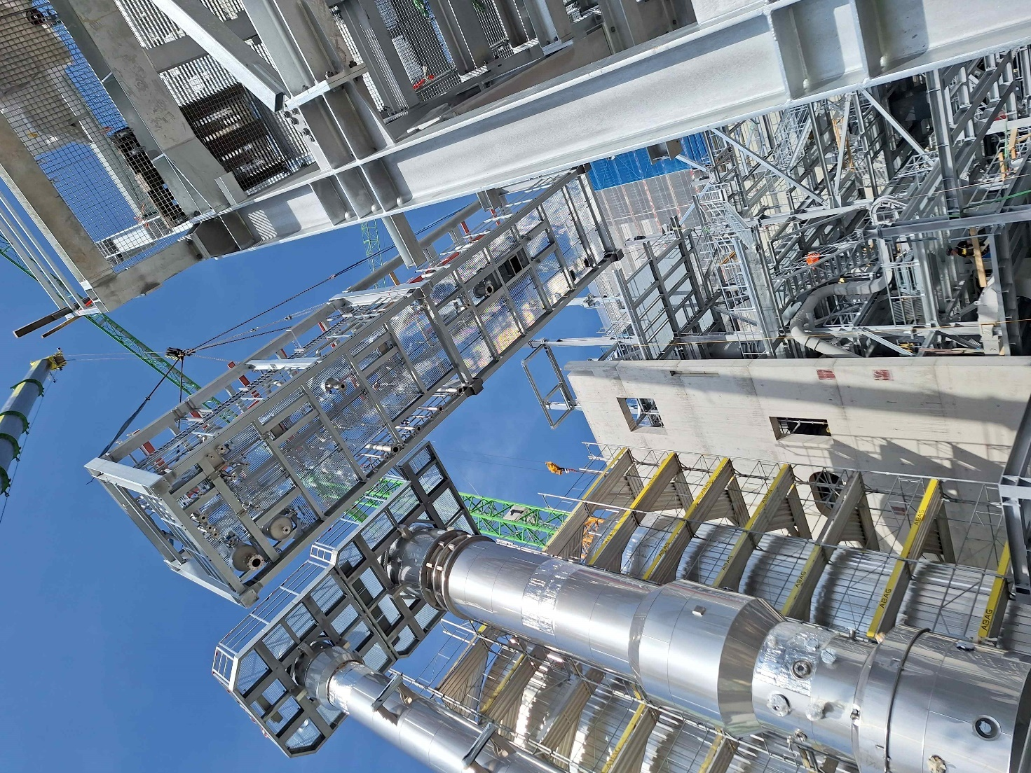

Photo 1, caption: GEA is supplying key components for a customized, three-stage water treatment solution at Lignatherm AG's new wood fiber insulation board factory in Küssnacht. (Photo: GEA)

Photo 2:

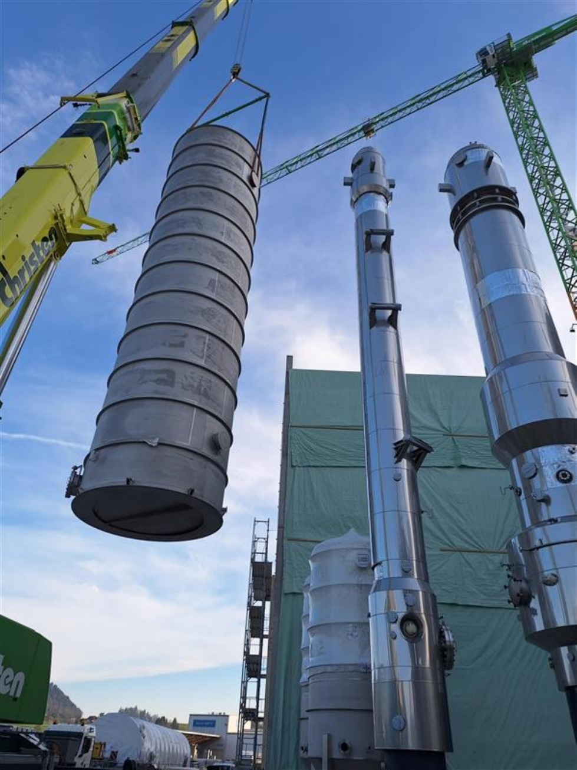

Photo 2, caption: At the heart of the plant is GEA's customized water treatment process, which is applied at three different critical points in the production process to ensure that more than 95 percent of the wastewater can be reused as steam – reducing the demand for fresh water by over 95 percent as well. (Photo: GEA)

Lignatherm AG
Lignatherm AG, a subsidiary of Schilliger Holz AG, is spearheading the revival of Swiss wood fiber insulation board production with its new state-of-the-art facility in Küssnacht am Rigi. Founded recently in 2023, Lignatherm is committed to producing eco-friendly insulation boards made exclusively from locally sourced wood chips, processing around 50,000 tons annually. The company integrates sustainable practices and advanced technology to minimize environmental impact, aiming to close a significant gap in the Swiss wood processing chain. Lignatherm’s products primarily serve the construction and packaging industries across Switzerland, France, and Italy, reinforcing its role in promoting resource-efficient, Swiss-made building materials under the “Lignatherm” brand.

About GEA
GEA is one of the world’s largest suppliers of systems and components to the food, beverage and pharmaceutical industries. The international technology group, founded in 1881, focuses on machinery and plants, as well as advanced process technology, components and comprehensive services. For instance, every second pharma separator for essential healthcare products such as vaccines or novel biopharmaceuticals is produced by GEA. In food, every fourth package of pasta or every third chicken nugget are processed with GEA technology. With more than 18,000 employees, the Group generated revenues of about EUR 5.4 billion in more than 150 countries in the 2024 fiscal year. GEA plants, processes, components and services enhance the efficiency and sustainability of customers’ production. They contribute significantly to the reduction of CO2 emissions, plastic usage and food waste. In doing so, GEA makes a key contribution toward a sustainable future, in line with the company’s purpose: ”Engineering for a better world.”

GEA is listed on the German MDAX, the European STOXX® Europe 600 Index and is also a constituent of the leading sustainability indices DAX 50 ESG, MSCI Global Sustainability and Dow Jones Best-in-Class World.

More information can be found online at gea.com.
If you do not wish to receive any further information from GEA, please send an e-mail to pr@gea.com.

NOTE TO EDITORS

- Further information about GEA
- To the GEA Press page
- To the GEA Media Center
- Background information on current topics can be found at Features
- Follow GEA on  

GEA
Media Relations GEA
Dr. Michael Golek
Peter-Müller-Str. 12, 40468 Düsseldorf
Phone +49 211 91361505
Tel. +491736205746
michael.golek@gea.com

