PRESS RELEASE
Schwäbisch Hall, July 20, 2020

For pen injectors: highly flexible assembly with an entry-level solution
The new machine platform OPTIMA FPA

Pen injectors consist of several components, which the OPTIMA FPA can assemble either fully or semi-automatically. The semi-automatic machine version is adaptable in terms of both performance and functions. It is particularly suitable for entering into this market segment.
A central, unique feature of this compact machine platform is the flexible mounting of pen components by gluing or clicking into place. Either of the functions is required, depending on the type of pen and the OPTIMA FPA is ready for both. The machine includes the appropriate processing stations and is versatile without having to change formats.
The machine also offers a priming function. This means that the patient using the pen has the added security of automatically administering a correct dose of the active pharmaceutical ingredient from the first dose onwards and does not have to do any manual priming.
Comprehensive inspection systems for high product quality
Another new feature of the OPTIMA FPA is the option of adding a printer combined with 360° labeling. This means that customer-specific printing and labeling can be incorporated and individually positioned. The printing and pharmacode is checked by a camera system using OCR software. Additional in process controls such as force-displacement measurement and other sensor technology ensures that the entire process meets the highest safety and quality requirements such as the FDA requirements 21 CFR Part 11 and GAMP 5.
The OPTIMA FPA is designed as a machine platform and is customizable for pen systems that are made by different manufacturers. These are constructed in a similar way, but still require individual adaptations to the machine and by its software.
Individually adaptable
Customer-specific requirements and functions are implemented using the machine platform. This can include various specific functions that can be integrated immediately or subsequently. In particular, the machine operator has the freedom to expand what was initially a semi-automatic process into a fully automatic process.

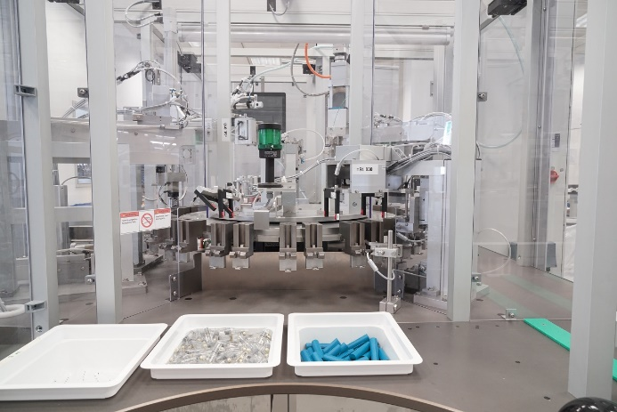
After the components have been manually inserted, the automated assembly process starts. The machine design can subsequently be adapted to be fully automated. (Source: Optima)

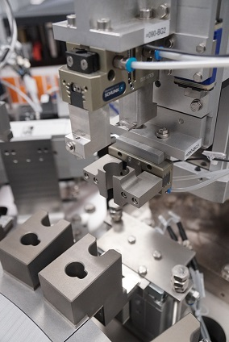
All processing stations are integrated on the rotary transfer machine. The dosing mechanism of the pen is pressed in at this station. (Source: Optima)

Characters (including spaces): 2,162

Press contact:
OPTIMA packaging group GmbH
Jan Deininger
Editor
+49 (0)791 / 506-1472
jan.deininger@optima-packaging.com
www.optima-packaging.com
Thank you for publishing this information. We would be pleased to receive a file copy.

