PRESS RELEASE
Schwaebisch Hall, October 24, 2019

New applications, new trends
Looking back – OPTIMA at Pack Expo 2019

The 2019 Pack Expo show illustrated a strong growth and interest in turnkey concepts. The demand for these products is strong in the pharmaceutical industry; however, the demand is also increasing in the food, cosmetics, and chemicals sectors. Other important topics for the Pack Expo show were sustainability, digitalization, and new applications where Optima presented innovative solutions.
At the 2019 Pack Expo show, Optima presented a selection of its comprehensive range of services, from classic filling technologies for liquids to turnkey solutions and Optima’s integrated life cycle management program, OPTIMA Total Care, which also integrates digital Smart Services. There was great interest from visitors on the versatility of the filling and packaging processes. Visitors also learned about the latest applications of robot systems, their uses in aseptic processes, and other solutions for flexible production.
Turnkey solutions and flexibility are in demand
Optima's expertise in turnkey solutions received a very positive response, not just from the pharmaceutical industry. An increasing number of food, cosmetics, and chemical companies are also realizing the advantages of comprehensive solutions featuring centrally managed machine interfaces that have been coordinated in advance.
Sustainability and digitalization are becoming more important.
Other trending issues included sustainability issues around packaging and appropriate processing technology. The digitization of packaging processes also emerged as another area of focus. Optima is leading the digitalization of packaging machine construction with numerous innovations. Optima impressed visitors with digital services including line management software. There was also a high demand for solutions for new products such as (legal) cannabis and product innovations that have not been launched in the market yet.
More visitors
The 2019 Pack Expo show in Las Vegas proved to be an important industry event from Optima's point of view. They noted a significant increase in the overall number of visitors compared to previous years and many concrete inquiries about projects. All of Optima’s divisions were able to benefit from this.

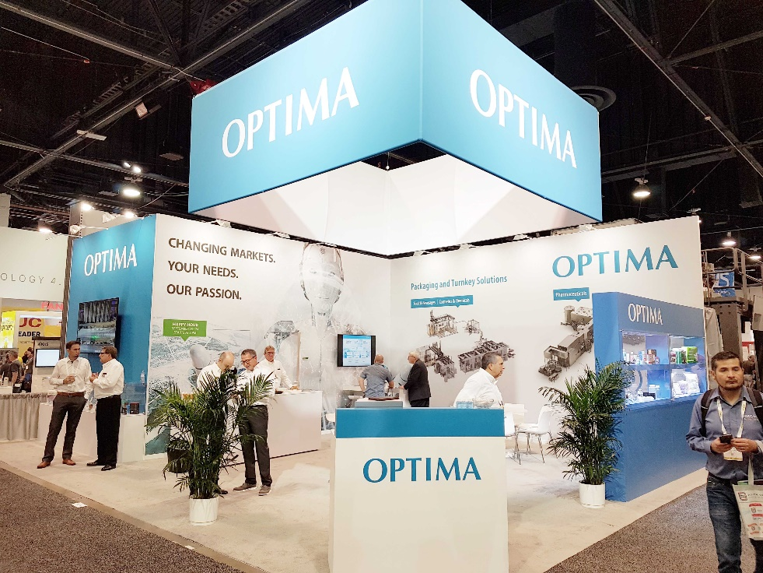
Optima presented a comprehensive range of services at the Pack Expo show in Las Vegas. Visitors were enthusiastic about the latest solutions for flexible production, greater sustainability and turnkey projects.

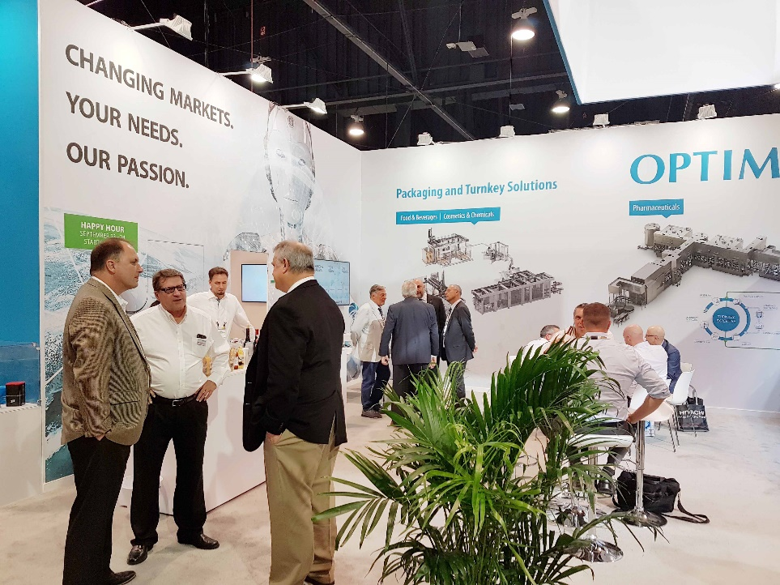
More visitors than in previous years and many discussions about specific projects. Optima was very satisfied with the 2019 Pack Expo Las Vegas show.

Characters (incl. spaces): 2,272

Press contact:
OPTIMA packaging group GmbH
Jan Deininger
Editor
+49 (0)791 / 506-1472
jan.deininger@optima-packaging.com
www.optima-packaging.com
Thank you very much for your publication. We look forward to receiving a specimen copy.

