Norbert Hönninger celebrates 40 years with LAUDA

Reliable Work Honored

Lauda-Königshofen, June 18, 2025 – LAUDA DR. R. WOBSER GMBH & CO. KG honored Norbert Hönninger for his impressive 40-year anniversary with the company. During a ceremony, the managing directors, the management team, the works council, and the mayor of Lauda-Königshofen honored the extraordinary performance of the long-serving employee, who has helped shape the company for four decades.
Norbert Hönninger began his career at LAUDA on June 1, 1985, where he initially worked in the pre-assembly of customer-specific refrigerated thermostats. Following a period of refrigeration pre-assembly, he transitioned to operational logistics in November 1987, where he remained for over 35 years. From 1986 to 1989, he attended the master school for mechanical engineering and toolmaking while working. In his role as production controller, he was responsible for the creation and optimization of production plans and the comprehensive management of production orders. Particularly during the coronavirus pandemic, he mastered the demanding challenge of parts supply with great commitment.
In his laudatory speech, Dr. Gunther Wobser, President & CEO of LAUDA, paid tribute to the special achievements of the jubilarian: “Norbert Hönninger has shaped LAUDA for over four decades with his thoughtful approach and foresight. We celebrate his anniversary, which demonstrates the value of long-term employees to our family business. His continuous development and commitment make him a role model.” Dr. Wobser presented Hönninger with the LAUDA Certificate of Honor and the Certificate of Honor from the Chamber of Industry and Commerce.
Dr. Lukas Braun, Mayor of the town of Lauda-Königshofen, emphasized the social significance of such work and life achievements and praised the anniversary as a sign of reliability. He emphasized that mutual trust between employers and employees is particularly important in difficult times. Norbert Hönninger had radiated stability and professional competence for over four decades and embodied the loyal core staff that was invaluable then as now. Dr. Braun conveyed his congratulations and the certificate of honor from the Minister President of Baden-Württemberg, Winfried Kretschmann.
Christoph Baumann, Director Global Production, emphasized the lasting impact of the jubilarian on the company: “Norbert Hönninger has achieved an impressive performance and played a decisive role in shaping LAUDA. He has always acted with composure and forward thinking and has been a central pillar for many years.”
Works Council Chairman Elmar Mohr referred to the significant social events of 1985 and paid tribute to the employee's continuous development from his beginnings at the production control station throughout his entire career. Mohr emphasized Norbert Hönninger's prudent approach and structured way of working and conveyed the greetings of IG Metall and the entire workforce.
Since November 1, 2024, the jubilarian has been in the release phase of partial retirement. The passionate fisherman and hiker will officially retire on October 31, 2026, at which point he will have more time for his hobbies.

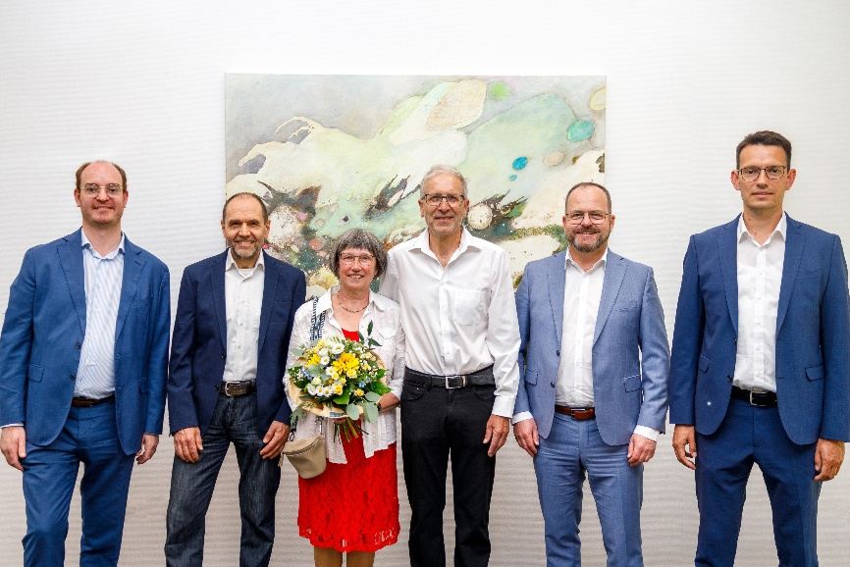

Picture: Dr. Gunther Wobser (2nd from right), CEO & President of LAUDA, honored Norbert Hönninger (center) for 40 years of service. Further congratulations and greetings were offered by (from left to right): Dr. Lukas Braun (Mayor of the town of Lauda-Königshofen), Works Council Chairman Elmar Mohr and Christoph Baumann (Director Global Production). © LAUDA

We are LAUDA – the world leader in precise temperature control. Our constant temperature equipment and systems are at the heart of important applications, contributing to a better future. As a complete one-stop supplier, we guarantee the optimum temperature in research, production and quality control. We are the reliable partner for electromobility, hydrogen, chemicals, pharmaceuticals/biotech, semiconductors and medical technology. We have been inspiring our customers for almost 70 years with our expert mentoring and innovative solutions – every day anew and all over the world.

In our company, we always go one step further. We support our employees’ development and are constantly developing ourselves: to create a better future together.

Press contact
We are more than happy to make prepared information about our company, the LAUDA Factory Gallery and our projects in the area of innovation promotion, digitalization and idea management available to the press. We look forward to hearing from you – just give us a call!

CHRISTOPH MUHR
Director Corporate Communications
T + 49 (0) 9343 503-349
christoph.muhr@lauda.de

LAUDA DR. R. WOBSER GMBH & CO. KG, Laudaplatz 1, 97922 Lauda-Königshofen, Deutschland/Germany. Limited partnership: Headquarters Lauda-Königshofen, Registration court Mannheim HRA 560069. General partner: LAUDA DR. R. WOBSER Verwaltungs-GmbH, Headquarters Lauda-Königshofen, Registration court Mannheim HRB 560226. Managing Directors: Dr. Gunther Wobser (President & CEO), Dr. Mario Englert (CFO), Dr. Marc Stricker (COO)

