At the Forefront of Sustainability

LAUDA earns silver medal from EcoVadis

Lauda-Königshofen, July 21, 2025 – LAUDA DR. R. WOBSER GMBH & CO. KG, the world's leading manufacturer of temperature control units and systems, has been awarded the silver medal by EcoVadis. With a score of 70 out of a possible 100 points, LAUDA ranks among the top 15 percent of all companies worldwide and thus underscores its commitment to sustainable business practices.

EcoVadis is considered the global market leader in sustainability ratings. The organization evaluates companies based on 21 detailed sustainability criteria covering four key areas: Environment, Labor and Human Rights, Ethics, and Sustainable Procurement. To date, more than 85,000 companies worldwide have undergone the rigorous EcoVadis assessment process, which is based on international standards, including the ten principles of the UN Global Compact, International Labor Organization conventions, and the ISO 26000 standard.

LAUDA receives this award in recognition of its comprehensive sustainability management efforts and strategic sustainability initiatives. “This recognition confirms our long-standing conviction that sustainable business practices and entrepreneurial success go hand in hand,” emphasizes Dr. Gunther Wobser, President & CEO of LAUDA. “Receiving the EcoVadis Silver Medal is an important milestone in our journey to becoming a more sustainable company.”

A key component of this success was the publication of the 2023 sustainability report, which was released at the end of 2024. This transparent reporting allowed LAUDA to document and demonstrate the quality and scope of its sustainability activities to EcoVadis. “The systematic documentation of ESG activities in our first sustainability report was a decisive factor in this assessment,” explains Dr. Marc Stricker, Managing Director of LAUDA and responsible for quality and environmental management. “We demonstrated to EcoVadis that we implement concrete actions that we measure and communicate transparently.”
The improvement in the EcoVadis rating was made possible by several measures that LAUDA systematically implemented. The company developed more detailed sustainability policies and significantly expanded the collection and publication of key figures relevant to EcoVadis. For the first time, the company published comprehensive reports on environmental and social aspects. In addition, a CSRD report was prepared in accordance with the new European reporting standards. This systematic approach enabled LAUDA to optimize its internal processes and significantly increase its external transparency.

“We are particularly proud that the more detailed specifications from LAUDA and the extended recording of key figures have led to measurable improvements”, adds Dr. Stricker. “This demonstrates the efficacy of our comprehensive approach to sustainability management and validates our strategic direction.”

For the future, LAUDA plans to make targeted use of the insights gained from the EcoVadis assessment process in customer discussions. The family-owned company will further refine its sustainability strategy and continue its ESG reporting.

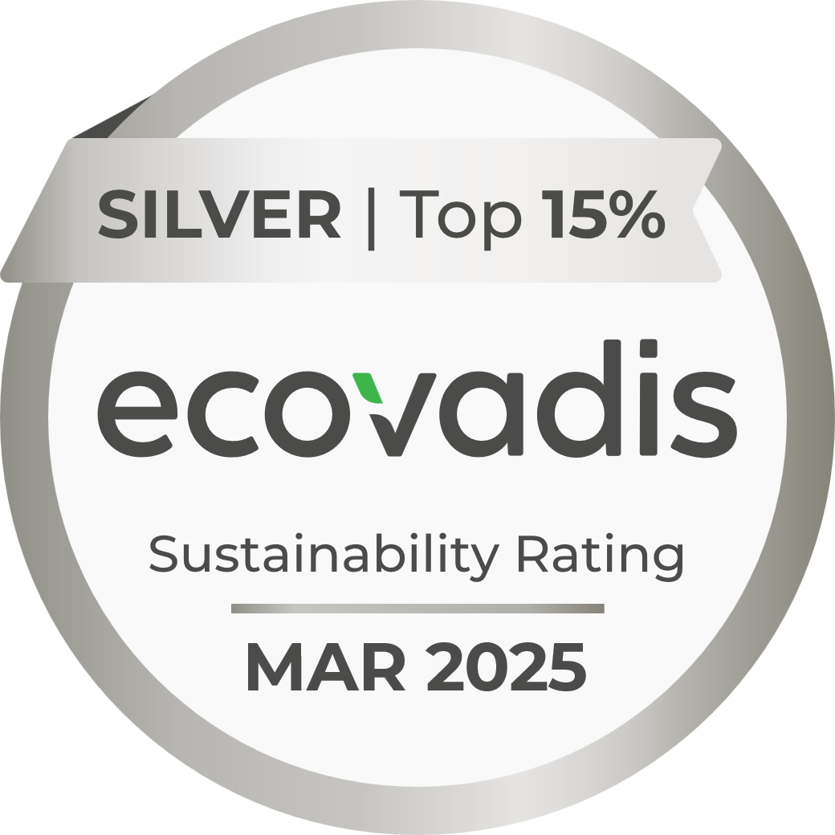  Picture 1: LAUDA received the EcoVadis Silver Medal in March 2025, placing it among the top 15 percent of all companies worldwide assessed in the field of sustainability. © LAUDA | 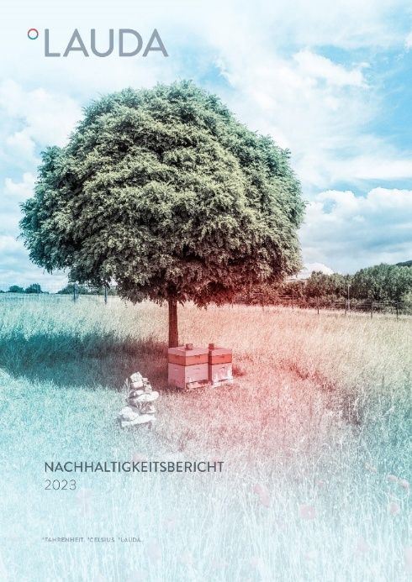  Picture 2: The first sustainability report, published in 2023, was a key factor for LAUDA in the successful EcoVadis assessment and documents the company's systematic sustainability initiatives. © LAUDA

We are LAUDA – the world leader in precise temperature control. Our constant temperature equipment and systems are at the heart of important applications, contributing to a better future. As a complete one-stop supplier, we guarantee the optimum temperature in research, production and quality control. We are the reliable partner for electromobility, hydrogen, chemicals, pharmaceuticals/biotech, semiconductors and medical technology. We have been inspiring our customers for almost 70 years with our expert mentoring and innovative solutions – every day anew and all over the world.

In our company, we always go one step further. We support our employees’ development and are constantly developing ourselves: to create a better future together.

Press contact
We are more than happy to make prepared information about our company, the LAUDA Factory Gallery and our projects in the area of innovation promotion, digitalization and idea management available to the press. We look forward to hearing from you – just give us a call!

CHRISTOPH MUHR
Director Corporate Communications
T + 49 (0) 9343 503-349
christoph.muhr@lauda.de

LAUDA DR. R. WOBSER GMBH & CO. KG, Laudaplatz 1, 97922 Lauda-Königshofen, Deutschland/Germany. Limited partnership: Headquarters Lauda-Königshofen, Registration court Mannheim HRA 560069. General partner: LAUDA DR. R. WOBSER Verwaltungs-GmbH, Headquarters Lauda-Königshofen, Registration court Mannheim HRB 560226. Managing Directors: Dr. Gunther Wobser (President & CEO), Dr. Mario Englert (CFO), Dr. Marc Stricker (COO)

