PRESS RELEASE
Schwaebisch Hall, August 16, 2018

Pack Expo 2018

Dynamic markets, individual requirements, passionate solutions
Changing Markets. Your Needs. Our Passion. This is the motto under which Optima will be presenting itself at the Pack Expo trade show in Chicago. Markets are reacting increasingly dynamically. Growing cost pressure, shorter and shorter time-to-market, increasingly complex packaging processes and digitalization are the challenges faced by the industry. At Pack Expo, the experts from Optima will be presenting flexible solutions for the individual needs of their customers.

Reacting flexibly to new market trends

Word of new product trends spreads faster than ever before. And these trends have worldwide effects. Globally networked influencers, bloggers and YouTubers can send the demand for specific product groups skyrocketing. Trends arising at one point on the globe influence production facilities that may be hundreds of kilometers away. Orders flood in from all over the world, putting increasing pressure on producers. But what if the manufacturer’s filling and packaging machines are not up to the task? At Pack Expo, Optima will be presenting flexible, modular system concepts to solve this problem.

Shorter decontamination times with the STISO

A sterility test isolator from Metall+Plastic sets new benchmarks in isolator technology. The STISO on show at Pack Expo is used for both aseptic and aseptic-toxic applications. Its advantages include a well thought-out operating ergonomics concept, full flexibility thanks to its modular design, quick commissioning and a glove testing system integrated into the HMI. With catalytic ventilation and the DECOjet® process, the STISO achieves particularly short cycle times during decontamination. Moreover, through the use of H₂O₂ flash evaporation, the STISO is extremely low-maintenance.

Solutions for particularly high-grade lyophilisate

In addition, the Pharma division will be presenting new and faster freeze-drying process options that at the same time result in particularly high-quality lyophilisate. At the trade show, Optima will also be showing how filling and sealing, freeze-drying processes and the latest isolator technology can be optimally integrated as well as introducing the latest solutions for small batches.

New alliance simplifies the small-scale manufacturing and packaging of transdermal patches and oral film strips

Optima Life Science has a strong reputation as a converting specialist across a number of industries. As well as combined manufacturing and packaging machines for wound dressings, transdermal patches, and oral film strips, the company makes systems that automatically coat microtiter plates for use in ELISA test kits. At ACHEMA 2018 the company announced a new alliance with Coatema Machinery GmbH. The alliance, which is known as Comedco, will make it easier for pharmaceutical companies to move into manufacturing and packaging transdermal patches and oral dispersable films with pharmaceutical active ingredients.

A new service level: Total Care

Optima is focusing its services on a new level: Total Care services from Optima support production efficiency optimally in each phase of the plant life cycle. The Total Care program contains digital products: With TCAM from Optima, a tool is available that uses sensors to analyze the condition of packaging systems and provide advanced notice of the need for maintenance while also accelerating the flow of information. Material such as videos, information on components, operating manuals, circuit diagrams and much more is available directly at the systems via mixed-reality glasses. At Pack Expo, Optima will be using TCAM to process a simulated service case live. With OPAL, the line management system from Optima, key figures such as OEE can be calculated, thus pinpointing potential for optimization in the packaging process. Moreover, OPAL can be used to control entire lines. OPAL is suitable for machines from all manufacturers and will also be on view at Pack Expo.

Optima will also be presenting current turnkey projects and technologies that demonstrate the modularity and flexibility of the latest Optima machine generation. Contact partners will be on hand for the Consumer, Pharma, Life Science and Nonwovens industry.

Optima at Pack Expo 2018 in Chicago,
14-17 October 2018: Stand N-6113

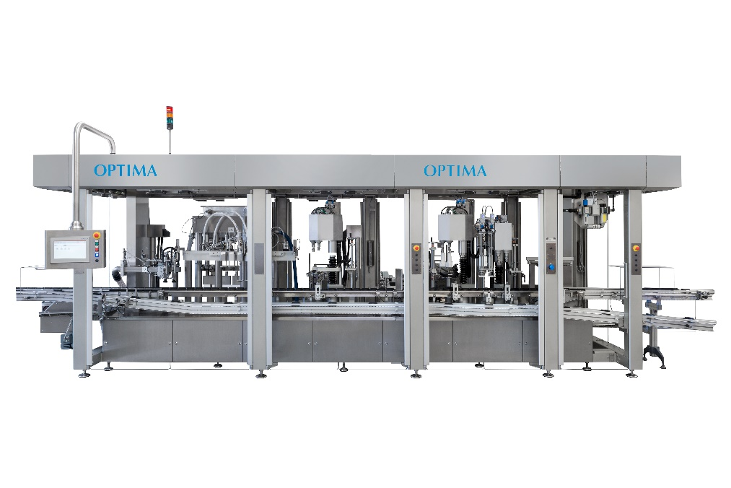
Flexible system concepts from Optima that allow the user to react quickly to new market trends.

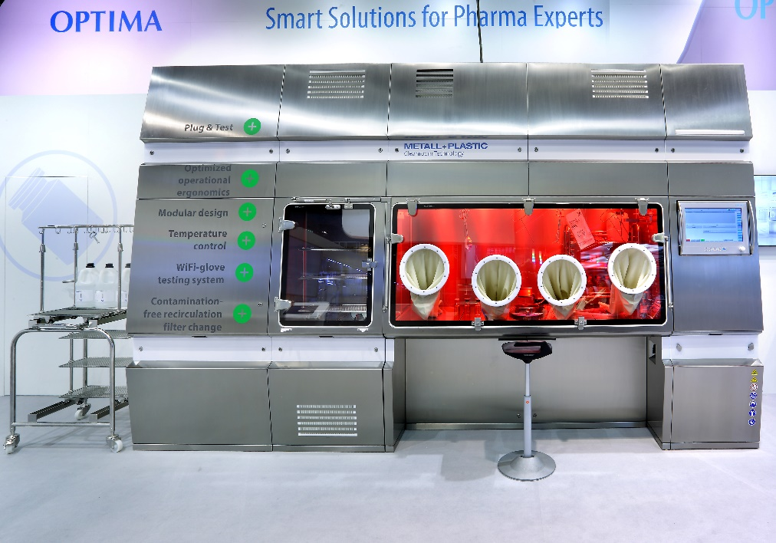
One of the numerous new features of the STISO is its modular design. This means it can be individually adapted to the needs of the user.

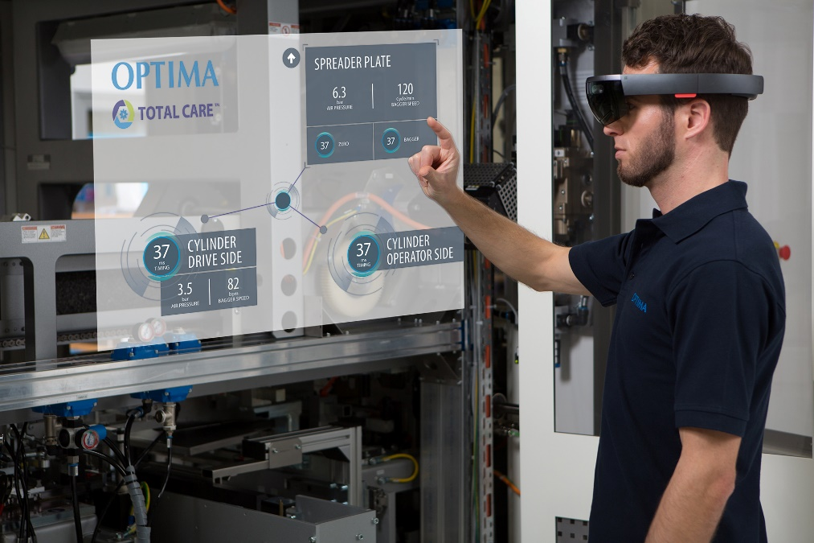
Material such as videos, information on components, operating manuals, circuit diagrams and much more is available directly at the systems via mixed-reality glasses.

Characters (incl. spaces): 4,238

Contact:
OPTIMA packaging group GmbH
Jan Deininger
Editor
+49 (0)791 / 506-1472
jan.deininger@optima-packaging.com
www.optima-packaging.com
Thank you very much for your publication. We look forward to receiving a specimen copy.

