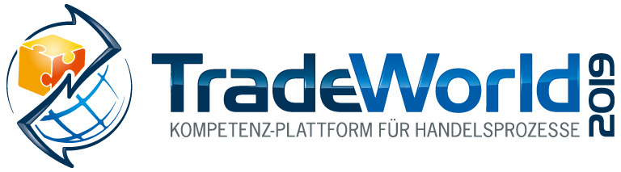
Messe- und Kongress-GmbH
Joseph-Dollinger-Bogen 7
D-80807 Munich, Germany
Phone: +49 89 323 91 259
Fax: +49 89 323 91 246
www.euroexpo.de/en
www.logimat-messe.de/en
www.tradeworld.de/en

February 19 - 21, 2019 | Messe Stuttgart

Presented at:

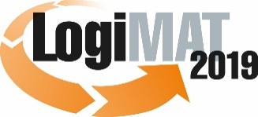

The 17th International Trade Show for
Intralogistics Solutions & Process Management
February 19 - 21, 2019 | Messe Stuttgart

Munich, January 7, 2019

Press Release

TradeWorld at LogiMAT 2019 in Stuttgart
The robots are mobilizing:
How AI and robotics impact trade and logistics

Rapid developments in artificial intelligence and the physical power of robotics applications make their use in commerce – both sales and logistics –increasingly realistic. Customer service and logistics are currently at the forefront of these developments. Marco Atzberger of the EHI Retail Institute joins experts to discuss the status quo and emerging trends of AI and robotics in trade and logistics at the TradeWorld platform, presented at LogiMAT, on February 21, 2019.

Point-of-sale digital technology is a diverse field. One of the most exciting trends currently unfolding is the use of robotics with the support of artificial intelligence (AI). This technology comes into play not only in mobile shopping assistants but also in inventory, shelf stocking, and last-mile delivery drones. Pure players are facing off with omnichannel retailers, and it’s too early to tell who will prevail. So the trade sector once again faces a daunting challenge: What’s worth trying, and what’s not?

Current trends in robotics and potential applications in trade are the latest chapter in a long history. The digital transformation of retail began back in the 1980s when barcodes were introduced and checkout scanners became the norm. Tech-friendly retailers soon began using the scanner data to establish materials management systems and eventually data warehouses.

The EHI Retail Institute launched the Robotics4Retail initiative to provide the big picture on automation and robotics in retail, highlight current trends and the challenges of potential applications, and develop recommendations that can be implemented in the commercial sector. The initiative also explores the acceptance of the various robotics applications, their implementation, and whether they offer good value for money. The idea is to produce a list of recommendations specifically targeting small and medium-sized businesses together with real-world suggestions for putting robotics into practice. The recommendations developed during the project also introduce a sociopolitical perspective by examining the ethical, legal, and social implications of automation and robotics at their most basic level and highlighting the regulations that retailers must follow.

“The Robots are Mobilizing” highlights use cases of AI and robotics in various retail environments

Marco Atzberger (Member of the Management Board, EHI Retail Institute) joins business representatives in the TradeWorld expert forum “The Robots Are Mobilizing” to talk about where robots are currently being deployed in retail. Matthias Krinke (Managing Director, pi4 robotics) shares the success story of a sales robot in Berlin’s Bikini shopping center. Jonas Reiling (Technology Manager for Branch Logistics, dm-drogerie markt GmbH + Co. KG) speaks on the subject of “Robotics in Retail Branches – Requirements and Challenges,” while Matthias Merz (Senior Director of Software Solutions for LMH EMEA, Linde Material Handling GmbH) presents “Linde Robotics – How Driverless Transport Systems Support Trade Processes.” In the panel discussion that follows, Marco Atzberger (EHI) and Jan-Andreas Daske (Head of Business Development, Salt Solutions AG) join the others to explore the major issues of AI and robotics in today’s trade sector. The expert forum takes place on February 21, 2019, from 10:00 to 11:15 a.m. in Hall 2, Forum T.

Event organizer:
EUROEXPO Messe- und Kongress-GmbH | Joseph-Dollinger-Bogen 7 | 80807 Munich
Phone: +49 89 323 91 259 | Fax: +49 89 323 91 246

4,155 characters (with spaces)

Munich, January 7, 2019 – This text may be reprinted free of charge, but please send a copy to EUROEXPO Messe- und Kongress-GmbH, Press and Public Relations Department, 80807 Munich.

About TradeWorld/LogiMAT

LogiMAT 2019, the 17th International Trade Show for Intralogistics Solutions and Process Management, will take place February 19 – 21 on the grounds of Messe Stuttgart, directly adjacent to Stuttgart International Airport. LogiMAT, now the world’s largest intralogistics trade show with over 1,600 exhibitors, offers a comprehensive overview of everything driving the intralogistics industry, from procurement to production to shipping. International exhibitors gather early in the year to showcase innovative technologies, products, systems, and solutions for streamlining operations, optimizing processes, and cutting costs in a company’s internal logistics.

LogiMAT includes the extra bonus of TradeWorld, a professional platform for trade processes, which showcases innovative e-commerce concepts for designing, managing, and integrating digital technology in the areas of procurement, online shops and marketing, software, fulfillment, parcel services, returns, and after-sales. The TradeWorld expert forum in Hall 2 rounds off the program with a new series of presentations each day covering the following themes: The B2B E-Commerce Challenge; Digitization Brings Transparency to Commercial Logistics; B2B Commerce in the Age of the Platform; From Fulfillment to Omnichannel Business; AI and Robotics in Logistics and Trade; and Making the Most of Returns.
TradeWorld’s exhibition area and expert forum are a special strategic component of LogiMAT.

For more information, please visit: www.tradeworld.de/en or www.logimat-messe.de/en.

