LAUDA doubles production area in China

New Pinghu plant near Shanghai inaugurated

Lauda-Königshofen, November 13, 2024 – LAUDA DR. R. WOBSER GMBH & CO. KG officially opened its new production facility in Pinghu, China, on October 18, 2024. With around 2,300 square meters, the plant doubles the previous production area and is an important milestone in the company's international expansion strategy. The global market leader for precise temperature control has been developing and manufacturing in China for eleven years.

Around 50 guests attended the opening ceremony, including LAUDA President & CEO Dr. Gunther Wobser, Dr. Marc Stricker (COO) and Christoph Baumann (Director Global Production). As local guests of honor, Ernest Liu, General Manager of LAUDA Production China, welcomed Miao He (Standing Committee Member of Pinghu Party Committee and Secretary of Party Working Committee of Pinghu Economic-Technological Development, abbreviated as: PEDZ), and the Director of the Administrative Committee of PEDZ, Xuebin Wang. The celebrations included traditional Chinese performances and rituals such as drum dancing, lion dancing and mask changing (Bian Lian).

In his speech, Dr. Gunther Wobser emphasized the importance of the move from Shanghai to Pinghu and gave an overview of the commitment of LAUDA in Asia: “Our expansion in the Far East began in 2006 with the 'Focus Asia' strategic project. In 2008, we established our own sales presence with LAUDA China and in 2013 we started production. With today's opening of the new production site in Pinghu, we are not only doubling our capacity, but also underlining our long-term commitment to this dynamic region.”

The investment in the new site underlines the confidence LAUDA has in the Chinese market and in the capabilities of the local team. Dr. Marc Stricker highlighted the efficiency of the project: “Thanks to the excellent cooperation of everyone involved, we were able to complete the relocation and expansion in just nine months. This is proof of the dynamics and commitment of our entire team.”

In recent years, LAUDA has continuously invested in quality assurance of the entry-level devices manufactured in China. Ernest Liu proudly reports: “For several years now, we have been able to guarantee the well-known LAUDA quality for all of our products manufactured in China and thus supply our customers worldwide directly.” With a planned annual turnover of around 120 million euros and over 600 employees worldwide, LAUDA sees the new plant as a geographically important basis for further growth.

Dr. Wobser accentuated the strategic importance of the new location. With the expansion, the family-owned company is ideally positioned to meet the growing demands of the Asian market and at the same time optimize the global supply chain. The new premises will enable the company to respond more flexibly to customer requirements and further strengthen its innovative power. At the same time, research and development will be expanded locally.
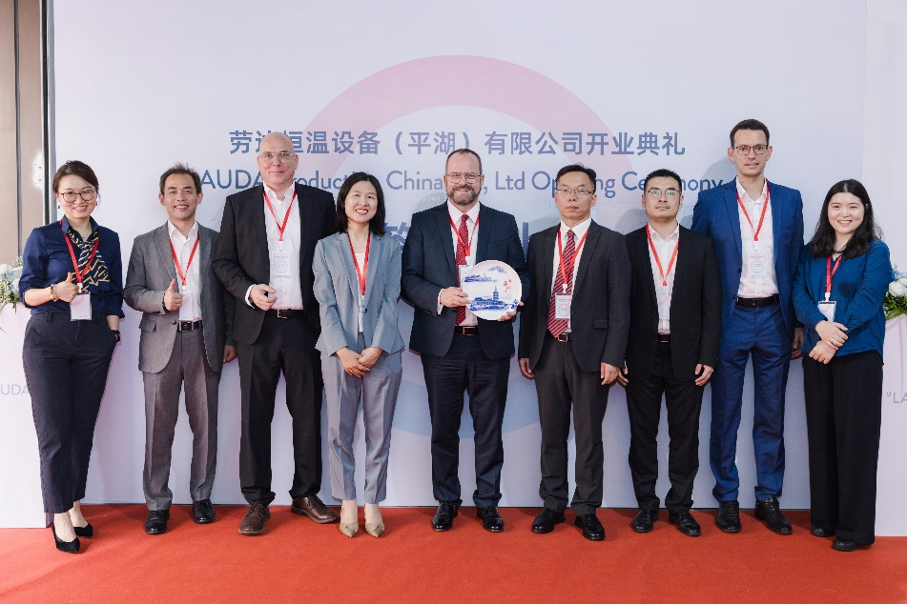
Fig. 1: The joy at the opening of the new LAUDA production facility in Pinghu is clear to see for everyone involved, from left to right: Lisa Zhang (Deputy General Manager of Investment Development Group of Pinghu Economic-Technological Development Zone), Ernest Liu (Managing Director LAUDA Production China), Dr. Marc Stricker (COO), Miao He (Standing Committee Member of Pinghu Party Committee and Secretary of Party Working Committee of Pinghu Economic-Technological Development Zone), Dr. Gunther Wobser (President & CEO of LAUDA), Xuebin Wang (Director of the Administrative Committee of PEDZ), Yifeng Shen (Vice Director of Administrative Committee of Pinghu Economic-Technological Development Zone), Christoph Baumann (Director Global Production at LAUDA) and Anni Chu (Director of German Investment Promotion Bureau of Pinghu Economic-Technological Development Zone). © LAUDA

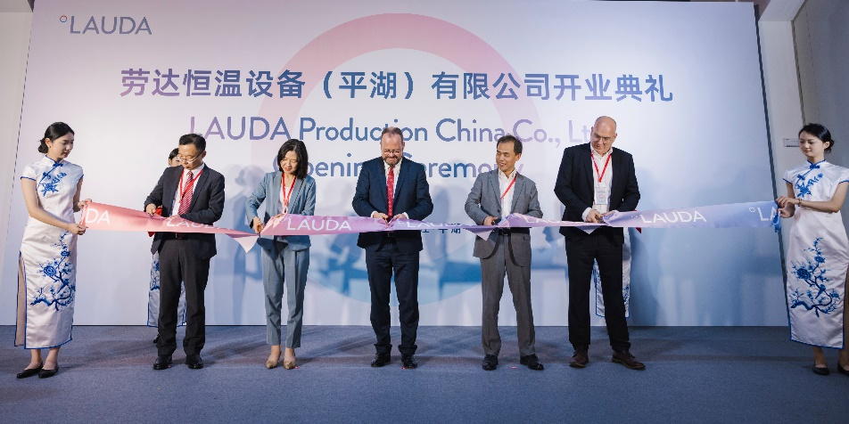
Fig. 2: Ceremonial moment: Xuebin Wang (Director of the Administrative Committee of Pinghu Economic-Technological Development Zone), Miao He (Standing Committee Member of Pinghu Party Committee and Secretary of Party Working Committee of Pinghu Economic-Technological Development Zone), Dr. Gunther Wobser (President & CEO of LAUDA), Ernest Liu (Managing Director LAUDA Production China) and Dr. Marc Stricker (COO of LAUDA) jointly cut the symbolic ribbon to open the new LAUDA production facility in Pinghu (from left to right). © LAUDA

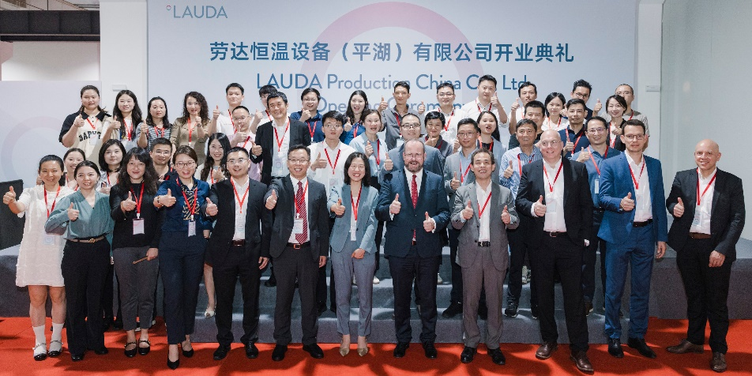
Fig. 3: Beaming faces and thumbs up: The group photo of all the guests reflects the positive mood and optimism that characterized the opening ceremony of the new LAUDA production facility in China. © LAUDA

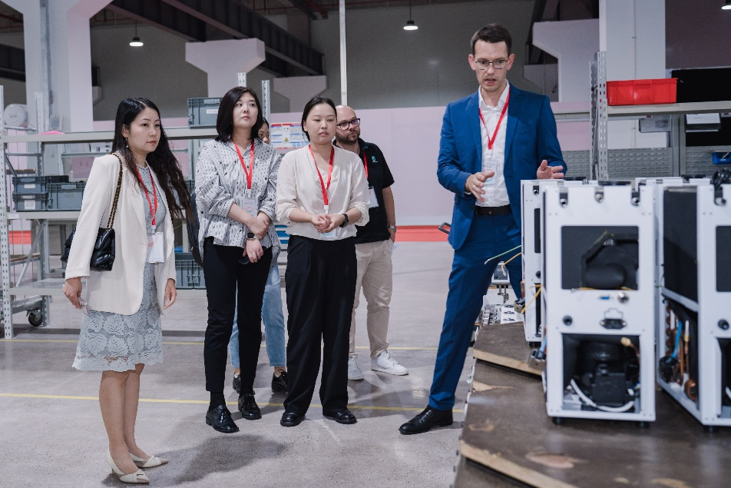
Fig. 4: Christoph Baumann (Director Global Production, right) explained the production steps at the new plant in Pinghu to the interested guests and provided interesting insights into the work processes. © LAUDA

We are LAUDA – the world leader in precise temperature control. Our constant temperature equipment and systems are at the heart of important applications, contributing to a better future. As a complete one-stop supplier, we guarantee the optimum temperature in research, production and quality control. We are the reliable partner for electromobility, hydrogen, chemicals, pharmaceuticals/biotech, semiconductors and medical technology. We have been inspiring our customers for almost 70 years with our expert mentoring and innovative solutions – every day anew and all over the world.

In our company, we always go one step further. We support our employees’ development and are constantly developing ourselves: to create a better future together.

Press contact
We are more than happy to make prepared information about our company, the LAUDA Factory Gallery and our projects in the area of innovation promotion, digitalization and idea management available to the press. We look forward to hearing from you – just give us a call!

CHRISTOPH MUHR
Director Corporate Communications
T + 49 (0) 9343 503-349
christoph.muhr@lauda.de

LAUDA DR. R. WOBSER GMBH & CO. KG, Laudaplatz 1, 97922 Lauda-Königshofen, Deutschland/Germany. Limited partnership: Headquarters Lauda-Königshofen, Registration court Mannheim HRA 560069. General partner: LAUDA DR. R. WOBSER Verwaltungs-GmbH, Headquarters Lauda-Königshofen, Registration court Mannheim HRB 560226. Managing Directors: Dr. Gunther Wobser (President & CEO), Dr. Mario Englert (CFO), Dr. Marc Stricker (COO)

