LAUDA Showcases AI Expertise in the SME Sector

Successful Events on Artificial Intelligence

Lauda-Königshofen, June 16, 2025 – LAUDA DR. R. WOBSER GMBH & CO. KG successfully presented its expertise in the field of artificial intelligence at two major events in May 2025. Dr. Gunther Wobser, President & CEO, and Florian Grunwald, Director IT, provided valuable insights into the practical application of AI technologies in SMEs at specialist events in Heilbronn and at the LAUDA headquarters. More than 120 participants from the region benefited from the practical experience of the world market leader for precise temperature control.
The event kicked off on May 20, 2025 with a joint event organized by the Heilbronn-Franken Chamber of Industry and Commerce and the appliedAI Institute gGmbH at the IPAI Spaces in Heilbronn. Dr. Gunther Wobser gave the keynote speech on AI strategies from an entrepreneurial perspective. Florian Grunwald added practical insights into the implementation of LAUDA.gpt, which was set up in collaboration with the Munich start-up meinGPT, and presented the procedure for the successful introduction of AI systems. In front of more than 90 managers from medium-sized companies, he explained how the company's own AI platform is driving the family business's digitalization strategy forward.
This was followed on May 22, 2025 by the ‘SMEs meet AI’ conference at LAUDA in Lauda-Königshofen. Organized by Unternehmer Baden-Württemberg e.V. (UBW) in cooperation with appliedAI and D11Z. Ventures GmbH & Co. KG, the event offered over 60 participants a platform for intensive discussions about AI applications. Five innovative start-ups – become.1, Semorai, S2 Data, Unchained Robotics and Resourcly – presented their AI solutions and promoted dialog between established companies and innovators.
“The rapid use of AI is crucial for the competitiveness of SMEs,” emphasized Dr. Gunther Wobser during the panel discussion in Lauda-Königshofen. “We must not allow ourselves to be held back by regulatory provisions such as the EU AI Act but must drive innovation forward with entrepreneurial courage. AI not only helps us with process efficiency but also opens new business areas and improves our customer solutions.”
At both events, LAUDA presented its proprietary AI platform LAUDA.gpt, which works with generative artificial intelligence and relieves employees of a wide range of tasks: It creates and translates texts, analyzes large amounts of data and supports the programming and automation of workflows. The modern, model-flexible architecture allows for the use of various AI models, with full compliance with all data protection regulations. This provides employees with the opportunity to focus on value-adding activities, leading to a substantial increase in productivity.
Florian Grunwald emphasized the central importance of a structured introduction: “The success of our AI implementation is largely based on the concept of key users. These employees act as multipliers and make a significant contribution to acceptance and successful integration. Thanks to an agile approach, we were able to achieve impressive efficiency gains in various areas of the company in a short space of time.”
At LAUDA, AI is not only used in the form of generative systems such as LAUDA.gpt, but also in the cybersecurity sector with AI-supported security solutions for the prevention, detection and defense against cyber threats. In addition, LAUDA is developing AI-based systems for predictive condition monitoring of temperature control units on automotive test benches in the joint research project ‘ProTemp’ with Aalen University.
The two specialist conferences highlighted the high level of interest shown by SMEs in practical AI solutions. In Lauda-Königshofen, Dr. Andreas Liebl from appliedAI gave the keynote speech ‘AI for SMEs’, before a moderated panel discussion explored specific strategies for the correct use of AI. Finally, Prof. Dr. Patrick Glauner shed light on the legal aspects of using AI. Tim Wenniges, Deputy Managing Director of Unternehmer Baden-Württemberg, and Tom Villinger, Managing Director of D11Z. Ventures, emphasized the innovative power of the approaches presented.
With both events, LAUDA is underlining its position as an innovative player in the integration of AI technologies in the SME sector. The company not only focuses on optimizing internal processes but also pursues the goal of integrating AI technologies into products and services in order to better meet customer needs and open up additional sources of revenue.
“The lively participation of many interested parties shows the hunger for knowledge of practical AI applications in SMEs,” summed up Dr. Gunther Wobser. “The exchange of experiences and the networking of different stakeholders are crucial to fully leveraging the potential of artificial intelligence. As an innovative family-owned business, LAUDA will continue to break new ground and share experiences with other companies and institutions.”

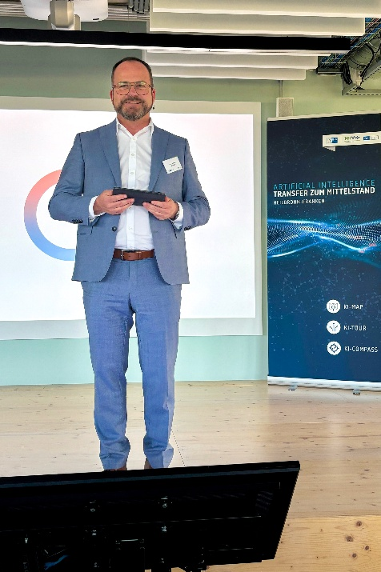  Picture 1: In his keynote speech at the IPAI in Heilbronn on 20 May 2025, Dr. Gunther Wobser, President & CEO of LAUDA, explained strategic approaches to successful AI integration in medium-sized companies. © LAUDA | 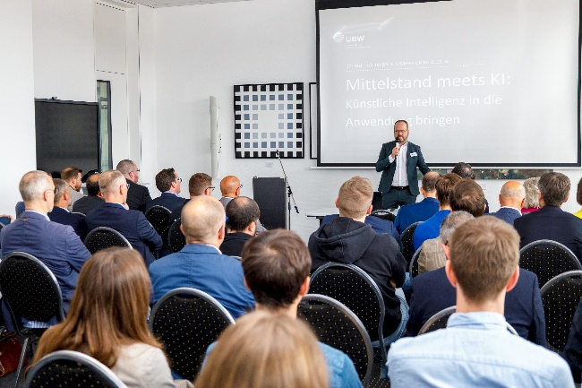  Picture 2: Dr. Gunther Wobser welcomed around 60 participants who followed the presentations and discussions at the UBW conference ‘SMEs meet AI’ on 22 May 2025 at the LAUDA headquarters in Lauda-Königshofen with interest. © LAUDA
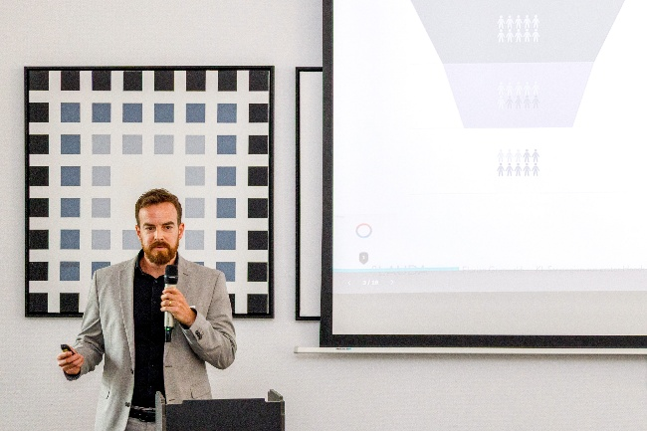  Picture 3: Florian Grunwald, Director IT at LAUDA, presented concrete best-practice examples and practical implementation strategies for LAUDA.gpt to executives from medium-sized companies. © LAUDA | 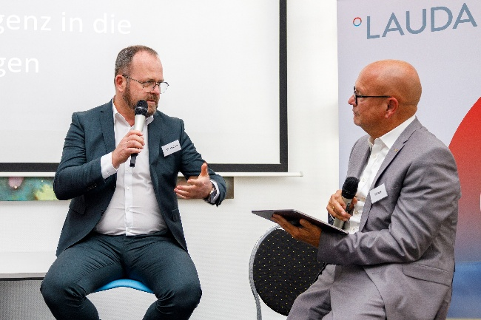  Picture 4: Dr. Gunther Wobser took part in the panel discussion on the correct use of AI, in which he pleaded for entrepreneurial courage in innovation despite regulatory challenges. © LAUDA

We are LAUDA – the world leader in precise temperature control. Our constant temperature equipment and systems are at the heart of important applications, contributing to a better future. As a complete one-stop supplier, we guarantee the optimum temperature in research, production and quality control. We are the reliable partner for electromobility, hydrogen, chemicals, pharmaceuticals/biotech, semiconductors and medical technology. We have been inspiring our customers for almost 70 years with our expert mentoring and innovative solutions – every day anew and all over the world.

In our company, we always go one step further. We support our employees’ development and are constantly developing ourselves: to create a better future together.

Press contact
We are more than happy to make prepared information about our company, the LAUDA Factory Gallery and our projects in the area of innovation promotion, digitalization and idea management available to the press. We look forward to hearing from you – just give us a call!

CHRISTOPH MUHR
Director Corporate Communications
T + 49 (0) 9343 503-349
christoph.muhr@lauda.de

LAUDA DR. R. WOBSER GMBH & CO. KG, Laudaplatz 1, 97922 Lauda-Königshofen, Deutschland/Germany. Limited partnership: Headquarters Lauda-Königshofen, Registration court Mannheim HRA 560069. General partner: LAUDA DR. R. WOBSER Verwaltungs-GmbH, Headquarters Lauda-Königshofen, Registration court Mannheim HRB 560226. Managing Directors: Dr. Gunther Wobser (President & CEO), Dr. Mario Englert (CFO), Dr. Marc Stricker (COO)

