LAUDA Once Again Global Market Leader

Temperature control specialist receives award for the tenth time

Lauda-Königshofen, December 18, 2025 – LAUDA DR. R. WOBSER GMBH & CO. KG has been named the global market leader in the field of “constant temperature equipment and systems for precise temperature control” for the tenth time in a row. The renowned “Index of World Market Leaders,” compiled under the direction of Prof. Dr. Christoph Müller from the University of St. Gallen, Switzerland, forms the basis for the annual awards presented by the leading business magazine “WirtschaftsWoche.”

The anniversary award comes at a time of change: after spectacular growth in 2022 and three years of consolidation due to the challenging macroeconomic situation, LAUDA has been able to expand its global market position with current sales of around 100 million euros and around 600 employees. For 2026, the third-generation family-run company is planning sales growth of around 15 percent to around 115 million euros.

Dr. Gunther Wobser, President & CEO of LAUDA, emphasizes the significance of this tenth award: “The continuous recognition over a decade fills us with extraordinary pride. It confirms the exceptional performance of our employees at three German locations, in five production and ten sales companies. Over the past three years, we have acted prudently, carefully adjusted capacities, and optimized our processes. In doing so, we have defended our technological leadership and laid the foundation for future growth.”

LAUDA focuses on innovation in the areas of energy efficiency, digitalization, and sustainable temperature control solutions. The technologies ensure the optimum temperature in areas such as electromobility, hydrogen technology, and the pharmaceutical industry. The renewed award confirms LAUDA as an innovation driver and sales leader in the industry.

“The award from WirtschaftsWoche is both a confirmation and an obligation,” summarizes Dr. Wobser. “We have consolidated our market position and expanded our global presence. We are devoting even more attention to our customers worldwide. With precise temperatures, we are improving the world together – this vision unites our employees worldwide.”

The year 2026 will be marked by special milestones for LAUDA: as part of its return to growth, the family-owned company will celebrate its 70th anniversary on March 1.
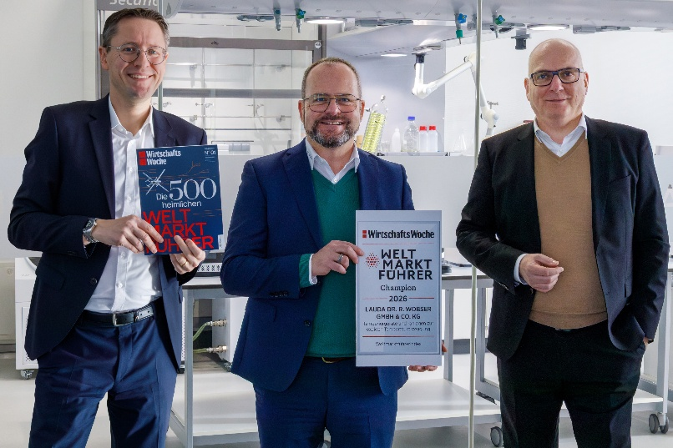

Picture: The managing directors of LAUDA, Dr. Mario Englert, Dr. Gunther Wobser, and Dr. Marc Stricker (from left to right), are delighted to receive their tenth “Global Market Leader Champion” award and, backed by major orders already secured, are aiming to return to growth by 2026. © LAUDA

We are LAUDA – the world leader in precise temperature control. Our constant temperature equipment and systems are at the heart of important applications, contributing to a better future. As a complete one-stop supplier, we guarantee the optimum temperature in research, production and quality control. We are the reliable partner for Aerospace, Electromobility, Hydrogen, Chemistry, Pharmaceuticals/Biotech, Semiconductors and Medtech. We have been inspiring our customers for almost 70 years with our expert mentoring and innovative solutions – every day anew and all over the world.

In our company, we always go one step further. We support our employees’ development and are constantly developing ourselves: to create a better future together.

Press contact
We are more than happy to make prepared information about our company, the LAUDA Factory Gallery and our projects in the area of innovation promotion, digitalization and idea management available to the press. We look forward to hearing from you – just give us a call!

CHRISTOPH MUHR
Director Corporate Communications
T + 49 (0) 9343 503-349
christoph.muhr@lauda.de

LAUDA DR. R. WOBSER GMBH & CO. KG, Laudaplatz 1, 97922 Lauda-Königshofen, Deutschland/Germany. Limited partnership: Headquarters Lauda-Königshofen, Registration court Mannheim HRA 560069. General partner: LAUDA DR. R. WOBSER Verwaltungs-GmbH, Headquarters Lauda-Königshofen, Registration court Mannheim HRB 560226. Managing Directors: Dr. Gunther Wobser (President & CEO), Dr. Mario Englert (CFO), Dr. Marc Stricker (COO)

