PRESS RELEASE
Schwaebisch Hall, February 4, 2021

Support software by OPTIMA is awarded
the Annual Multimedia Award 2021
With it, challenges with machinery
can be overcome in real time

With the "Remote Assist" software solution Optima has found the right answer to today's challenges. This was the conclusion of the jury for the digital creative competition "The Annual Multimedia Award", who conferred a silver award on the support software. Optima's software experts developed the application in cooperation with the Crailsheim-based digital agency Stoll von Gáti, and they nominated the innovative product for the Annual Multimedia Award. The Annual Multimedia Award is one of the digital industry's most important prizes.
On-site service assignments have become more difficult due to the pandemic; machines have to be set up or serviced. With the "Remote Assist" software solution, Optima has found the right solution for the current situation. The Annual Multimedia Award's expert jury also thinks so. The support software received
the Silver Award in the category "Best Use of Creative Technology/Digital Services".
Communicating simply, rapidly and securely in real time
The software simply, quickly and securely establishes an audio and video link between the customer and Optima Support. It also features a chat function, a practical drawing function and the ability to send data. The intuitive application is complemented by encrypted communication and external hosting. Optima uses Remote Assist on laptops, tablets and smartphones as well as with augmented reality glasses. The digital service is part of the OPTIMA Total Care life cycle management program. With this program, Optima provides its customers with support throughout the entire machine life cycle.
A joint development between OPTIMA and Stoll von Gáti
"We are delighted that our digitalization strategy is paying off and being honored with this important digital award," says Dr.-Ing. Benjamin Haefner, Group Leader Industrial IT at Optima. "We would like to thank our partners at Stoll von Gáti, who have made a major contribution to Remote Assist's success," says Haefner.
In an online session, and after extensive discussions, the Annual Multimedia Awards jury awarded a total of 42 prizes to outstanding projects in digital communication and creation: 11 Gold, 25 Silver and 6 Digital Talents. This is one of the digital industry's most prestigious awards.

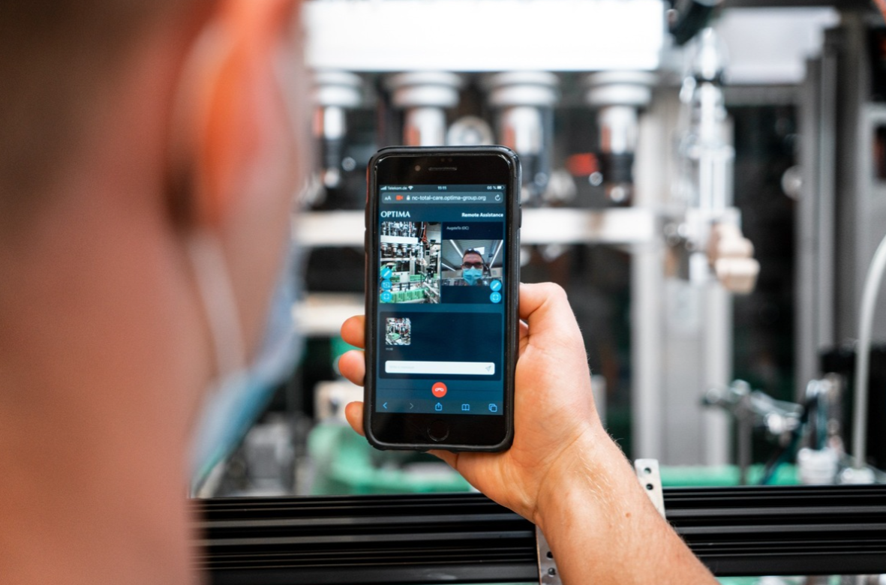
Remote Assist is a real-time communication system
that enables Optima service experts to interact with the customer. (Source: Optima)

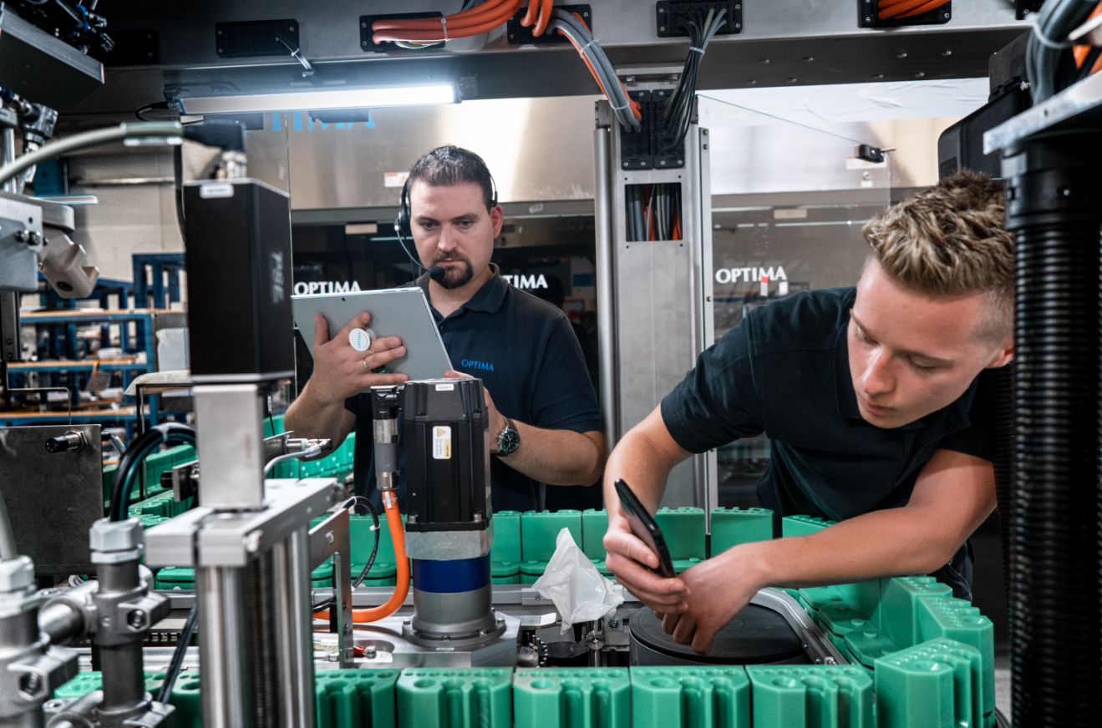
The software solution's strengths have particularly been demonstrated during the COVID-19 pandemic. Any challenges that may arise can be solved quickly and cooperatively, directly on the machine. (Source: Optima)

Characters (incl. spaces): 2,386

Press contact:
OPTIMA packaging group GmbH
Jan Deininger
Group Communications Manager
+49 (0)791 / 506-1472
jan.deininger@optima-packaging.com
www.optima-packaging.com

About OPTIMA
Optima supports companies worldwide with flexible and customer-specific filling and packaging machines for pharmaceuticals, consumer goods, paper hygiene and medical devices markets. As a provider of solutions and systems, Optima accompanies these companies from the product idea through to successful production and throughout the entire machine life cycle. 2,450 experts around the globe contribute to Optima's success. 19 locations in Germany and abroad ensure the worldwide availability of services.

Thank you very much for your publication. We look forward to receiving a specimen copy.

