LAMILUX composites are lightweight for dry freight trailers

GRP – the all-rounder for safe transport

Every day, tons of different kinds of freight, cooled or unrefrigerated, are transported from A to B worldwide. The reliable and efficient transport of goods at an ambient temperature, so-called dry freight, requires safe, robust and particularly light material face sheets. The transport containers are usually permanently connected to the respective dry freight trailer and can be used to transport all types of goods with the exception of liquids and are available in different sizes depending on the service provider. The dry freight trailers must withstand many influences during their journey and secure the goods against slipping, for example – side walls, floors and roofs made of glass fibre-reinforced plastics (GRP) help with this.

GRP is the all-rounder for dry-freight trailers in the commercial vehicle industry, particularly the composites from LAMILUX, Europe’s leading producer of high-tech glass fibre-reinforced plastics (GRP). Produced in a continuous, industrial-scale flat sheet process, these lightweight materials provide optimal stability whilst also being extremely light construction elements. LAMILUX inspires customers from the dry freight industry worldwide with its production reliability, wide range of application options and consistently high quality.

GRP for safe, stable and robust dry freight trailers

Fibre-reinforced composites are incorporated as face sheets in roofing, flooring and side walls. These materials provide major advantages over conventional materials such as aluminium and sheet steel thanks to their strength, low weight and durability. Fibre-reinforced plastics are also extremely non-corrosive, weatherproof and UV resistant, all of which ensures a long-lasting, attractive appearance. The high degree of quality which has been certified on numerous occasions and the material properties that ideally cater to the respective applications have aided in maintaining the company's leading position in the international market for fibre-reinforced composites.

Certified products with quality guarantee

The certification of LAMILUX test methods by the German testing institute TÜV Süd is a confirmation of the application-specific, high quality of LAMILUX GRP. LAMILUX commissioned TÜV Süd to appraise and inspect most of its laboratory and testing facilities to ensure consistently high, flawless quality. At the end of the detailed, comprehensive certification process, the TÜV specialists had assessed seventeen analysis, measurement and test methods with regard to their usefulness and validity for quality assurance and product development. This allows LAMILUX to reliably assure quality in its end products based on a wide range of tests. The specialist in fibre-reinforced composites tests its products during mechanical, chemical and climatic tests in state-of-the-art laboratories.

Would you like to find out more about LAMILUX products with a quality guarantee? Then don't miss the webinar on "LAMILUX GRP: value retention and safety through TÜV-certified quality" on Wednesday, 20 October 2021 at 10:30 a.m.

Robust protection against hail and stone damage – yet lightweight

One of the greatest advantages of LAMILUX GRP is certainly its extreme hailstone and impact resistance. Thanks to the high material rigidity and an extremely low deformation tendency, this is the greatest advantage when used in the roof, but also in the outer wall of trailers. While hailstones cause visible and permanent dents in roof and side wall materials such as aluminium or competitors' GRP, LAMILUX’s fibre-reinforced plastic sheets usually withstand this phenomenon unscathed.

Furthermore, a vehicle's tare or dead weight can be substantially reduced by using fibre-reinforced plastics. Use of GRP can lead to a 40 percent reduction in weight in comparison to steel, and around 15 percent in comparison to aluminium. Construction elements in roofs and side walls are able to feature a slimmer design as fibre-reinforced plastics provide a strong reinforcing effect. The reduction in weight produces a direct benefit for truck operators as a result of increased pay load, i.e. greater loading capacity and, consequently, lower transport costs as well as reduced fuel consumption.

An overview of some LAMILUX products:

- For indoor applications: LAMILUX High Impact features the impact resistance and surface appearance of painted metal face sheets, low thermal conductivity and elastic workability of thermoplastic materials. If goods are loaded and unloaded by a forklift truck, for example, there are very often impacts against the inner wall. LAMILUX High Impact can withstand this and displays no signs of damage.
- For external use on the vehicle roof or the external side wall: LAMILUX Woven Roving Gelcoat is particularly well-suited here, as its gelcoat sealer provides outstanding resistance to UV light and weathering. LAMILUX HG 4000 is also a particularly attractive and customisable material alternative for outer wall cladding.
- For floor areas: LAMILUX Anti Slip provides anti-slip protection and soundproofing. The extremely robust resin and glass fibre composite, on whose surface a layer of quartz sand or granite granulate is applied during the lamination process, ensures that goods do not slip and thus prevents damage to the vehicle and the transported goods. The material has another great product benefit: Used as flooring, LAMILUX Anti Slip significantly minimises rolling noise during loading and unloading, thereby achieving sound insulation values below 60 db(A). This significantly reduces noise emissions and facilitates round-the-clock loading in noise protection zones.
- LAMILUX Woven Roving Gelcoat translucent provides additional light incidence through the vehicle roof. The material’s transparent property enables daylight to stream into the dry freight trailer interior, highly useful when loading and unloading.
A wide range of product information is available at www.lamilux.com.

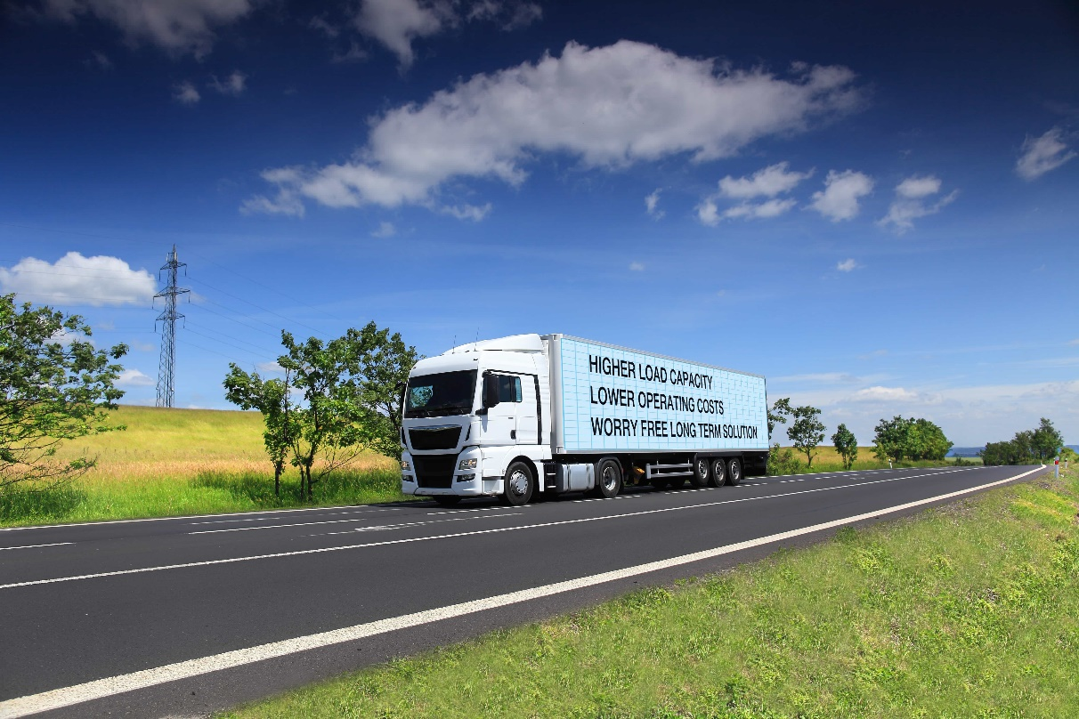Picture caption: LAMILUX fibre-reinforced composites are used in commercial vehicle construction in the side walls, floors and roofs of dry freight trailers.

About LAMILUX Composites GmbH
LAMILUX Composites GmbH has been producing fibre-reinforced plastics for around 70 years. The medium-sized company is the leading European producer thanks to its technologically advanced continuous production process, large manufacturing capacities and wide product range. LAMILUX supplies customers around the globe in a wide range of sectors, such as the building industry, the automotive and recreational vehicle sectors, refrigerated store room and cell construction, and many other industrial sectors. In 2020, LAMILUX and its some 1,200 employees achieved a turnover of 293 million euros. The family-managed company is based in Rehau, Bavaria.
…
www.lamilux.com

