iF Design Award 2018

Kärcher vierfach ausgezeichnet

Pressekontakt
Alexander Becker
Pressereferent
Alfred Kärcher GmbH & Co. KG
Alfred-Kärcher-Str. 28-40
71364 Winnenden
T +49 71 95 14-4256
F +49 71 95 14-2193
alexander.becker@de.kaercher.com
Winnenden, im Februar 2018 – Gleich vier Produkte von Kärcher wurden mit dem iF Design Award 2018 ausgezeichnet, der weltweit zu den anerkanntesten Designpreisen zählt. Dabei war die Konkurrenz außerordentlich groß: Die Juroren hatten unter 6.400 Einreichungen aus 54 Ländern das begehrte Gütesiegel zu vergeben.
Die folgenden Kärcher-Produkte für gewerbliche Anwender wurden mit einem iF Design Award 2018 ausgezeichnet:
Nass-/Trockensauger-Reihe NT Tact: Die neue Generation Nass-/Trockensauger ist mit einer verbesserten automatische Filterabreinigung (TACT) ausgestattet. Die Saugleistung der Modelle NT 30/1 Tact L, NT 30/1 Tact Te L, NT 40/1 Tact Te L und NT 50/1 Tact Te L bleibt selbst bei großen Feinstaubmengen konstant hoch. Für Anwender im KFZ- und Baugewerbe oder in Industriebetrieben wurden die Geräte sehr robust gestaltet; zugleich macht das überarbeitete Zubehör die Handhabung besonders komfortabel.
SB-Sauger SB Vac: Das neue Modell verfügt über eine einzigartige Schlauchaufhängung, mit der Bodenkontakt und somit Schmutzeintrag ins Fahrzeug minimiert wird. Mit der neu gestalteten ergonomischen Autosaugdüse können sowohl größere Flächen als auch Ritzen effizient gereinigt werden. Für eine konstant hohe Saugleistung sorgt die automatische Filterabreinigung Tact. Der neue SB-Sauger kommt an Tankstellen, in Pflegecentern und Autohäusern zum Einsatz.
Aus dem Programm für private Anwender wurden zudem der Hartbodenreiniger FC 5 und der Luftreiniger KA 5 mit einem iF Design Award 2018 ausgezeichnet.
Allen Produkten gemeinsam ist eine Gestaltung, die mit funktionalen Vorteilen für den Anwender überzeugt. Gleichzeitig folgt die Formgebung dem Kärcher Corporate Design. Dadurch ist für den Anwender die Zugehörigkeit der Produkte zu der Marke erkennbar, die unter anderem für sehr gute Reinigungsleistung, Werterhalt und Umweltverträglichkeit steht. Nicht zuletzt werden die Produkte bei Kärcher stets mit Blick auf eine lange Lebensdauer und eine hohe Recyclingquote entwickelt.
Über den iF DESIGN AWARD:
Seit 65 Jahren ist der iF DESIGN AWARD ein weltweites, anerkanntes Markenzeichen, wenn es um ausgezeichnete Gestaltung geht. Die Marke iF ist als Symbol für herausragende Designleistungen international etabliert. Der iF DESIGN AWARD gehört zu den wichtigsten Designpreisen der Welt. Er prämiert Gestaltungsleistungen aller Disziplinen: Produkt-, Verpackungs-, Kommunikations- und Service-Design/UX, Architektur und Innenarchitektur sowie Professional Concept. Alle ausgezeichneten Beiträge werden im iF WORLD DESIGN GUIDE präsentiert, in der iF design app veröffentlicht und in der iF design exhibition Hamburg ausgestellt.
Über Kärcher:
Kärcher ist weltweit führender Anbieter für Reinigungstechnik. Das Familienunternehmen beschäftigt in 67 Ländern und mehr als 110 Gesellschaften über 12.300 Mitarbeiter. Für einen weltweit lückenlosen Kundendienst sorgen 50.000 Servicestellen in allen Ländern. Im Jahr 2017 erzielte Kärcher mit 2,5 Mrd. Euro den höchsten Umsatz in seiner Geschichte.
Eine Word-Datei und druckfähige Bilder zu dieser Presseinformation liegen für Sie in unserem Newsroom https://www.kaercher.com/presse zum Download bereit.

Kaercher_iF_Design_Award_2018_Prof.docx

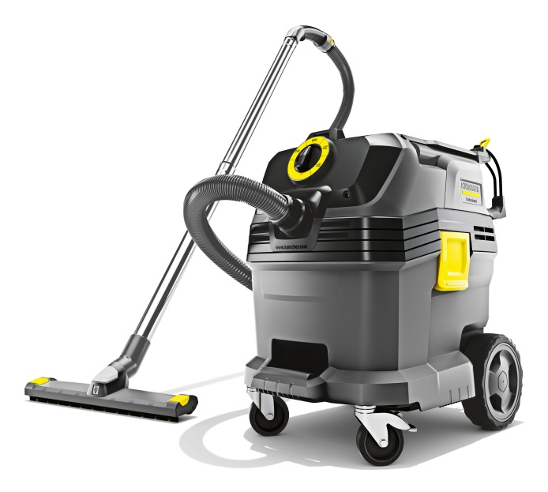
Die Saugleistung der neuen Nass-/Trockensauger bleibt selbst bei großen Feinstaubmengen konstant hoch. Für Anwender im KFZ- und Baugewerbe oder in Industriebetrieben wurden die Modelle besonders robust gestaltet.
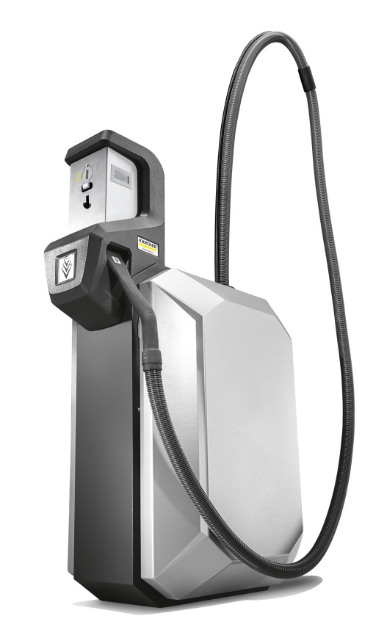
Die Schlauchführung der neuen SB-Sauger vermeidet Bodenkontakt und sorgt für mehr Komfort beim Saugen.
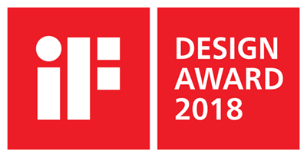
Der iF DESIGN AWARD gehört weltweit zu den wichtigsten Designpreisen.

