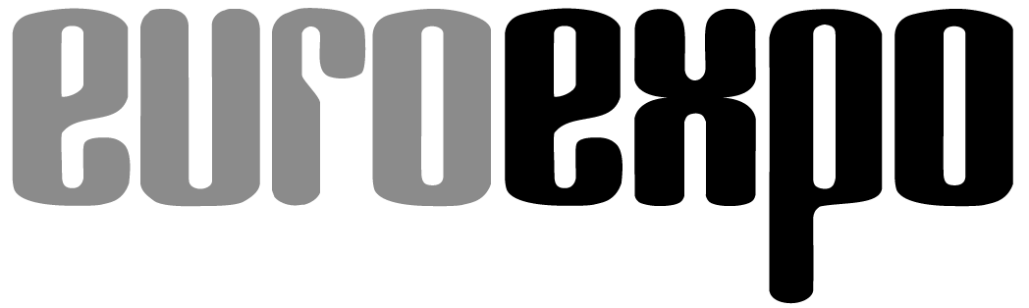
Messe- und Kongress-GmbH
Joseph-Dollinger-Bogen 7
D-80807 Munich, Germany
Phone: +49 89 32391 259
Fax: +49 89 32391 246
www.euroexpo.de/en
www.logimat-messe.de/en
www.tradeworld.de/en

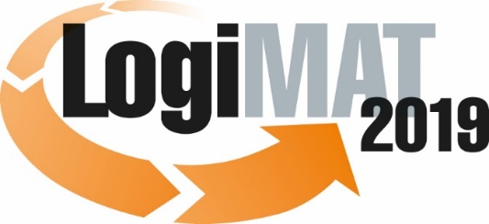

The 17th International Trade Show for
Intralogistics Solutions & Process Management
February 19–21, 2019 | Messe Stuttgart

Also featured at LogiMAT:
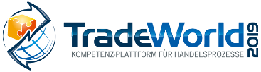

Munich, September 5, 2018

Press Release

LogiMAT a Magnet for Visitors from around the World

LogiMAT is further internationalizing as its global brand recognition grows. The number of international exhibitors and visitors at the International Trade Show for Intralogistics Solutions and Process Management has grown fivefold over the past decade – significantly faster than the German trade show industry as a whole according to the latest data.

A recent study of exhibitor and visitor trends underscores LogiMAT’s position as the leading international trade show for intralogistics solutions and process management. The study finds that LogiMAT boosted its contingent of international industry professionals in attendance over the past ten years from 13 percent to nearly 20 percent. Among the 55,375 visitors at LogiMAT in 2018, some 11,000 traveled from abroad – and one in ten of them even came from overseas. This means that over the past decade, LogiMAT was able to grow the number of international visitors overall and those from overseas by a factor of more than five – significantly higher than the figure published recently by the Association of the German Trade Fair Industry (AUMA), which recorded growth of 30 percent in visitors from overseas at events in Germany over the past ten years. “The success of international exhibitors at LogiMAT, the leading information platform and trade show for direct business contacts in the intralogistics industry, further enhances its brand recognition in international markets and among industry professionals,” notes Peter Kazander, Managing Director of event organizer EUROEXPO Messe- und Kongress-GmbH in Munich, explaining the show’s extraordinary internationalization in the past ten years. “This kind of development is gradual. With everything LogiMAT has to offer, it has grown into a one-of-a-kind magnet for international visitors as well.”

A similar trend can be seen in the share of international exhibitors, where LogiMAT has shot up nearly eight percentage points in the last five years alone: In 2013, a total of 181 of 1,003 exhibitors on hand in Stuttgart to present their products and solutions (18 percent) were headquartered abroad. By 2018, this contingent grew to 25.6 percent, with 400 of 1,564 exhibitors coming from outside Germany, and 12.5 percent of them from overseas – Australia, New Zealand, Asia, and North America. “The growing international profile of LogiMAT into what is likely the leading global platform for state-of-the-art intralogistics solutions will set a new record in the coming year in the number of exhibitors from overseas,” predicts Michael Ruchty, the event’s new project director. “For LogiMAT 2019, taking place February 19 to 21 in Stuttgart, a total of 44 companies from China and Taiwan alone have already registered. What this suggests is that among the international exhibitors at the next LogiMAT, the contingent of companies from overseas will rise to between 26 and 30 percent. This will also be reflected in the trend of international visitor numbers.”

The latest AUMA publication sheds some light on what’s driving this, showing that the interest in German trade shows among Chinese purchasers has surged much faster than it has among exhibitors. Kazander sees another reason behind LogiMAT’s uniquely rapid rise in internationalization: LogiMAT China, which EUROEXPO will present for the fifth time from April 15 to 17, 2019 – and for the first time in the Shanghai New International Expo Centre (SNIEC). Exhibitors will include the Chinese offices of many leading manufacturers such as Kaup, Crown, Jungheinrich, and Kardex Remstar. “The intralogistics solutions presented there, tailored to the specific needs of the local market, have made Asian industry professionals hungry for more,” Kazander concludes. “At the same time, it enhances the global visibility of the LogiMAT brand and draws more exhibitors and visitors alike from China to Stuttgart as well.”

Event organizer: EUROEXPO Messe- und Kongress-GmbH
Joseph-Dollinger-Bogen 7 | 80807 Munich, Germany
Phone: +49 89 32391 259 | Fax: +49 89 32391 246
www.euroexpo.de | www.logimat-messe.de | www.tradeworld.de

3,922 characters (with spaces)
Munich, September 5, 2018 –This text may be reprinted free of charge, but please send a copy to EUROEXPO Messe- und Kongress-GmbH, Press and Public Relations Department, 80912 Munich.

About LogiMAT

LogiMAT 2019, the 17th International Trade Show for Intralogistics Solutions and Process Management, will take place February 19 – 21 on the grounds of Messe Stuttgart, directly adjacent to Stuttgart International Airport. LogiMAT, the world’s largest intralogistics trade show, offers a comprehensive overview of everything driving the intralogistics industry, from procurement to production to shipping. International exhibitors gather early in the year to showcase innovative technologies, products, systems, and solutions for streamlining operations, optimizing processes, and cutting costs in a company’s internal logistics.
TradeWorld, the Professional Platform for Trade Processes embedded within LogiMAT, features products and solutions for e-commerce and omnichannel. Beyond the exhibitor booths, visitors to this combined event can also experience a different program of presentations each day covering a wide range of topics.

