PRESS RELEASE
Schwaebisch Hall, February 15, 2021

OPTIMA EGS is awarded the International FoodTec Award
The prestigious innovation prize is awarded by the German Agricultural Society to recognize groundbreaking developments in food technology

The innovative OPTIMA EGS machine concept from OPTIMA consumer GmbH was awarded the silver International FoodTec Prize by the German Agricultural Society (DLG). The OPTIMA EGS handles the fully automated evacuation, gassing and seaming of baby milk powder containers in the high-care room, and considerably increases production reliability. This year, there were 20 innovation projects from the international food and supplier industry that were awarded the renowned technology prize by an international jury of experts with a range of specializations.
"We are delighted to receive this award. Receiving this award from renowned experts in the food industry is the confirmation that the OPTIMA EGS can offer our customers greater production reliability, product quality and conservation of resources in baby milk powder production," says Christoph Held, Managing Director at OPTIMA consumer GmbH. The market requirements of baby milk powder producers were assessed in detail during the development of the EGS. According to Held, this strategy has paid off. There is high demand for the machine, and the order books are full. There are further groundbreaking developments in the pipeline, such as a non-destructive 100% leakage check.
The company's sustainability strategy is also having an effect, says Dominik Broellochs, Optima's Group Sustainability Manager. Sustainably designing machine technologies is part of the EGS concept. "Compared to conventional post-gassing systems, the amount of space required has been reduced by over 40 percent," says Broellochs. Besides manufacturing space, the considerations of effective usage of materials, processing accuracy, optimum use of packaging materials, machine recycling and maximizing the machine lifecycle all play a major role in the Optima Group's sustainability strategy.

The most prestigious innovation award in the food and supplier industry

This year was the eleventh time that the International FoodTec Award, the most distinguished innovation prize in international food technology, was presented. The international jury of experts selected 20 innovations from numerous applications to receive a gold or silver award. Once every three years, the International FoodTec Award honors successful implementations of innovative concepts in the sectors of process technology, including measurement and control technology, automation and robotics, filling and packaging technology, environmental technology, biotech, process management including software solutions, logistics, food safety and quality management. The DLG and its partners have awarded the International FoodTec Award since 1994 to recognize pioneering developments in innovation, sustainability and efficiency in the food technology sector. In 2021, five innovations received the gold International FoodTec Award and fifteen received the silver award.

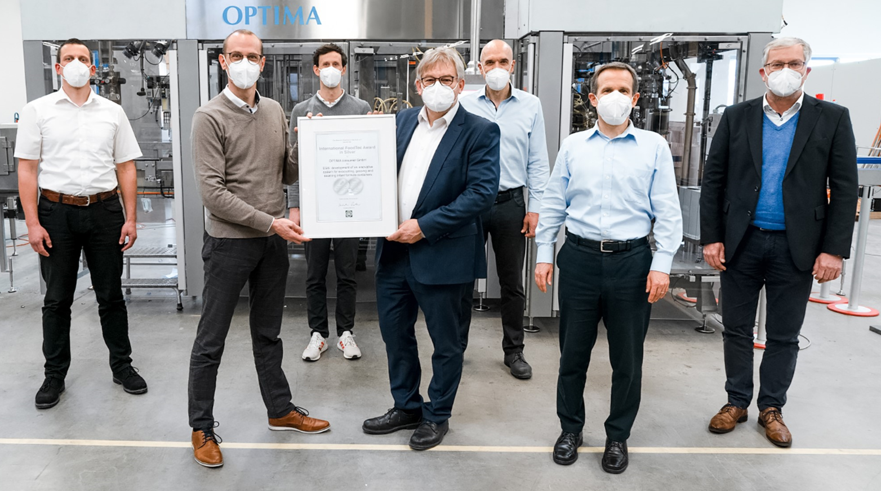
The Optima Consumer team, which played a leading role in the development of the OPTIMA EGS. Left to right: Matthias Schaal (Director Engineering), Thomas Probst (Business Development Manager), Dr. Tobias Freiberger (Group Leader Development), Ulrich Burkart (Sales Coordinator), Herbert Trautwein (Project Engineer), Sieghardt Lay (Director Sales Food & Beverages), Christoph Held (Managing Director). (Source: Optima)

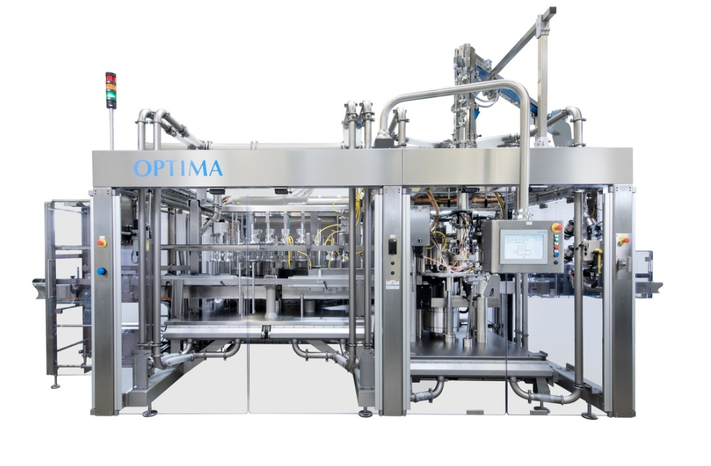
The innovative OPTIMA EGS machine concept from OPTIMA consumer GmbH was awarded the silver International FoodTec prize. (Source: Optima)

Characters (incl. spaces): 3,061

Press contact:
OPTIMA packaging group GmbH
Jan Deininger
Group Communications Manager
+49 (0)791 / 506-1472
jan.deininger@optima-packaging.com
www.optima-packaging.com

About OPTIMA
Optima supports companies worldwide with flexible and customer-specific filling and packaging machines for pharmaceuticals, consumer goods, paper hygiene and medical devices markets. As a provider of solutions and systems, Optima accompanies these companies from the product idea through to successful production and throughout the entire machine life cycle. 2,450 experts around the globe contribute to Optima's success. 19 locations in Germany and abroad ensure the worldwide availability of services.

Thank you very much for your publication. We look forward to receiving a specimen copy.

