LAMILUX managing directors receive award

Johanna and Dr. Alexander Strunz awarded as “Bavarian young entrepreneurs of the year”

The family business LAMILUX has good reason to celebrate, as its managing directors Johanna and Dr Alexander Strunz were named “Bavarian young entrepreneurs of the year” at the Bavarian Family Business Congress on Thursday 29.06.23 at Hoch5 in Munich. The award recognises the commitment and achievements of the young entrepreneurs, who took the helm of the family business LAMILUX just a few days ago.

The award ceremony took place in the presence of top-class personalities from business, politics and the media. The award is presented by the association DIE FAMILIENUNTERNEHMER e.V. DIE JUNGEN UNTERNEHMER.

The winners of the "Bavarian young entrepreneurs of the year" category: Johanna and Dr. Alexander Strunz, who have already been working hard as part of the management team since 2019 to ensure the success of the family business LAMILUX and were officially handed over the controls of the family business by their parents last weekend.

Johanna Strunz accepted the award with visible joy and gratitude: " Especially because the association stands for similar values as our family business LAMILUX and unites so many impressive companies behind it, this award is a particularly great honour for us."
Strunz herself was involved as deputy federal chairperson of the young entrepreneurs for many years. "This recognition confirms us in our efforts to always live a high level of responsibility for our company and all those involved in creating value, as well as for the environment and society," says Strunz.

As the political lobby for more than 180,000 family entrepreneurs, DIE FAMILIENUNTERNEHMER follows the values of freedom, ownership, competition and responsibility. Within the association, DIE JUNGEN UNTERNEHMER is the forum for young family and owner-managers up to the age of 40. Based on the motto freedom, property, competition and responsibility, the association takes a clear stand for a competition-oriented and social market economy and against unnecessary state intervention.

Dr Alexander Strunz added: "Our success would not be possible without the dedicated team at LAMILUX. We are proud to work with talented employees who share our vision and pull together with us. This award is an incentive for all of us to continue the positive development of the past years."

The award as "Bavarian young entrepreneur of the year" is a confirmation of the work of Johanna and Dr. Alexander Strunz as well as the commitment of the entire LAMILUX team. The company faces the future with great optimism and plans to further expand its position as market leader.

…

www.lamilux.com

LAMILUX Heinrich Strunz Group, Rehau
Continuous rooflights, glass roofs or rooflights: the LAMILUX Heinrich Strunz Group is one of the leading manufacturers of skylights in Europe. The skylights ensure efficient use of natural daylight in a wide variety of buildings. In addition, special smoke and heat extraction systems provide safety in case of fire and are thus essential components of fire protection concepts. LAMILUX is also known for its solutions for building smoke extraction. Furthermore, the medium-sized family business founded in 1909 is one of the world's largest producers of carbon and glass fibre reinforced plastics. These composite materials provide stability, lightweight construction and impact resistance, for example as roof, wall and floor linings in commercial vehicles. LAMILUX is an innovation leader and strives to be the performance leader in all areas relevant to its customers. The family-owned company based in Rehau is managed by Johanna and Dr Alexander Strunz in the fourth generation, currently employs around 1,300 people and has achieved a turnover of around 392 million euros in 2022.

Image description
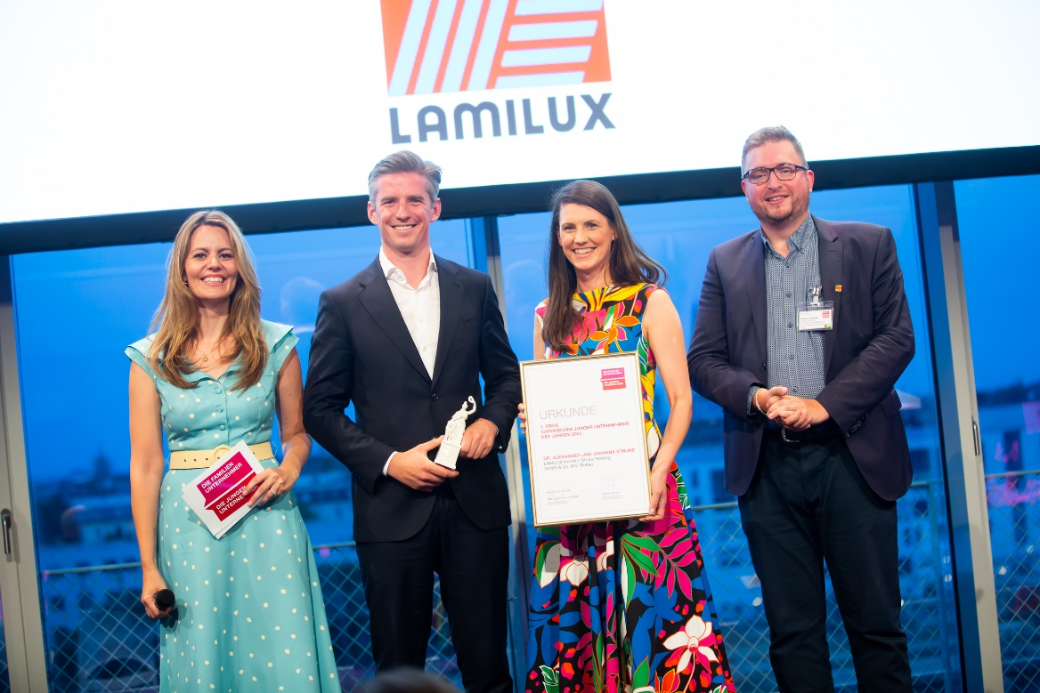
Image source: Anne Großmann Fotografie

From left to right: Presenter Monika Eckert (Munich TV), LAMILUX Managing Director Dr. Alexander Strunz, LAMILUX Managing Director Johanna Strunz and the State Chairman of the Young Entrepreneurs Raphael Sallinger

