**PRESS RELEASE**

Schwaebisch Hall, June 19, 2023

**OPTIMA strengthens the Consumer business unit in North America**

Brandon Hall appointed as Director Consumer   
at Optima Machinery Corporation

**Brandon Hall has been the new Director Consumer at Optima subsidiary Optima Machinery Corporation in Green Bay, WI since mid-June. Optima is thus strengthening its sales of filling and packaging equipment for the consumer goods market in North America and taking account of the positive growth in the Consumer business unit.**

“I’m thrilled to have Brandon join our team,” says Ulrich Unterriker, Managing Director of Optima Machinery Corporation. “His diverse background uniquely positions him to lead our Consumer Business Unit as it continues to grow. His knowledge and expertise will be tremendous assets to our team and customers as we continue to provide innovative packaging and filling solutions.” Optima Consumer produces high-precision dosing, filling and packaging systems for consumer goods of almost any consistency. This includes cosmetics, food, portion packs, chemicals and filtration solutions.

**More than 30 years of experience**

Hall brings more than 30 years of experience in manufacturing, engineering, product design, and business development to Optima. Before joining Optima, Hall was the Strategic Business Unit Manager for one of the world’s largest systems and components suppliers to the food, beverage, and pharmaceutical industries. He holds multiple degrees in business administration and mechanical engineering. “I look forward to joining Optima Machinery Corporation and the opportunity to help grow and expand the Consumer business unit,” says Hall.

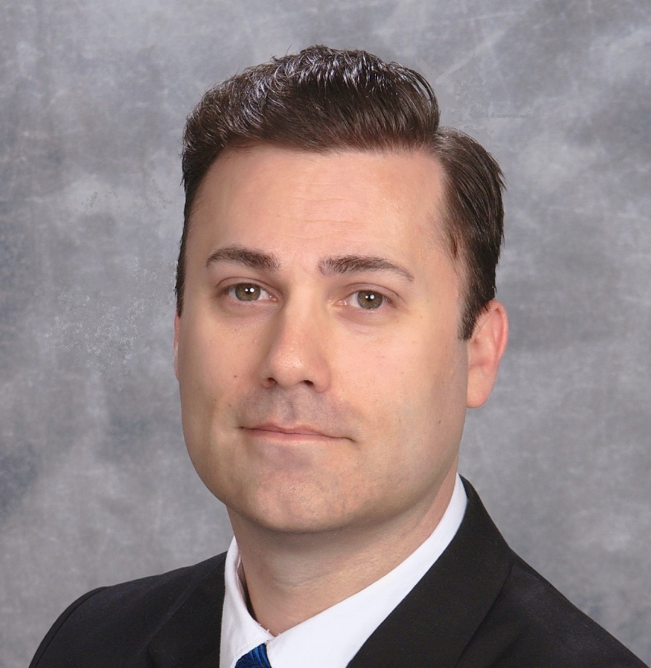

Brandon Hall joined Optima Machinery Corporation in Green Bay, WI, as the new Director Consumer in mid-June 2023. (Source: Optima)

Characters (incl. spaces): 1,613

Press contact:

OPTIMA packaging group GmbH

Jan Deininger

Group Communications Manager

+49 (0)791 / 506-1472

pr-group@optima-packaging.com

www.optima-packaging.com

**About OPTIMA**

Optima supports companies worldwide with flexible and customer-specific filling and packaging machines for pharmaceuticals, consumer goods, paper hygiene and medical devices markets. As a provider of solutions and systems, Optima accompanies these companies from the product idea through to successful production and throughout the entire machine life cycle. Over 3,000 experts around the globe contribute to Optima's success. 20 locations in Germany and abroad ensure the worldwide availability of services.

Thank you very much for your publication. We look forward to receiving a digital specimen copy.