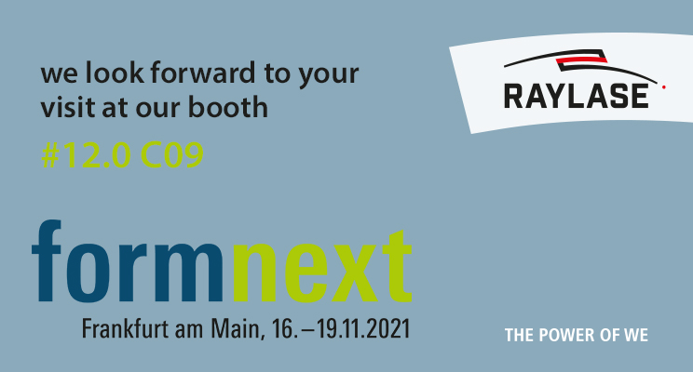
Ideas given shape: RAYLASE's innovation offensive at Formnext
On the way to Industry 4.0, new laser technologies are giving wings to Additive Manufacturing
towards precision, quality, time savings and production efficiency
Weßling 10 November 2021: Formnext, the leading trade fair for additive manufacturing, including all pre and post processes, will soon be opening its doors again in "real life". RAYLASE GmbH will be there with innovative laser deflection units, control electronics and the associated laser process software for industrial production. This year, among deflections units and control, the company will be showing a new product category at Hall 12.0 booth C09 that many have been waiting for: the SCAN-FIELD-CALIBRATOR.
The SFC calibrates process fields for the laser processing of large components such as those used in additive manufacturing. Instead of being measured manually, as is often the case, the SCAN-FIELD is automatically measured and digitally corrected. This means that difficulties literally disappear into thin air - no considerable time expenditure, no limited correction accuracy, and no risk of error. With the SFC, fields of up to 600 x 600 mm² can be calibrated, even overlapping scan fields are automatically aligned with each other. The accuracy of the measurement results is unsurpassed. The average measurement accuracy of the SFC is ± 4 μm with a standard deviation of 2 μm. This means that an average process field correction accuracy of ± 15 μm is achievable. And all this happens in only about 5 minutes per scan field, in contrast to the very labour-intensive, error-prone manual laser process field calibration in several hours or even days. The SFC thus consistently supports the industry on its transformation path to more digitalisation towards easier handling, greater speed and, at the same time, better quality of the laser processes.
Better quality and increased productivity in the AM sector are also the focus of a special combination of two products that the TU Munich and the iwb, the Institute for Machine Tools and Industrial Management, are currently investigating. Prof. Dr.-Ing. Katrin Wudy, expert and professor for laser-based additive manufacturing, will report on the metallurgy results to date of the unique interaction of the RAYLASE AM MODULE with the nLight AFX-1000 laser at the nLight stand in Hall 12.0, B128 on Tuesday, 16 October at 2 pm. With RAYLASE's patented AM MODUL Next Gen including zoom axis, which allows a doubling of the spot diameter with optimal focus position, machine builders achieve extraordinary possibilities in the generation of different beam profiles in combination with the programmable fibre laser nLight AFX-1000 laser. The intensity distribution of the beam sources, consisting of a single-mode centre beam and a ring beam, can be switched from a typical Gaussian profile to six different ring-shaped profiles in the blink of an eye. The different powers of the two superimposed laser beams not only produce an extremely attractive homogeneous energy input while avoiding splashes and heat cracks, but also increase production in additive manufacturing by a factor of four. RAYLASE employees will provide further information about all the advantages in the "LPBF - Laser Powder Bed Fusion" process during Professor Wudy's presentation. "TUM, Optoprim, the German distributor of nLight lasers, and RAYLASE have joined forces to solve the critical process limitations in LPBF applications such as lack of reproducibility and reduced production speed," says Wolfgang Lehmann, Product Manager at RAYLASE, emphasising the benefits of the extraordinary cooperation.
At this year's Formnext, RAYLASE will also be showing its product portfolio of AXIALSCAN-FIBER laser deflection units with the RAYSPECTOR monitoring unit. The RAYLASE laser components offer machine builders in the AM sector in particular the opportunity to use them to design their 3D parts more effectively. The focus here is on the process of "hatching", i.e. the efficient, overlapping filling of the 2D contours of a powder layer with a relatively large spot diameter and the subsequent "redrawing" of the contour with a small spot diameter and maximum precision.
The RAYSPECTOR optimally complements the AS FIBER as an opto-mechanical platform for the crucial process monitoring. It offers two parallel optical paths for camera and sensor technology for the "melt pool". The camera, which is tracked highly dynamically in the focus, is used here for production set-up and monitoring. A ratio pyrometer or a light intensity measuring device can be connected to the second sensor path. In combination, the two products prove to be an unbeatably efficient unit for important process steps in AM production.
RAYLASE's digital opto-mechanical laser deflection units significantly optimise and improve numerous laser processes in additive manufacturing. They can be easily integrated into machine builders' production lines and allow easier scaling at high production speeds and outstanding precision. As a result, they lead to greater output in less time and reduce costs in many important AM production steps.
________________________________________________________________________
RAYLASE GmbH is a highly innovative, internationally established company operating in the laser industry and based in Weßling near Munich. Founded in 1999, the firm from Upper Bavaria offers high-precision opto-mechanical components, control cards and software for rapid laser beam deflection and modulation for laser material processing in industrial production. Employing over 130 staff worldwide, the RAYLASE Group stands for innovative technologies of the highest quality. Since 2007, the company has had a subsidiary and its very own production facility in Shenzhen, China, not to mention several international representatives in the USA, Italy, Japan, South Korea and Taiwan.
The laser deflection units are made up of opto-mechanical scan heads, which are digital control electronics with an intuitive software interface. They form the core of industrial laser systems and enable a wide variety of materials like metal, plastic, paper, textiles and much more besides to be processed more flexibly, economically and precisely. Opto-mechanical deflection units also offer optimum image processing for better calibration, simple automation and the most accurate monitoring of a wide range of laser processes.
Customers come from the electronics, automotive, photovoltaic, textile and packaging industries. RAYLASE’s current focus markets are in electromobility (e.g. battery production), the solar industry, solar wafer production for photovoltaics and additive manufacturing. RAYLASE supports its customers primarily in the following four core applications: laser cutting, laser welding, laser surface processing and selective laser sintering or welding for additive manufacturing. The company is driving digital innovations combined with established technologies forward in these segments.

