PRESS RELEASE
Schwaebisch Hall, April 26, 2021

The new INTISO from METALL+PLASTIC
Smart isolator technology for aseptic processes

The new INTISO integrated isolator from Metall+Plastic offers complete isolator protection for filling and sealing processes with a massive reduction in outlay. What sets the new isolator design apart is the elimination of an HVAC unit and the relocation of the cooling and ventilation units from the technical floor to the isolator plenum. The INTISO isolator's modular design is another innovation that contributes to cost savings, with pharmaceutical safety remaining unchanged at a high level.
In the INTISO, key isolator functions are relocated to the isolator plenum. Previously, the ventilation and cooling units were always positioned on the technical floor, but now, in the INTISO, they are compact and can be easily accessed above the manipulation unit. This eliminates the need for the large HVAC unit that in conventional isolators is installed on the mechanical floor, requiring extensive pipework.
The INTISO from Metall+Plastic draws in preconditioned air from the clean room. This means that this isolator design is suitable for standard applications. What differentiates the INTISO and sets it completely apart from similar concepts available on the market is a supportive temperature control system. A temperature adjustment of around +/- 6° C can be carried out with a cooling unit that is integrated into the isolator plenum. In practice, this is used to offset waste heat from fans or other isolator components, for instance. This enables constant temperature conditions to be generated regardless of batch sizes. The INTISO is also able to compensate for temperature fluctuations occurring in the clean room with its integrated cooling and ventilation technology.
Its simplified installation and modular design make it cost-effective
The INTISO's modular design is another of its special features. To achieve this, Metall+Plastic has introduced a modular system for the manipulation unit, with the frames now being pre-engineered. With costs reduced further still, the system remains flexible and can be adapted to meet customer requirements. Connection to filling and closing machines is unaffected. The highly efficient DECOpulse® decontamination system by Metall+Plastic is integrated into the INTISO.
For standard applications, the new INTISO is just as safe as customer-specific versions, but it is more cost-effective and can be made available more rapidly. That's why Metall+Plastic is expecting the INTISO to become the preferred model for standard applications.
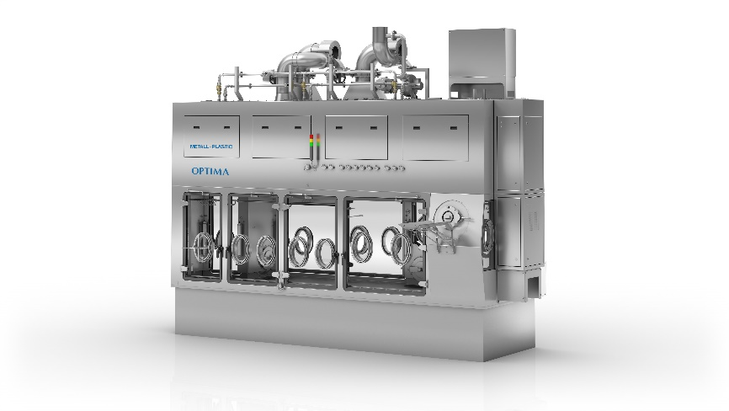
The ventilation and cooling technology in the new INTISO isolator from Metall+Plastic has been pared down to the essentials. It offers the highest pharmaceutical safety, cost and time benefits for standard applications. (Source: Optima)

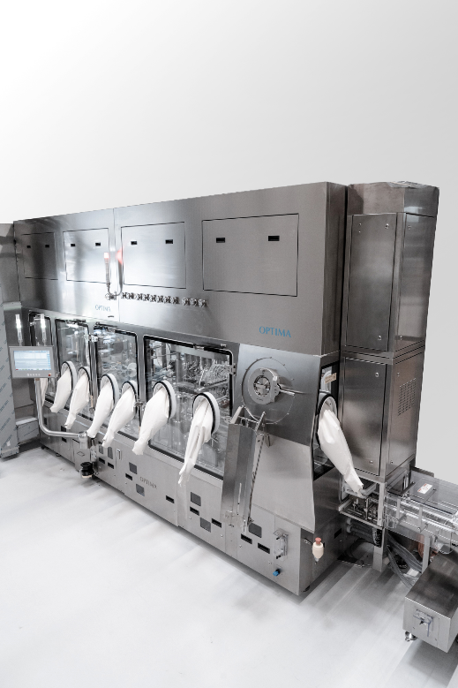
The new INTISO isolator from Metall+Plastic is the leading containment solution for standard applications. It combines the highest levels of pharmaceutical safety with time and cost benefits. (Source: Optima)

Characters (incl. spaces): 2,570

Press contact:
OPTIMA packaging group GmbH
Jan Deininger
Group Communications Manager
+49 (0)791 / 506-1472
jan.deininger@optima-packaging.com
www.optima-packaging.com

About OPTIMA
Optima supports companies worldwide with flexible and customer-specific filling and packaging machines for pharmaceuticals, consumer goods, paper hygiene and medical devices markets. As a provider of solutions and systems, Optima accompanies these companies from the product idea through to successful production and throughout the entire machine life cycle. Over 2,650 experts around the globe contribute to Optima's success. 19 locations in Germany and abroad ensure the worldwide availability of services.

Thank you very much for your publication. We look forward to receiving a specimen copy.

