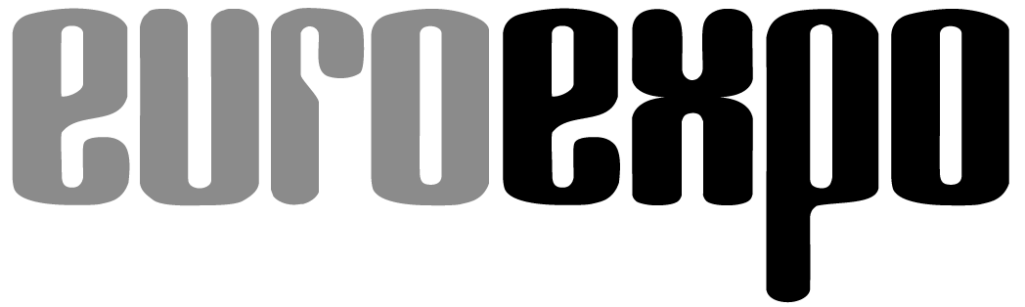
Messe- und Kongress-GmbH
Joseph-Dollinger-Bogen 7
D-80807 Munich, Germany
Phone: +49 89 32 391 259
Fax: +49 89 32 391 246
www.euroexpo.de/en
www.logimat-messe.de/en
www.tradeworld.de/en

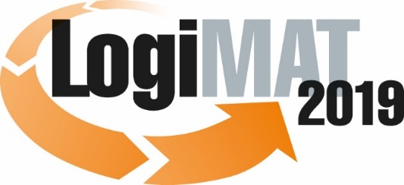

The 17th International Trade Show for
Intralogistics Solutions & Process Management
February 19–21, 2019 | Messe Stuttgart

Also featured at LogiMAT:
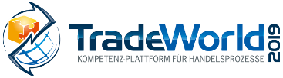

Munich, January 15, 2019

Press Release

LogiMAT 2019 in Stuttgart
LogiMAT 2019 – first-hand material handling technology

All the world’s leading forklift truck manufacturers are coming to the 17th International Trade Show for Intralogistics Solutions and Process Management. Industry professionals from around the world gather in Stuttgart for a sneak peek at exciting new innovations-many not yet seen anywhere else in the world.

“LogiMAT has established a worldwide reputation as the most important trade show for the lift truck industry,” says Ken Dufford, Vice President for Europe at Crown. The industry has responded by seizing upon the 17th International Trade Show for Intralogistics Solutions and Process Management as a platform to present the latest developments for optimized intralogistics material transport to an audience of international industry professionals. “The 17th LogiMAT in Stuttgart brings together all leading global manufacturers as well as many smaller businesses specializing in individualized solutions and custom manufacturing,” notes LogiMAT Exhibition Director Michael Ruchty from event organizer EUROEXPO Messe- und Kongress-GmbH in Munich, explaining the event’s importance in the industry. “Competition is very intense in the industry. Manufacturers are working very hard to develop new equipment and accessories, driver assistance and fleet management systems, automated guided vehicles, and alternative drive technologies to stand out from their competitors. LogiMAT, as the world’s largest and most important intralogistics event, offers the ideal platform for them to present the latest developments and innovations to their existing customers and potential new customers.”

Forklift truck manufacturers have a prominent presence at LogiMAT 2019, filling Halls 7, 9, 10, and part of Hall 2 (featuring Toyota Material Handling and others) at the Messe Stuttgart convention center. Many manufacturers have already announced plans to present new innovations, with a focus on equipment classes 1- 3, especially low-lift pallet trucks, automated guided vehicles (AGVs), tugger trains, pedestrian and articulated pallet stackers, and reach trucks. For outdoor use, new class 4 and 5 forklifts with internal combustion engines compliant with emissions standard level 5 are also in the lineup.

Some highlights:
Crown Gabelstapler GmbH & Co. KG (Hall 10, Booth D41) introduces its WAV series Work Assist Vehicle, the latest generation of the Wave® multi-purpose vehicle to hit the market. These high-lift pickers, with their built-in safety and control system, are the ideal solution for retrieving smaller loads in shelf storage facilities. Linde Material Handling (Hall 10, Booth B19+B21) is bringing two new low-lift pallet trucks to Stuttgart, the Linde T25 and T30, and is also presenting the Linde D10 AP double-deck loader with an improved assistance system that adjusts the unit’s speed based on the load weight and main hoist. The low-lift pallet trucks are designed for short to medium-length transport distances and capable of carrying loads up to 2.5 (T25) or 3.0 (T30) metric tons. They can be used as a pedestrian model or with a fold-down driver platform. Vanderlande Industries B.V. (Hall 2, Booth A05) is presenting a new collaborative robot (cobot), a solution from its portfolio of smart item robotics (SIR), that facilitates the work of pickers alongside AGVs and can manage dynamic product lines without the need for guidance from SKUs.

The new products on display from Still, Toyota Material Handling, Hyster, and others represent the next equipment class higher. Still GmbH (Hall 10, Booths B55 and B61), based in Hamburg, is accommodating the growing demand for forklift-free intralogistics by introducing the LTX 50 automated tugger train with automatic frame and conveyance technology. Still is exhibiting its RX 20 electric forklift in Stuttgart with bonus features such as an on-board charger, Easy View mast, and safety components. Toyota Material Handling (Hall 2, Booth A05) presents the Toyota BT Reflex reach truck with tilting cab and its automated counterpart, the Autopilot RAE.

AGVs are the big new thing. The Swiss company Anronaut GmbH (East Entrance, Booth EO80) offers its Vehicle Support Package, which customers can use for project-specific upgrades of the appropriate standardized vehicles to powerful, autonomous specialized vehicles, robots, and/or high-rack forklifts. Amadeus and Oscar omni are two more of the many AGV intralogistics solutions on display at the 17th LogiMAT. DS Automation GmbH from Austria (Hall 7, Booth D21) is presenting its Amadeus high-lift AGV and the space-saving Oscar drive-under AGV-two standardized free-navigation AGVs of the next generation. MLR Systems GmbH (Hall 7, Booth D41) is exhibiting an extensive portfolio of standardized modules for its AGVs, while Yale Europe Materials Handling (Hall 9, Booth B33) is showing off its autonomous, driverless forklift with Balyo technology unveiled in September 2018.

The 17th edition of LogiMAT also reflects another trend in the area of forklift technology: Lithium-ion battery (LIB) technology has been adopted almost universally for electric vehicles in equipment classes 1 to 3. Nearly all manufacturers are using LIBs across the board for at least their small equipment lines-and are increasingly upgrading their heavy equipment to this technology as well. Burger Hub- und Transportmittel GmbH (Hall 10, Booth D57), for example, is presenting its new A-series 1.5- to 5-ton electric counterbalance forklift trucks, made by HC Hangcha of China, with LIB technology. UniCarriers Germany GmbH (Hall 10, Booth D61) has announced that it will equip all future forklift models energy-efficient LIBs. Stöcklin Logistik AG (Hall 3, Booth C30) is coming to Stuttgart with a redesigned ED driver platform for the low- and high-lift pallet trucks and order-picking forklifts, all with the proprietary Stöcklin Power LIB and, for the truck bed models, with an optional transformer for charging from a truck. LogiMAT 2019 will also feature many exhibitors presenting innovative solutions for LIBs themselves and for new charging processes and stations.

This year’s LogiMAT will be the first edition offering visitors the chance to admire the products of Tailift Material Handling of Taiwan. W. Körner GmbH (Hall 9, Booth B44) a forklift manufacturer based near Brunswick (Germany) and majority-owned by Toyota Industries Corporation since 2015-is presenting two of its classic models: a 3-wheel electric forklift and a gas-powered front loader. Hyster Europe (Hall 10, Booth B15) is focusing on the latest add-ons to the Fortens® forklift trucks with internal combustion engine and lifting capacities of 2.0 – 3.5 metric tons.

“The 17th annual LogiMAT trade show once again offers industry professionals from around the world a unique overview of the latest products and service portfolios, with exhibitors that span all contemporary themes and emerging innovations in the forklift truck industry,” concludes LogiMAT’s Exhibition Director Ruchty. “This, together with the expert and innovation forums providing key information on the major trends in equipment development, make LogiMAT 2019 a must-attend event for anyone who wants to stay abreast of forklift truck technology or who wishes to make wise investments in new technology.”

Event organizer: EUROEXPO Messe- und Kongress-GmbH
Joseph-Dollinger-Bogen 7 | 80807 Munich, Germany
Phone: +49 89 32 391 259 | Fax: +49 89 32 391 246
www.logimat-messe.de | www.tradeworld.de

7,332 characters (with spaces)
Munich, January 15.01.2019-This text may be reprinted free of charge, but please send a copy to EUROEXPO Messe- und Kongress-GmbH, Press and Public Relations Department, 80912 Munich.

About LogiMAT

LogiMAT 2019, the 17th International Trade Show for Intralogistics Solutions and Process Management, takes place February 19–21 on the grounds of Messe Stuttgart, directly adjacent to Stuttgart International Airport. LogiMAT, the world’s largest intralogistics trade show, offers a comprehensive overview of everything driving the intralogistics industry, from procurement to production to shipping. International exhibitors gather early in the year to showcase innovative technologies, products, systems, and solutions for streamlining operations, optimizing processes, and cutting costs in a company’s internal logistics.
TradeWorld, the Professional Platform for Trade Processes embedded within LogiMAT, features products and solutions for e-commerce and omnichannel. Beyond the exhibitor booths, visitors to this combined event can also experience a different program of presentations each day covering a wide range of topics.

