MAP Packaging

GEA introduces PowerPak 5000 thermoformer for mid-range food packaging applications

Düsseldorf (Germany), May 04, 2026 – GEA launches at interpack 2026 the PowerPak 5000, a new thermoforming packaging machine for medium-sized food producers that need several different pack sizes, reliable daily operation, and scalable automation in the mid-size performance range. The system replaces former GEA thermoformer models in the midsize segment and is designed for processors seeking a practical balance between performance, operational simplicity, and long-term cost control.

Broad application range for diverse product categories
The PowerPak 5000 is intended for companies operating in competitive food markets where product variety, frequent changeovers, and pricing pressure require packaging equipment that can maintain output and product quality without unnecessary system complexity. The machine addresses applications in meat and poultry, fish and seafood, cheese and dairy, bakery, ready meals, and plant-based food categories.

Designed for standard and mid-range applications
Built on GEA’s established PowerPak series and decades of thermoforming experience, the PowerPak 5000 is positioned for standard and mid-range applications rather than highly specialized peak-output scenarios. GEA states that the new model has been developed as a broadly applicable solution for the majority of thermoforming use cases, with emphasis on repeatable output, ease of operation, and predictable lifecycle costs.

Current market conditions continue to increase pressure on food producers to improve efficiency while maintaining product quality, shelf appeal, and product diversity at commercially viable price points. Automation has therefore become increasingly relevant not only for large-scale processors, but also for medium-sized manufacturers and scale-ups. In many plants, the main requirement is no longer maximum theoretical output alone, but a packaging process that combines flexibility, process reliability, and a manageable investment level. In this context, the PowerPak 5000 has been designed to align with market demand for essential performance capability without over-engineering.

Multiple packaging formats on one platform
The machine supports a broad packaging range, including MAP, vacuum, skin, and steam applications. By covering these formats on one machine, the PowerPak 5000 is designed to help processors manage multiple product categories while simplifying product and format changes. According to GEA, the system has been developed for stable, everyday industrial use, with a service-friendly design intended to simplify cleaning and maintenance, reduce downtime, and support repeatable production across shifts and product runs. Tool-free changes are designed to shorten the time between batches.

Centralized operation and digital support in line production
The machine is equipped with GEA SmartControl, the company’s control interface for operation and monitoring. In practical terms, this means the operator uses a centralized human-machine interface, or HMI, to manage machine settings, production status, and process adjustments. The operating concept is intended to reduce dependence on highly specialized labor and support more consistent machine performance even when staffing structures change.

The PowerPak 5000 has also been prepared for connectivity and condition monitoring. GEA’s condition monitoring system GEA InsightPartner refers to the continuous observation of machine status data, such as component behavior, temperature, or operating patterns, to identify potential issues at an early stage and support planned maintenance rather than reactive repair. This digital readiness is intended to improve uptime and maintenance planning in plants where unplanned stops can affect line efficiency and delivery performance.

The new InsightPartner Notification Service and its accompanying Mobile App provide a fully integrated solution for delivering real-time machine notifications directly to users. The system enables operators to configure and receive targeted alerts on alarms, KPIs, and maintenance requirements, ensuring faster reaction times, reduced downtime, and improved overall equipment availability. With seamless access to live machine data and proactive maintenance insights, the mobile application supports data-driven decision-making and enhances transparency throughout the entire production process.

With GEA Changeover Assist, GEA introduces an innovative digital solution that guides machine operators— even those without extensive machine expertise—safely and efficiently through every product changeover. The system provides step-by-step instructions, visual guidance, and intelligent checklists to ensure that all required adjustments and component changes are completed correctly. This significantly reduces human error, prevents production downtime, and minimizes material and food waste. Operators benefit from faster onboarding, consistent product quality, and fewer unplanned stoppages through checklists that only show what matters. Visit our booth to see it live on the PowerPak 5000.

Modular expansion for changing production requirements
A key aspect of the new machine is its modular design. The solution can be expanded with advanced technologies as production requirements change, allowing processors to add functionality selectively rather than investing upfront in a fully customized system. These options include PowerHeat, PowerJet, and PowerLabel technologies.

PowerHeat is GEA’s heating system for thermoforming applications and is designed to improve heating efficiency, particularly when processing mono-materials. Mono-materials are packaging structures made primarily from a single polymer family, which can simplify recycling compared with multi-material laminates. According to GEA, PowerHeat can reduce energy consumption by 25 to 30 percent in relevant mono-material applications. PowerJet is the company’s evacuation and gassing system, which supports pack atmosphere control during vacuum and MAP processes. PowerLabel is a modular labeling concept previously available primarily on larger GEA thermoforming systems.

Industrial-standard components and maintenance-friendly design
In mechanical terms, the system uses the same industrial component standards applied across the broader GEA thermoforming portfolio to simplify spare parts management for the customer. The company also highlights lubrication-free bearings, which are intended to reduce maintenance demand and lower contamination risk in food production environments.

In addition, GEA Valve Technology is designed to improve accessibility when adjusting sensitive, product-depended process parameters like vacuum and gas-flushing behavior.

The machine frame has been developed according to GEA’s Kinetic Edge Design approach. This design philosophy removes protruding edges and unnecessary structural complexity, reducing the number of components and creating a smoother machine layout. In practical use, this can improve accessibility for operators during cleaning, operation, and service.

Live at interpack 2026
GEA presents the PowerPak 5000 at interpack 2026 in Düsseldorf, Germany, from May 7 to 13, at Hall 6, Booth C27. At the show, the machine will be integrated into a mid-size One-Line Concept combining the OptiSlicer 7000, OptiLoader 5000, PowerPak 5000, and PowerLabel 7000. GEA states that the synchronized line is designed for outputs of up to 600 kg/h, with coordinated slicing, loading, packaging, and labeling intended to improve process stability, support consistent product quality, and increase overall efficiency across the line.

Picture Overview (Download link for high resolution versions of the picture)

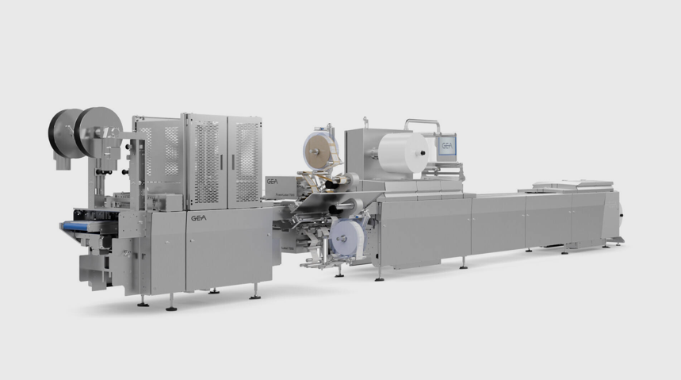

Pic. 1: The new PowerPak 5000 thermoforming packaging machine offers food manufacturers with medium to high production volumes flexible format handling, high process stability and scalable automation. Source: GEA

NOTES TO EDITORS
- Further information about GEA
- To the GEA Media Library
- Features on current topics
- Overview press events
- Follow GEA on  

Media Relations
GEA Group Aktiengesellschaft
Nicole Hoffmann
Ulmenstraße 99, 40476 Düsseldorf, Germany
Phone +49 211 9136-1503
nicole.hoffmann@gea.com

About GEA
GEA is one of the world’s largest suppliers of systems and components to the food, beverage and pharmaceutical industries. The international technology group, founded in 1881, focuses on machinery and plants, as well as advanced process technology, components and comprehensive services. For instance, every second pharma separator for essential healthcare products such as vaccines or novel biopharmaceuticals is produced by GEA. In food, every fourth package of pasta or every third chicken nugget are processed with GEA technology.

With more than 18,000 employees, the group generated revenues of about EUR 5.5 billion in more than 150 countries in fiscal year 2025. GEA plants, processes, components and services enhance the efficiency and sustainability of customers’ production. They contribute significantly to the reduction of CO2 emissions, plastic usage and food waste. In doing so, GEA makes a key contribution toward a sustainable future, in line with the company’s purpose: “Engineering for a better world.”

GEA is listed on the DAX, the STOXX® Europe 600 Index and is also a constituent of the leading sustainability indices DAX 50 ESG, MSCI Global Sustainability and Dow Jones Best-in-Class World.

More information can be found online at gea.com.
If you do not want to receive any further information from GEA, please send an e-mail to pr@gea.com.

About the GEA Foundation
The GEA Foundation, established in 2025 by GEA Group, supports global and local projects in STEM education, child poverty reduction, infrastructure access and disaster relief. Through its Mission 30 strategy, GEA commits to donating one percent of annual net profit to build resilient communities.

More information can be found online at gea.com/foundation.

